
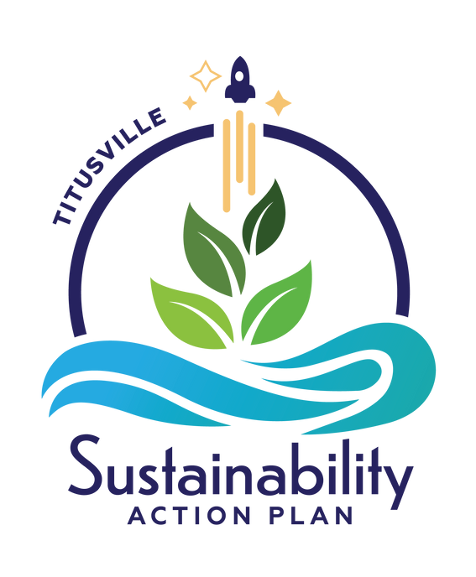
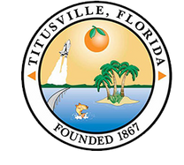

ADOPTED: 4/25/2023

Titusville.com/Sustainability
2023

Table of Contents
Acknowledgements 2
Introduction 3
Current Initiatives 6
Focus Areas 16
Community and Livability 18
Ecosystems and Resiliency 21
Infrastructure and Energy 24
Water 28
Smart Growth 31
Sustainable Economy 34
Attachments
Definitions 38
Acronyms 42
Implementation Matrix 43

Acknowledgements

Mayor and City Council
Daniel E. Diesel - Mayor
Joe C. Robinson - Vice Mayor
Herman A. Cole, Jr. COL USAF, Retired Dr. Sarah Stoeckel
Jo Lynn Nelson

City Leadership
Scott Larese - City Manager
Tom Abbate - Assistant City Manager Richard Broom - City Attorney

Special thanks to S&ME of Orlando, the City of Titusville Community Development Department and Public Works Department.

Thank you to our partners: Brevard County, East Central Florida Regional Planning Council, Florida Power and Light, North Brevard Economic Development Zone, Space Coast Transportation Planning Organization, Titusville Chamber of Commerce, Titusville Housing Authority, & UF/IFAS Brevard County Extension.

Authored By Rachel Muller

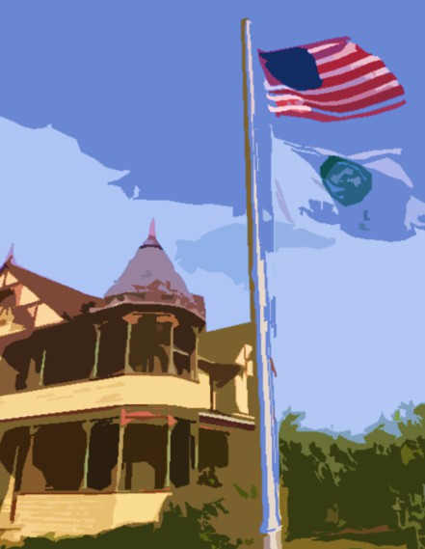
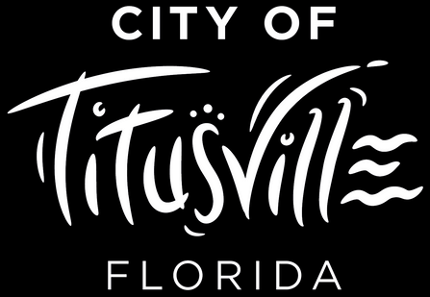
INTRODUCTION

Introduction
The creation of Titusville's first Sustainability Action Plan (SAP) has been a multi-phased project incorporating extensive community engagement, collaborative departmental communication, and ambitious goal setting to guide all aspects of city operations and investments to ensure sustainable, inclusive , climate-friendly options are implemented.
Titusville is a coastal community on the east coast of Florida, well known for its close proximity to the Kennedy Space Center. The City was incorporated in 1887 and has seen substantial changes over the decades with several busts and booms due to the Space Program, including the most recent boom of commercial and residential development. This has come with increased traffic, a growing demand for housing, and better services. At the same, time challenges have persisted, including the deterioration of the Indian River Lagoon, loss of tree canopy, threats of sea level rise, storm surge and more intense flooding events. These economic, environmental, and quality of life changes require forward thinking and planning to help the City continue to develop in a safe, accessible, and responsible manner.
City Council directed staff to develop a Sustainability Action Plan to better understand current and future challenges to be better equipped to make smart and innovative decisions that keep the city
vibrant for future generations.

Titusville Today
Nestled along the Indian River Lagoon on Florida's Space Coast, the City of Titusville provides unique opportunities and an array of public amenities that demonstrate the City's resiliency. It's close proximity to the Canaveral National Seashore, NASA and other Space Industries, and numerous recreational activities makes Titusville an unparalleled place to call home.
Race and Ethnicity
48, 847
Population
$48,118
Medi hold
an House
Income
2,032
Total Businesses
24%
Higher Education Degree
47
Median Age
21,093
Total holds
House
Other/ Two or More Races

Asian / Pacific
5.5%

Islander 1.9%
Black
14.3%
White
78.3%

Hispanic Origin (Any Race)

Population Growth

48,847
2021
9.3%

51,707
2026
1.14%

43,675
2010
1% Growth
(Projection)

Source: City of Titusville Economic Development Office, www.titusville.com/1146/Demographic-Regional-Information

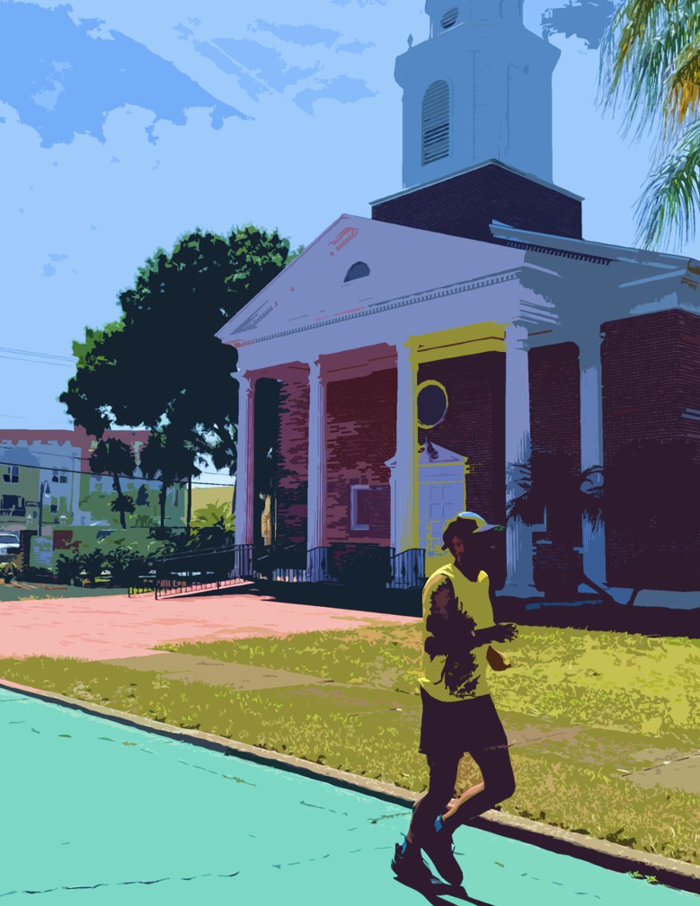
CURRENT INITIATIVES

Current Initiatives
The adoption of the Sustainability Action Plan symbolizes the formal beginning of sustainability programming within the City. Previous and current initiatives embody many of the components of sustainability and will help guide the implementation of new programs and policies. The following section highlights current and recent achievements that will provide the foundation for successful implementation of future projects that incorporate sustainability within decision-making and daily operations.

Greenhouse Gas Emissions Inventory

Greenhouse gases (GHG) include carbon dioxide (CO2), methane (CH4), water vapor (H2O), nitrous oxide (N2O), and several fluorinated gases. They exist naturally in Earth’s atmosphere and help regulate the planet’s temperature by retaining heat from the sun. Similar to how the glass in a greenhouse retains heat to allow plants to flourish, greenhouse gases make our planet habitable. Too much of a good thing can backfire, like putting on a blanket to keep you warm but not being able to take the blanket off once you warm up. Adding more greenhouse gases into the atmosphere acts like putting a thicker blanket on the planet. The thicker the blanket, the more heat gets trapped and causes the planet to warm. Common sources of GHG emissions include the burining of fossil fuel for cars, trucks, ships, trains, and planes, as well as the use of coal and natural gas for electricity generation.

In 2019, a municipal operations greenhouse gas (GHG) emissions inventory was compiled for the City with the assistance from the International Council for Local Environmental Initiatives (ICLEI) – Local Governments for Sustainability USA. In 2022, a community wide greenhouse gas emissions inventory was derived with the assistance from the East Central Florida Regional Planning Council and the United States Green Building Council (USGBC) Leadership in Energy and Environmental Design (LEED) for Cities program. These inventories act as a baseline from which to measure the city’s current and future emissions reduction progress. The standard unit for measuring emissions is metric tons of carbon dioxide equivalents (MTCO2e). These inventories provide the framework for greenhouse gas reductions goals and metrics for future updates.

As shown in Figure 1, emissions from municipal operations only account for 1.8% of the total community-wide GHG emissions. For Titusville to meet reduction goals, the focus must be on community-wide strategies to reduce emissions. Nonetheless, the City will lead by example and reduce emissions within municipal operations and use demonstration projects to educate the larger community on ways to reduce private, commercial, and industrial emissions.
Community-wide emissions are broken down into six sectors. These sectors include transportation, residential, solid- waste, commercial, public, and industrial emissions. Transportation emissions are a combination of vehicle miles traveled (VMT) from gasoline and diesel vehicles.
MUNICIPAL OPERATIONS AS A SHARE OF COMMUNITY WIDE GHG EMISSIONS
City Operations 1.8%

Community Wide 98.2%

Figure 1. Municipal Operations as a share of community wide GHG emissions

This is the largest share of emissions within the City, representing 31% of emissions. The second largest share is residential emissions with 28% of the total community-wide emissions. Residential emissions include electricity use and natural gas. Solid Waste emissions accounts for 23% of community-wide emissions and is a derivative of Brevard County’s emissions for waste generated by Titusville’s population. Together, these three sectors account for 82% of the community-wide emissions. Figure 2 shows the percentage breakdown of each sector.
2019 COMMUNITY WIDE EMISSIONS BY SECTOR

Commercial 12.1%
Public 4%
Industrial 1%

Transportation 31.3%

Solid Waste 23.2%

Residential 28.3%
Figure 2. Pie Chart breakdown of 2019 Community Wide Emissions by sector

Data provided by the East Central Florida Regional Planning Council, Regionwide GHG Inventory, https://www.ecfrpc.org/regional-ghg-inventory

Brownfields Assessment Program
A brownfield is a property in which the redevelopment or reuse of which may be complicated by the presence or potential presence of a hazardous substance, pollutant, or contaminant. Prior site uses that are commonly associated with brownfield determination are auto repair, dry cleaning, or fueling station.

In October 2021, the City received grant funding from the Environmental Protection Agency (EPA) to fund Phase I and Phase II environmental site assessments (ESA). A Phase I ESA is the recommended first step in obtaining information on the condition of a property to assess any potential contamination and source. A Phase II ESA evaluates the presence or absence of hazardous substances like petroleum products in the subsurface of the site. This includes testing soil, soil gas, and/ or the groundwater to identify sources of contamination. On April 6, 2022 the Titusville's Office of Economic Development hosted a community workshop to acquire input from the public on identification of potential brownfield sites.
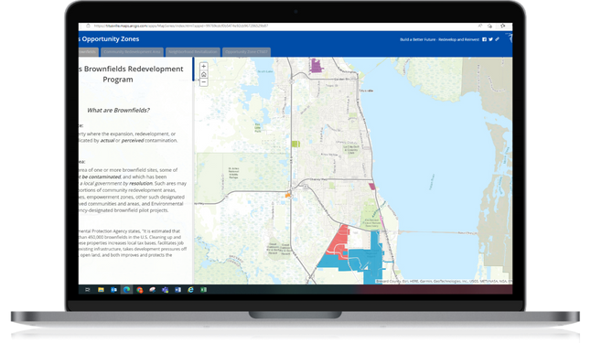
The City's Brownfields Assessment Program provides funds for eligible brownfield activities within the city limits. As part of this program the City is able to directly fund eligible projects for ESAs that support redevelopment efforts For more information on identified brownfields, visit the

City's storymap.
Figure 3. Titusville's Local Brownfield Areas StoryMap

Low Impact Development

Low Impact Development (LID) is an approach to land development that works with nature to manage and treat stormwater as a resource rather than a waste product. Low impact development refers to systems and practices that use or mimic natural processes to mimic natural movement of water within a watershed.
The City continues to prioritize low impact development (LID) on two-fronts: city operations and development incentives. The former includes a bundle of techniques and systems throughout the City designed to work with nature to remove excess pollutants from stormwater to protect local waterbodies including the Indian River Lagoon. In an effort to prevent nutrients from entering the lagoon, several projects aimed at removing nitrogen and phosphorous have been completed and others are lined up for construction, including two new baffle boxes.
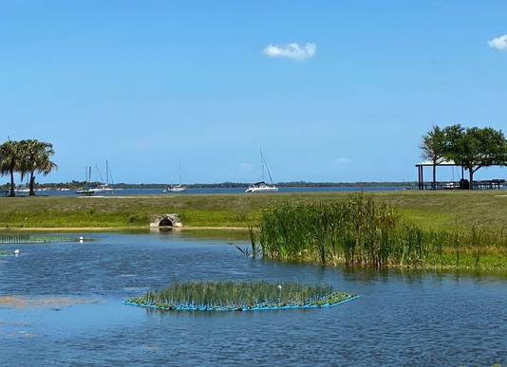
On October 20, 2021 City Council passed Ordinance 30-2021 and established an incentive program in the site plan review process to encourage new development, infill, and redevelopment to use a mix of LID techniques to manage site specific stormwater runoff. The City's technical manual

has been updated to
Figure 4. Floating Treatment Wetland at Sandpoint Park

include a list of approved LID techniques and incentives offered.

Neighborhood Revitalization Strategy Area

A neighborhood revitalization strategy area (NRSA) is an incentive- based program created by the U.S. Department of Housing and Urban Development (HUD) to revitalize the most distressed neighborhoods within a community. Funded through the Community Development Block Grant a NRSA is a means to create communities of opportunity by stimulating reinvestment by empowering low income residents.

Titusville has one designated neighborhood revitalization strategy area (NRSA) incorporating Census Tract 604, Blocks 1
through 4, and Census Tract 607, Blocks 1
and 2. Approximately, 7,395 residents live within the NRSA and a majority of those residents qualify as low- or moderate- income residents (60%). Residents within the NRSA experience a set of interrelated challenges at a higher rate than the city as a whole. Those challenges span from low educational attainment to housing insecurity.
The NRSA planning process was community- driven and embodies many elements discussed in the Sustainability Action Plan including enhancing park space, open space and recreational opportunities; prioritizing walkability and alternative modes of transportation; and equitable economic development that supports the growth of local small businesses.

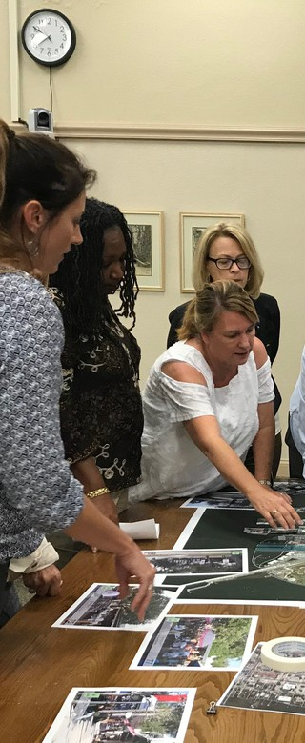
Figure 5. Community Engagement Event

Certified Florida Green Local Government

The Certified Florida Green Local Government is a program offered by the Florida Green Building Council (FGBC) to recognize outstanding environmental stewardship in designated cities and counties.
Titusville received recognition as a Certified Green Local Government in 2019 after going through an extensive evaluation process. The City received bronze certification for achieving 83 eligible credits. This included initiatives from providing new hires with reusable water bottles to utilizing renewable energy at city facilities.
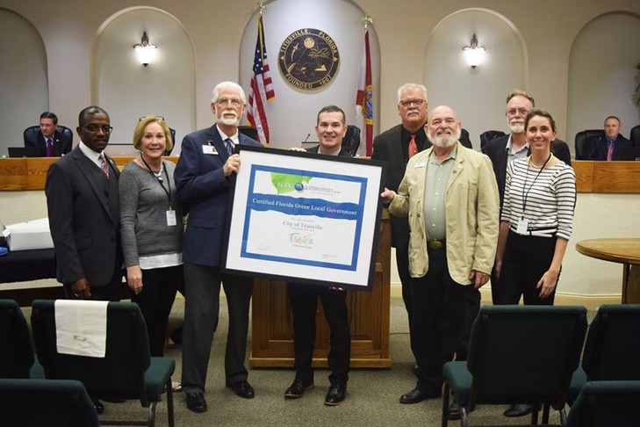
Figure 6. Titusville City Council receives Florida Green Local Government Certification

Traffic Calming Program

Traffic Calming is a street design method aimed at reducing vehicle speed and volume on a single street or throughout a street network. Through the use of physical and/or perception, traffic calming features are a self-enforcing mechanism to improve safety, mobility and comfort resulting in enhanced livability in the surrounding area.
The City of Titusville Public Works Department gets numerous citizen requests to review local traffic conditions and has developed a five step process to identify the proper solution for each location. To eligible for the program the street must: be a residential neighborhood; have a traffic volume greater than 300 vehicles per day with a posted speed limit of 30 MPH; and be at least 500 feet in length. Cul-de-sacs are not eligible for this program. Residents must obtain signatures from at least 50% plus 1 property owners within the impacted area to move forward with the request. A phase one solution usually consists of the least restrictive measures possible that fall into three categories: Education, Enforcement, and
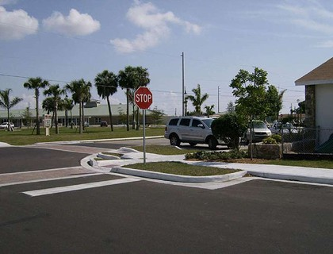
Engineering. If phase one efforts do not achieve the desired results, a priority ranking process allows the Public Works department to prioritize traffic calming projects. There are over 15 acceptable identified engineering solutions for local streets that range from a cost of $1,000 to $60,000 to implement.
Figure 7. A corner extension slows vehicle turning speed

Education and Outreach Programs

Education and outreach is a tool for local municipal governments to engage in dialogue with the broader community. Incorporating education and outreach into the city operations allows for decision- makers to be better informed and well equipped to meet community needs.
The City currently hosts many education and outreach programs throughout the different departments and appointed-boards to better educate residents, businesses, and visitors alike on the wide variety of programs and resources provided. Below is a list of some of the current programs and offerings to better educate and engage with the community on issues related to sustainability.
- Free Bike Helmets for Youth 16 and younger offered by the Fire Department.
- Kirk Point Park Educational Series by the Public Works Department on ways the City is restoring the Indian River Lagoon.
- Bag it Trash It Dog Waste Program by the Water Resources Conservation Program.
- Water Conservation retrofits including aerators, replacing older toilets, and showerheads by the Water Resources Conservation Program.
- Resiliency Stewardship and Education Program by the Community Development Department in collaboration with East Central Florida Regional Planning Council.
- Titusville Environmental Commission Elementary School Education Grant.
- Bicyclist and Boaters Business-Friendly Program by the Community Redevelopment Agency.

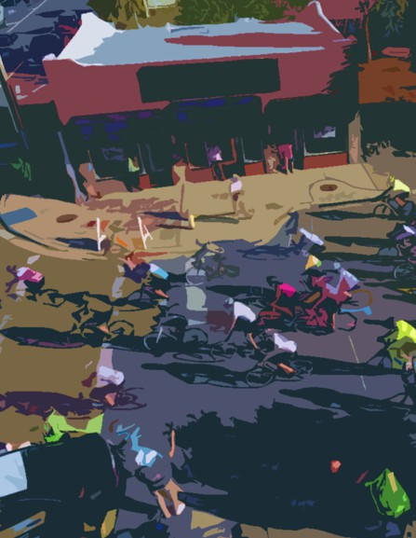
FOCUS AREAS

Focus Areas
The development of Focus Areas allows the City to create structure and organization to achieve sustainability goals. The City encouraged the community to determine the Focus Areas of the SAP over the several month community engagement process between October to December 2021. The first part of the public engagement process focused on creating an inventory of sustainability ideas, principles, and practices provided by the community. After the Preliminary Focus Areas were determined in the first half of the public engagement process, the next step was to empower the community to prioritize which of the Focus Areas should receive the most attention within the SAP. The Consultant S&ME of Orlando provided the following six Focus Areas: Community and Livability, Ecosystem and Resiliency, Infrastructure and Energy, Water, Smart Growth, and Sustainable Economy. Each Focus Area is explained throughout this section with their respective objectives and action items to drive future sustainability progress in Titusville.

Community Outreach & Engagement
From October to December 2021;
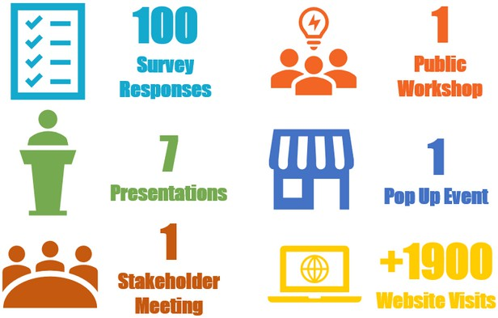

Community & Livability

The act of community building requires communicating, educating, and working towards a sense of place that fosters shared values and ideals. Sustainability could not be accomplished without a strong community and it is therefore imperative that any action to promote the economy and protect the environment, must also protect and promote the local population as well. The following goal, objectives and action items seek to improve the quality of life and livability of Titusville. These actions target enhanced communication, collaboration, and opportunity.

Planning efforts to enhance Titusville's sense of community and livability occur at various scales and involves strong collaborations with community stakeholders. To strengthen connectivity while also efficiently conserving land, compact and dense development with ample access to community resources (including schools, parks, recreational greenspace, commercial centers, public transit, and more) must be prioritized moving forward.

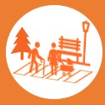
Providing equitable access to community resources strengthens community identity and resiliency. Walkable and connected neighborhoods that inspire activity and engagement foster a sense of place that the community can proudly embrace.

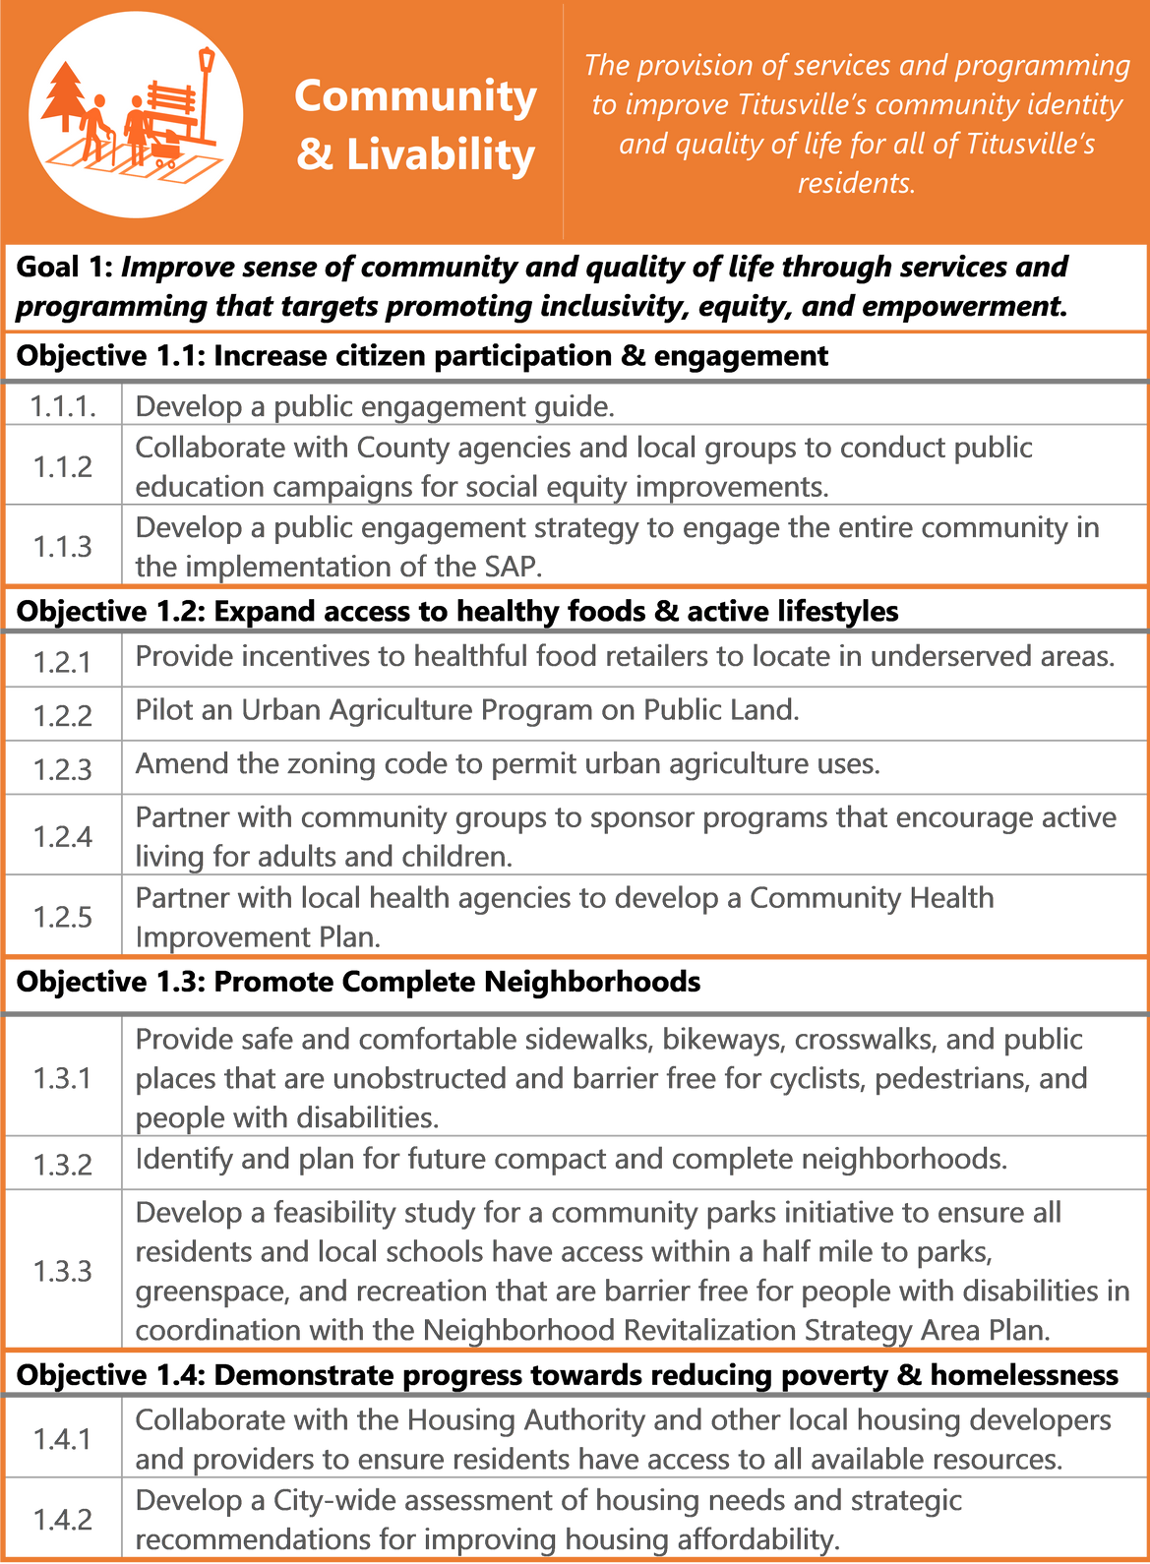

Targets
  - : Demonstrate higher turnout to public workshops, City sponsored engagement events, and response rate to community-wide City surveys.
  - : Measure baseline access to healthy food and work to increase access to healthy food to within ½ mile of every resident.
  - : Measure baseline access to pedestrian pathways and bikeways and increase the miles of pedestrian pathways and sidewalks.
  - : Demonstrate increased density and the number of businesses located within compact and complete neighborhoods.
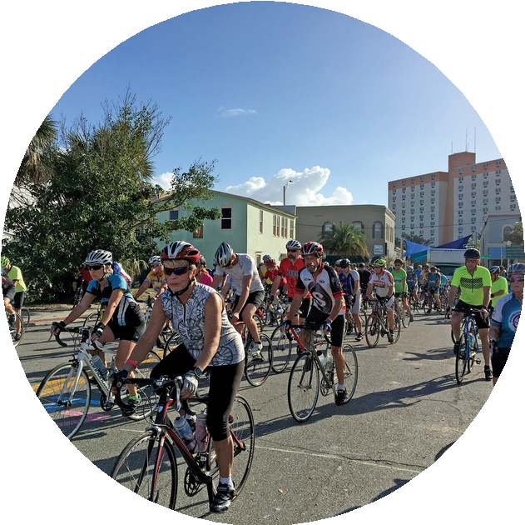
  - : Measure baseline and demonstrate progress toward reducing the number of residents living in poverty.
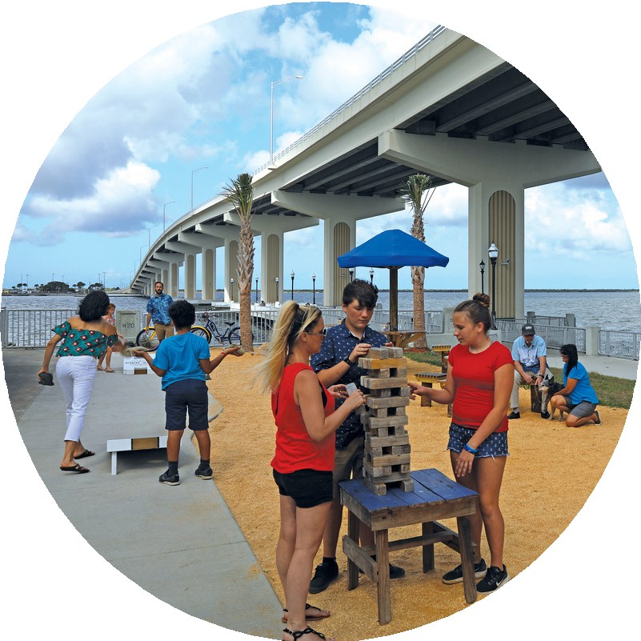
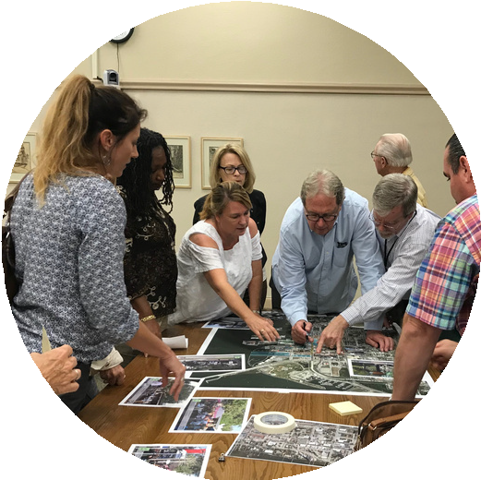

Ecosystems & Resiliency

Cities are engines for development, innovation, close connections, and opportunity. At the same time, cities can exacerbate environmental challenges by attempting to carve a place for humans outside of nature. For Titusville to be a smart, resilient, and sustainable city, it must harness the power of nature and embrace nature-based solutions. Examples of nature-based solutions include low impact development, connected ecosystem corridors, living shorelines, and much more.

The care and stewardship of natural lands and waterways has been a top priority for the people of Titusville for many years. The Indian River Lagoon has seen declines in sea grass growth, fish and other marine life, and the quality of water. On land, the City continues to see loss of tree canopy as development continues to boom. For the City to continue to grow in a sustainable manner while require evaluating the state of current natural resources and prioritize ecosystem health and resiliency in decision making.


The protection of natural resources is essential to maintain healthy air, water, and protecting residents and businesses from the impacts of natural disasters. The continued care of our environment will continue to attract tourism, economic growth, and a high quality of life.

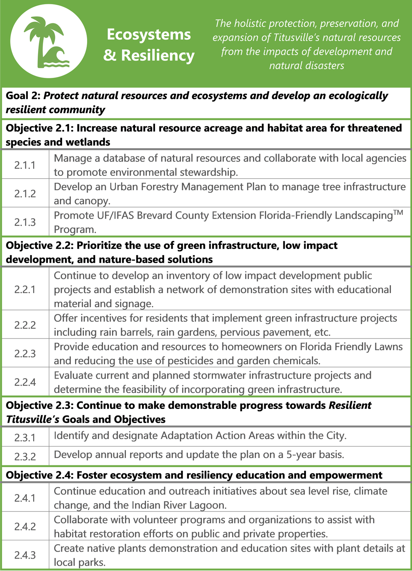

Targets
  - : Measure baseline natural resources acreage and work to increase natural resource acreage, habitat areas, and protected wetlands.
  - : Measure baseline application of low impact development, green infrastructure, and nature-based solutions and demonstrate increase in use on municipal projects
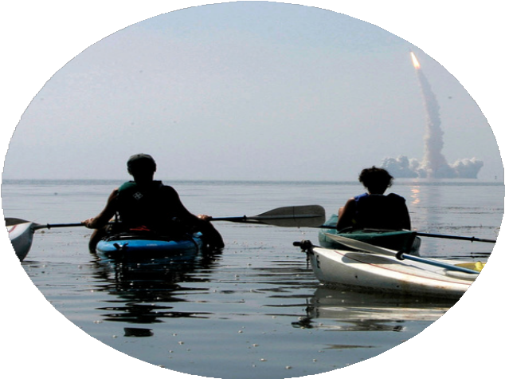
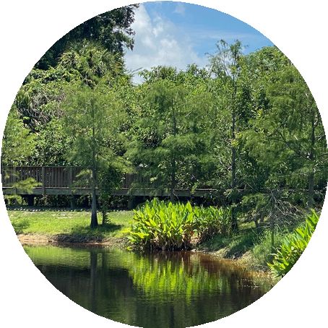
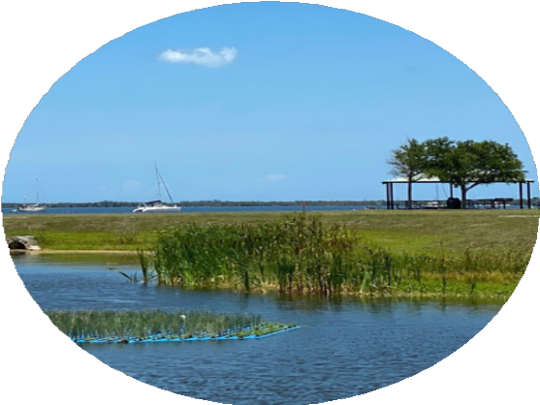
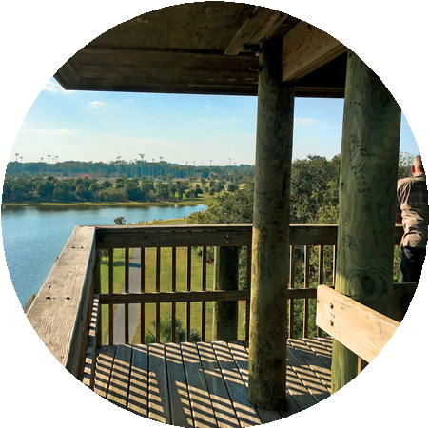
  - : Measure baseline community understanding of resiliency and work to increase community awareness

Infrastructure & Energy
There is a significant opportunity to reduce energy waste and increase efficiency city-wide. Coupled with strategic infrastructure investments, strategies listed in the infrastructure and energy focus area can lead to a smart, resilient, and innovative city. Titusville's transition to clean, renewable, and energy-efficient resources will help minimize environmental impacts and progress towards reducing Greenhouse Gas (GHG) emissions in the coming years and decades. The transition to cleaner energy will have additional economic benefits and job creation to keep the city up to speed with regional, state, and national goals and policies.

Infrastructure improvements will contribute to Titusville's goal of reducing Greenhouse Gas Emissions. By committing to reducing the amount of waste headed to landfills, the city will not only reduce emissions but also reduce the demand for virgin resources and promote a circular economy. Achieving waste reduction goals will require a shift in perception and lifestyles. However, it presents opportunities to be innovative and build a stronger community.

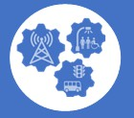
Implementing smart technology and multimodal transportation solutions will further enhance the sustainability and resiliency of the community. Together they will move people and goods more efficiently, reduce traffic congestion and associated air pollution.

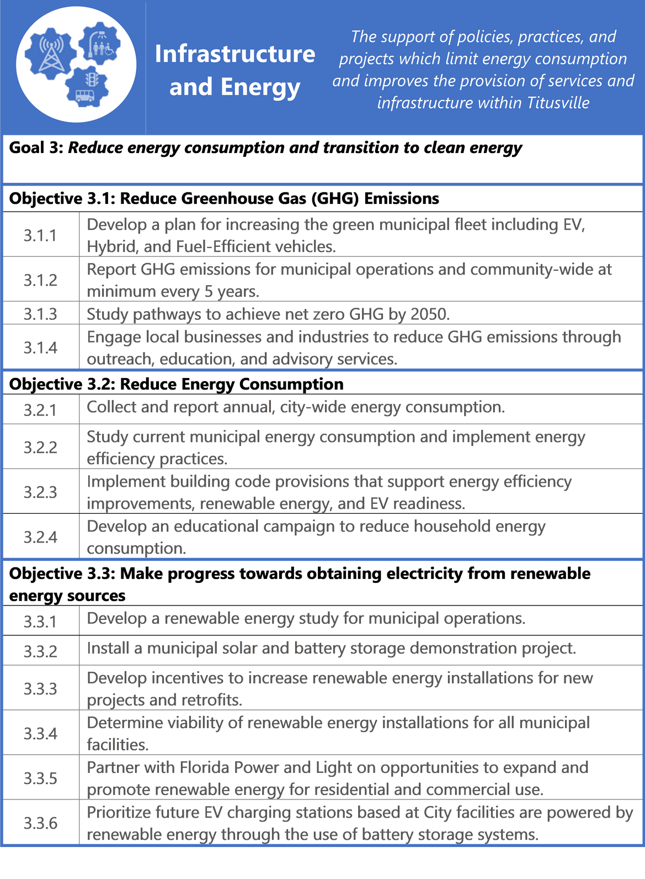

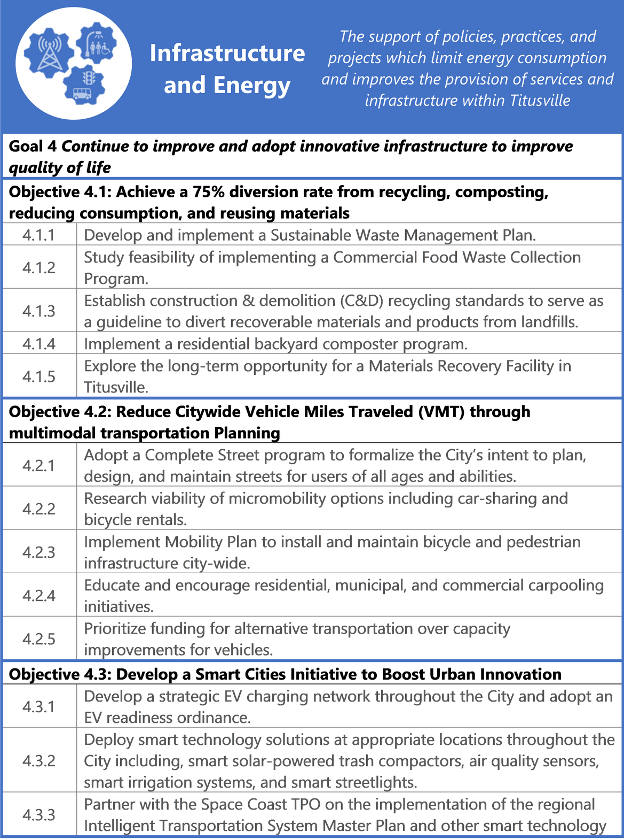

Targets
  - : Incrementally reduce GHG emissions and set an achievable timeline to reach a GHG emission goal.
  - : Incrementally reduce energy consumption and set an achievable timeline to reach energy consumption goals.
  - : Determine a goal and timeline to have a certain percent of city operations on renewable energy.
  - Make considerable progress towards a 75% diversion rate from landfill use.
  - Make considerable progress towards reducing the number of vehicles per household by the next census count.
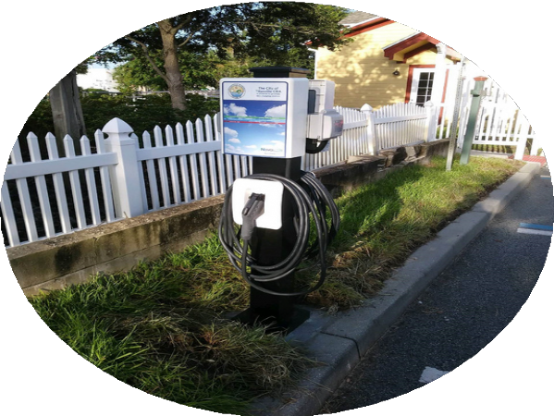
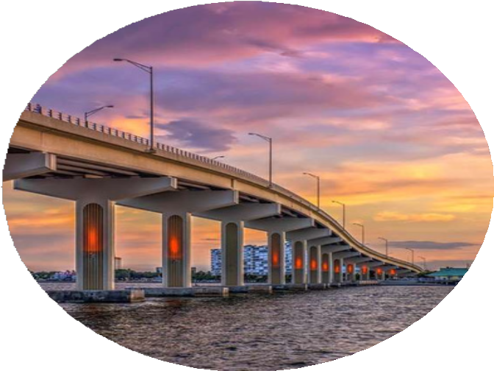

Water
The current and long-term availability of water is a top priority of the community. Throughout the engagement process, the availability and quality of drinking water was listed as a top concern.

National and International headlines continue to show the severity of mismanaged and outdated water supply systems. It is therefore imperative that the City of Titusville continue to communicate to and educate residents on the city's approach to managing water resources.


Drinking water resources face stresses of population growth, frequency and intensity of precipitation, and saltwater intrusion. The city manages its own drinking water and has remained resilient by designating the wellfield areas as Areas of Critical Concern with special land use considerations including maximum impervious regulations. However, as water insecurity becomes more of a threat within the State and Nationally, it is important that Titusville continues to manage water demand by reducing water consumption in the City to sustainable levels. The following objectives and action items will continue the City's effort to provide the highest quality drinking water and keep the supply of drinking water at secure levels.

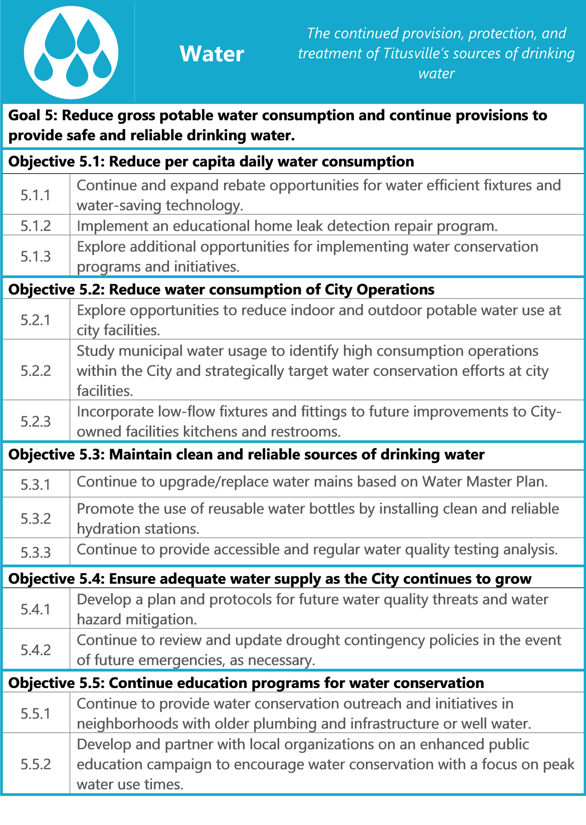

Targets

  - : Measure baseline water consumption and work to decrease water consumption to sustainable levels.
  - : Demonstrate reductions in water consumption at city facilities and operations.
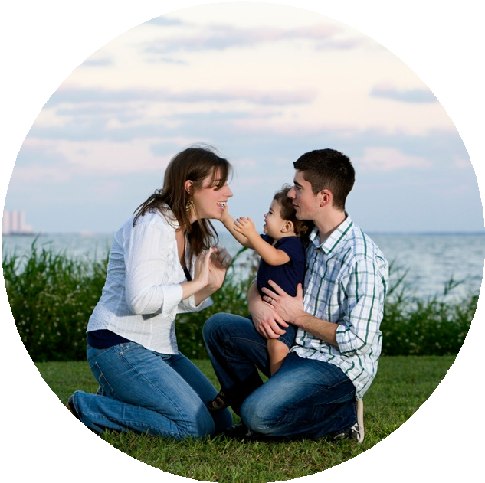
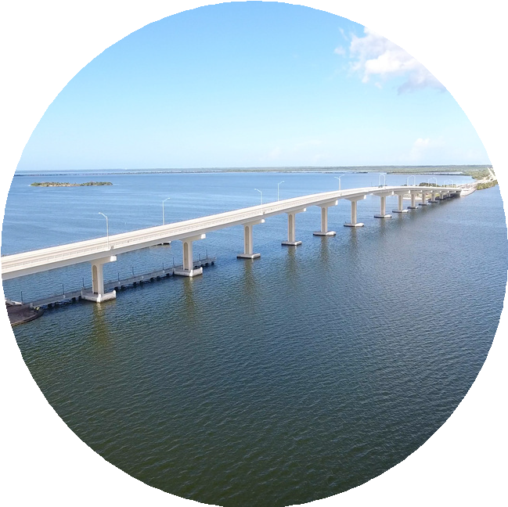
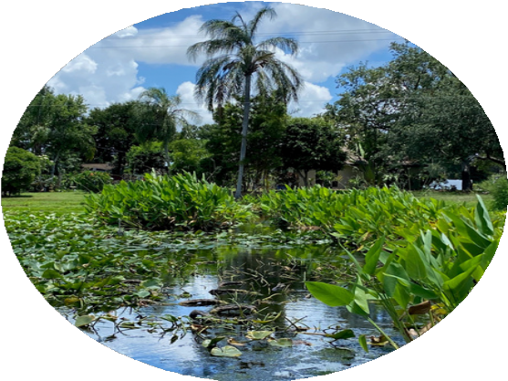
  - : Demonstrate effectiveness of water conservation education programs.

Smart Growth
Where we live impacts our health, economic opportunity, quality of life, and our children's futures. Smart growth is an approach to development that encourages a mix of building types, land uses, multi-modal transportation options, diverse housing stock, and robust community engagement. Smart growth principles prioritize compact design, walkable neighborhoods, and a strong sense of place. The objectives and action items in the Smart Growth focus area are designed to make the fabric of our community one that prioritizes sustainability at all levels- from the design of each individual street to our collaboration with partner organizations to provide regional transportation options.

Many of the action items are complimentary, by increasing access to pedestrian and bicycle infrastructure, we can make steps towards reducing the household cost on transportation by providing easily accessible alternatives to our personal vehicles.


Smart growth also requires for us to be more thoughtful in our approach to building. Green building standards are critical to minimize the environmental impacts of new construction and redevelopment. It ensures more efficient use of energy, water, and other valuable resources. Buildings that utilize sustainable or green building standards are better equipped to provide climate resiliency.

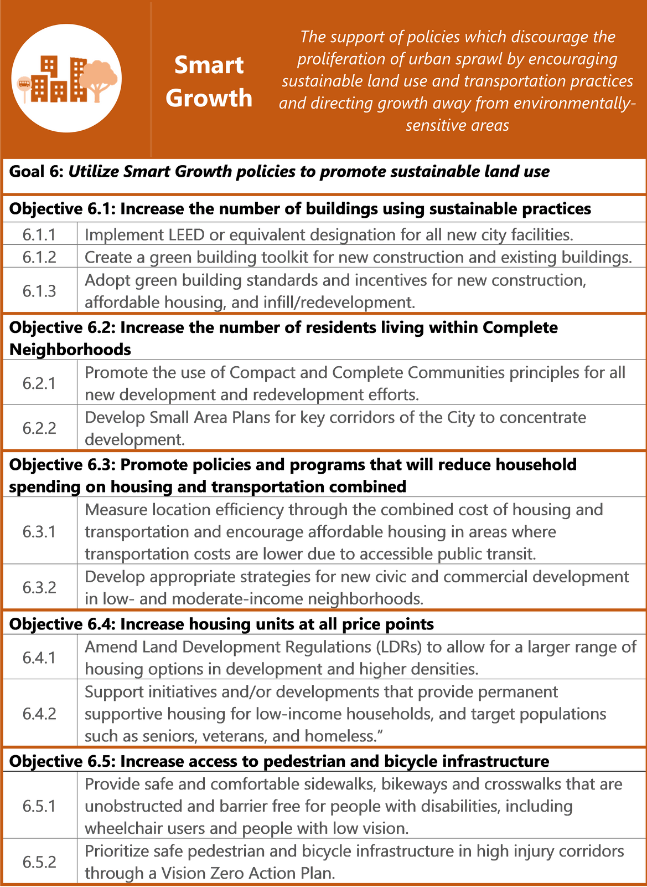

Targets
  - : Continuously track buildings using sustainable practice and show year over year growth in building using said practices.
  - : Demonstrate higher densities in key areas within the city.
  - : Make progress towards reducing the City's average (H+T®) index.
  - : Demonstrate equitable distribution of housing types and price points.
  - : Measure baseline access to pedestrian and bicycle infrastructure and show improvements in access.
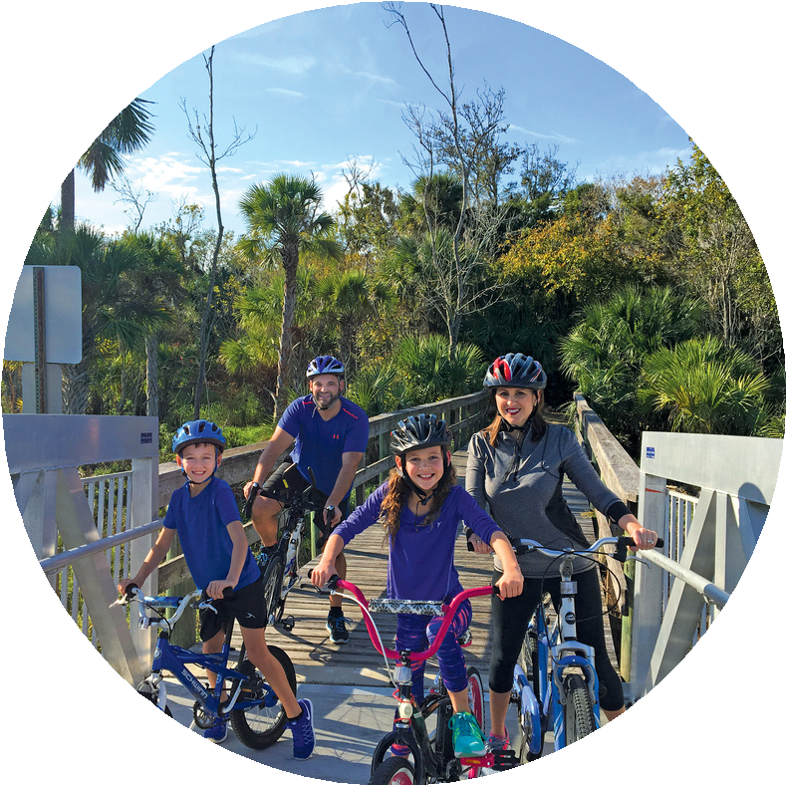
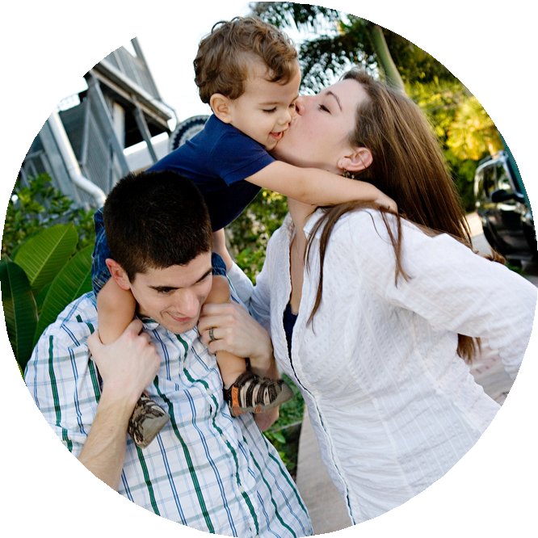
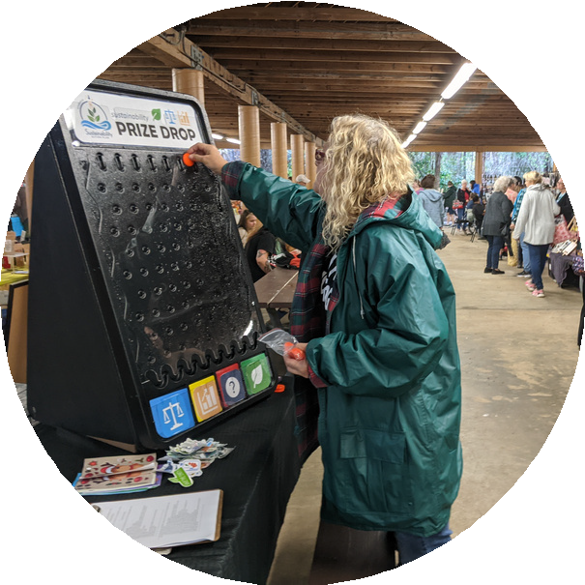

Sustainable Economy
A sustainable, resilient, and thriving local economy is a critical aspect to making progress towards a future-ready Titusville. Equitable access to quality jobs, prioritizing the local economy over importing goods and services, and connecting local residents to local jobs all have direct and meaningful impact on the City's sustainability and resiliency.

Titusville is in the midst of an economic boom with the continuous advancements and investments in space exploration. It's important that the city is a place where one can Live, Work, and Play. Now is the time to celebrate economic success but also focus on challenges, such as economic mobility, access to jobs, and the type of work available for local residents.


A circular economy is one that not only eliminates negative environmental impacts, but also creates new pathways by prioritizing new sources of value. A circular economy requires a systemic transportation of business models, technologies, and collaboration. The City will demonstrate leadership in achieving this transition through alternative business models and purchasing patterns. This transition will require a shared vision and strong leadership from government, civic society, and business partners. Together, we will create high value and pathways towards a better, more sustainable and resilient future.

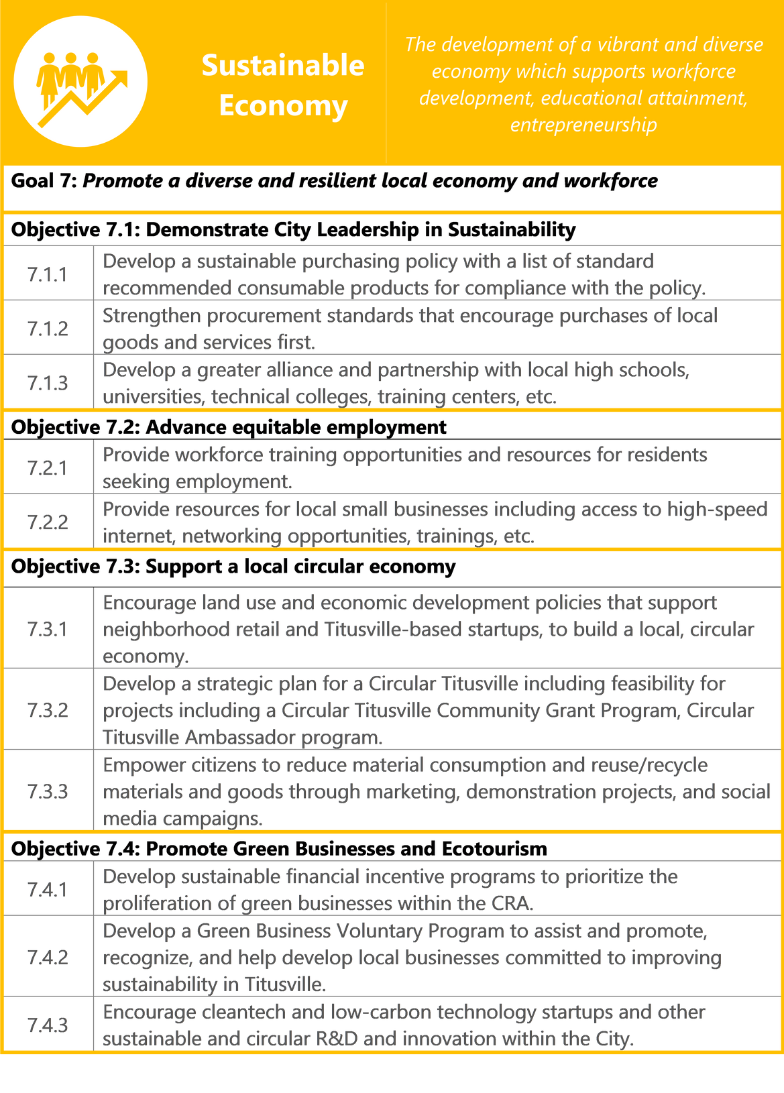

Targets
  - : Demonstrate that the unemployment rate for key sociocultural groups is within 5 percentage points of the overall unemployment rate.
  - : Create metrics for the determination of green businesses and demonstrate growth in the number of business that are green within the city.

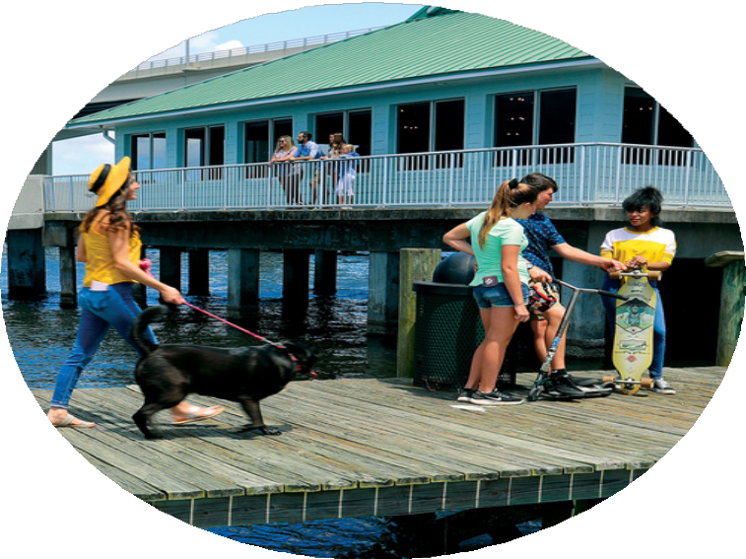

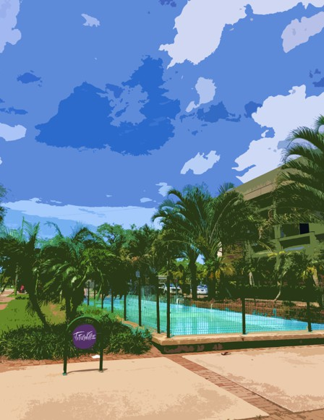
ATTACHMENTS

Definitions

Adaptation Action Areas are an optional comprehensive plan designation for areas that experience coastal flooding and are vulnerable to the related impacts of rising sea levels for the purpose of prioritizing funding for infrastructure needs and adaptation planning. (Source: https://floridajobs.org/community-planning-and- development/programs/community-planning-table-of-contents/adaptation- planning)

Brownfield Sites are the property, the expansion, redevelopment, or reuse of which may be complicated by the presence or potential presence of a hazardous substance, pollutant, or contaminant. (Source: https://www.epa.gov/brownfields/overview-epas- brownfields-program)

Circular Economy keeps materials, products, and services in circulation for as long possible. A circular economy reduces material use, redesigns materials, products, and services to be less resource intensive, and recaptures “waste” as a resource to manufacture new materials and products. (Source: https://www.epa.gov/recyclingstrategy/what-circular-economy)

Community Health Improvement Plan as a long-term, systematic effort to address public health problems on the basis of the results of community health assessment activities and the community health improvement process. This plan is used by health and other governmental education and human service agencies, in collaboration with community partners, to set priorities and coordinate and target resources. A community health improvement plan is critical for developing policies and defining actions to target efforts that promote health. It should define the vision for the health of the community through a collaborative process and should address the gamut of strengths, weaknesses, challenges, and opportunities that exist in the community to improve the health status of that community. (Source: https://www.cdc.gov/publichealthgateway/cha/plan.html)

Definitions

Compact and Complete Neighborhoods provides residents safe and convenient access to the goods and services they need on a daily or regular basis. This includes a range of housing options, grocery stores and other neighborhood-serving commercial services, quality public schools, public open spaces, recreational facilities and access to frequent transit. A complete neighborhood also includes an interconnected network of streets, sidewalks and trails that makes walking and bicycling within and to these places safe and relatively easy for people of all ages and abilities. (Source: https://sacompplan.com/complete-neighborhoods/)

Green Infrastructure is the range of measures that use plant or soil systems, permeable pavement or other permeable surfaces or substrates, stormwater harvest and reuse, or landscaping to store, infiltrate, or evapotranspirate stormwater and reduce flows to sewer systems or to surface waters. (Source: https://www.epa.gov/green-infrastructure/what-green-infrastructure)

Greenhouse Gases (GHG) include carbon dioxide (CO2), methane (CH4), water vapor (H2O), nitrous oxide (N2O), and several fluorinated gases. They exist naturally in Earth’s atmosphere and help regulate the planet’s temperature by retaining heat from the sun. (Source: https://www.epa.gov/ghgemissions/overview-greenhouse- gases

The Housing and Transportation (H+T®) Affordability Index provides a comprehensive view of affordability that includes both the cost of housing and the cost of transportation at the neighborhood level. (Source: https://htaindex.cnt.org/)

Low Impact Development specific to Titusville is an approach to land development (or re-development) that works with nature to manage stormwater as close to its source as possible. LID employs principles such as preserving and recreating natural landscape features, minimizing effective imperviousness to create functional and appealing site drainage that treat stormwater as a resource rather than a waste product. (Source: https://www.epa.gov/nps/urban-runoff-low-impact-development)

Definitions

Nature Based Solutions are sustainable planning, design, environmental management and engineering practices that weave natural features or processes into the built environment to promote adaptation and resilience. (Source: https://www.fema.gov/emergency-managers/risk-management/nature-based- solutions)

Resiliency is the capacity of individuals, communities, institutions, businesses, and systems within a region to plan, sustain, adapt, recover, improve and grow collaboratively – regardless what kind of chronic stresses and acute shocks they experience – through specific actions and implementation strategies geared to address specific vulnerabilities.. (Source: https://www.ecfrpc.org/resiliency)

Sustainability is based on a simple principle: Everything that we need for our survival and well-being depends, either directly or indirectly, on our natural environment. To pursue sustainability is to create and maintain the conditions under which humans and nature can exist in productive harmony to support present and future generations. (Source: https://www.epa.gov/sustainability/learn-about-sustainability)

Traffic Calming is a street design method aimed at reducing vehicle speed and volume on a single street or throughout a street network. Through the use of physical and/or perception, traffic calming features are a self-enforcing mechanism to improve safety, mobility and comfort resulting in enhanced livability in the surrounding area. (Source: https://www.transportation.gov/mission/health/Traffic- Calming-to-Slow-Vehicle-Speeds)

Tree Infrastructure is a key part of green infrastructure in many cities. Trees provide benefits that promote sustainability and help alleviate environmental problems. Urban areas often experience higher temperatures than their surrounding areas, due to the urban heat island effect. Trees can help combat this problem by providing shade and decreasing building energy use. Additionally, trees can help cities control stormwater runoff. Trees can provide other benefits, such as improved air quality, carbon storage, reduced noise, and aesthetic value. (Source: https://www.epa.gov/water-research/urban-street-trees-and-green-infrastructure)

Definitions

Urban Heat Island Effect occurs when structures such as buildings, roads, and other infrastructure absorb and re-emit the sun’s heat more than natural landscapes such as forests and water bodies. Urban areas, where these structures are highly concentrated and greenery is limited, become “islands” of higher temperatures relative to outlying areas. (Source: https://www.epa.gov/heatislands/learn-about- heat-islands)

Vehicle Miles Travelled (VMT) per capita is calculated as the total annual miles of vehicle travel divided by the total population in a state or in an urbanized area. (Source: https://www.transportation.gov/mission/health/vmt-capita)

Vision Zero acknowledges that even one death on our transportation system is unacceptable and focuses on safe mobility for all road users. This idea was first adopted in Sweden in 1997. (Source: https://highways.dot.gov/safety/zero-deaths)

Acronyms

Acronym | Definition
CRA | Community Redevelopment Agency
EPA | Environmental Protection Agency
ESA | Environmental Site Assessment
FGBC | Florida Green Building Council
GHG | Greenhouse Gas
HUD | Housing and Urban Development
ICLEI | Local Governments for Sustainability
LDR | Land Development Regulation
LEED | Leadership in Energy and Environmental Design
LID | Low Impact Development
NRSA | Neighborhood Redevelopment Strategy Area
SAP | Sustainability Action Plan
USGBC | United States Green Building Council
VMT | Vehicle Miles Traveled

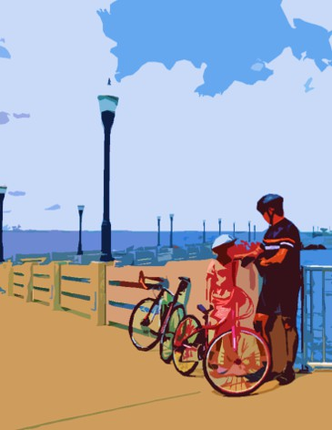
Implementation Matrix

Sustainability Action Plan Implementation Matrix

Action |  | Implementation Tool | Acting Agency |  | Estimated Time- frame | Estimated Cost | Focus Area  Co-benefits
 |  | Implementation Tool | Lead | Support | Estimated Time- frame | Estimated Cost | Focus Area  Co-benefits
Community & Livability
Goal 1: Improve sense of community and quality of life through services and programming that targets promoting inclusivity, equity, and empowerment.
1.1 | Objective: Increase citizen participation & engagement
1.1.1 | Develop a public engagement guide | Planning Document | Community Development | Community Groups | SHORT  0-5  Years | $ | 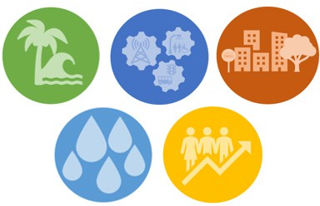
1.1.2 | Collaborate with County agencies and local groups to conduct public education campaigns for social equity improvements. | Partnership | Community Development | Brevard County / Community Groups | SHORT  0-5  Years | $
1.1.3 | Develop a public engagement strategy to engage the entire community in the implementation of the SAP. | Planning Document | Community Development | Community Groups | SHORT  0-5  Years | $
1.2 | Objective: Expand access to healthy foods & active lifestyles
1.2.1 | Provide incentives to healthful food retailers to locate in underserved areas. | Incentives | Community Development | Chamber of Commerce | SHORT  0-5  Years | $ | 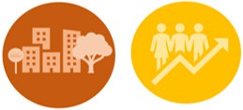
1.2.2 | Pilot an Urban Agriculture Program on Public Land. | Partnership | Community Groups | Public Works / Brevard County | MEDIUM  5-10  Years | $$ | 
1.2.3 | Amend the zoning code to permit urban agriculture uses. | Land Development Regulations | Community Development | Community Groups | SHORT  0-5  Years | $

Action |  | Implementation Tool | Acting Agency |  | Estimated Time- frame | Estimated Cost | Focus Area  Co-benefits
 |  | Implementation Tool | Lead | Support | Estimated Time- frame | Estimated Cost | Focus Area  Co-benefits
Community & Livability
Goal 1: Improve sense of community and quality of life through services and programming that targets promoting incusivity, equity, and empowerment.
1.2 | Objective: Expand access to healthy foods & active lifestyles
1.2.4 | Partner with community groups to sponsor programs that encourage active living for adults and children. | Partnership | Community Development | Community Groups | SHORT  0-5  Years | $ | 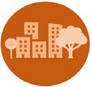
1.2.5 | Partner with local health agencies to develop a Community Health Improvement Plan. | Partnership | Community Development | Community Groups | MEDIUM  5-10  Years | $$
1.3 | Objective: Promote Complete Neighborhoods
1.3.1 | Provide safe and comfortable sidewalks, bikeways, crosswalks, and public places that are unobstructed and barrier free for cyclists, pedestrians, and people with disabilities. | Infrastructure Improvements | Public Works | Community Development | LONG  10-15  Years | $$$ | 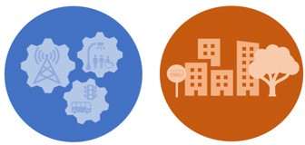
1.3.2 | Identify and plan for future compact and complete neighborhoods. | Planning Document | Community Development | Community Groups | SHORT  0-5  Years | $$
1.3.3 | Develop a community parks initiative to ensure all residents and local schools have access within a half mile to parks, greenspace, and recreation that are  barrier free for people with disabilities in coordination with the NRSAP. | Partnership | Community Development | Public Works | LONG  10-15  Years | $$$ | 

Action |  | Implementation Tool | Acting Agency |  | Estimated Time- frame | Estimated Cost | Focus Area  Co-benefits
 |  | Implementation Tool | Lead | Support | Estimated Time- frame | Estimated Cost | Focus Area  Co-benefits
Community & Livability
Goal 1: Improve sense of community and quality of life through services and programming that targets promoting incusivity, equity, and empowerment.
1.4 | Objective: Demonstrate progress towards reducing poverty & homelessness
1.4.1 | Collaborate with the Housing Authority and other local housing developers and providers to ensure residents have access to all available resources. | Partnership | Community Development | Titusville Housing Authority | MEDIUM  5-10  Years | $$
1.4.2 | Develop a City-wide assessment of housing needs and strategic recommendations for improving housing affordability. | Planning Document | Community Development | Titusville Housing Authority | SHORT  0-5  Years | $

Action |  | Implementation Tool | Acting Agency |  | Estimated Time- frame | Estimated Cost | Focus Area  Co-benefits
 |  | Implementation Tool | Lead | Support | Estimated Time- frame | Estimated Cost | Focus Area  Co-benefits
Ecosystems & Resiliency
Goal 2: Protect natural resources and ecosystems and develop an ecologically resilient community.
2.1 | Objective: Increase natural resource acreage and habitat area for threatened species and wetlands
2.1.1 | Manage a database of natural resources and collaborate with local agencies to promote environmental  stewardship. | Partnership | Community Development | Brevard County | SHORT  0-5  Years | $ | 
2.1.2 | Develop an Urban Forestry Management Plan to manage tree infrastructure and canopy. | Planning Document | Community Development | Public Works | SHORT  0-5  Years | $$
2.1.3 | Promote UF/IFAS Brevard County Extension Florida-Friendly LandscapingTM Program. | Education & Outreach | Community Development | UF/IFAS Brevard County Extension | SHORT  0-5  Years | $ | 
2.2 | Objective: Prioritize the use of green infrastructure, low impact development, and nature-based solutions
2.2.1 | Continue to develop an inventory of low impact development public projects and establish a network of demonstration sites with educational material and signage. | Online Interactive Database / Infrastructre Improvements | Community Development | Public Works | ONGOING  0-15  Years | $$$ | 
2.2.2 | Offer incentives for residents that implement green infrastructure projects including rain barrels, rain gardens, pervious pavement, etc. | Incentives | Community Development | Community Groups | SHORT  0-5  Years | $

Action |  | Implementation Tool | Acting Agency |  | Estimated Time- frame | Estimated Cost | Focus Area  Co-benefits
 |  | Implementation Tool | Lead | Support | Estimated Time- frame | Estimated Cost | Focus Area  Co-benefits
Ecosystems & Resiliency
Goal 2: Protect natural resources and ecosystems and develop an ecologically resilient community.
2.2 | Objective: Prioritize the use of green infrastructure, low impact development, and nature-based solutions
2.2.3 | Provide education and  resources to homeowners on Florida Friendly Lawns and reducing the use of pesticides and garden chemicals. | Education & Outreach | Public Works | UF/IFAS Brevard County Extension | SHORT  0-5  Years | $$
2.2.4 | Evaluate current and planned stormwater infrastructure projects and determine the feasibility of incorporating additional green infrastructure. | Infrastructure Improvements | Public Works | Community Development | ONGOING  0-15  Years | $$
2.3 | Objective: Continue to make demonstrable progress towards Resilient Titusville’s Goals and Objectives
2.3.1 | Identify and designate Adaptation Action Areas within the City. | Planning Document | Community Development | Community Groups | LONG  10-15  Years | $$ | 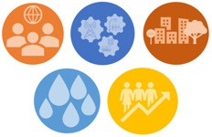
2.3.2 | Develop annual reports and update the plan on a 5-year basis. | Planning Document | Community Development | East Central Florida  Regional Planning Council | SHORT  0-5  Years | $
2.4 | Objective: Foster ecosystem and resiliency education and empowerment
2.4.1 | Continue education and outreach initiatives about sea level rise, climate change, and the Indian River Lagoon. | Partnership | Community Development | Community Groups | SHORT  0-5  Years | $

Action |  | Implementation Tool | Acting Agency |  | Estimated Time- frame | Estimated Cost | Focus Area  Co-benefits
 |  | Implementation Tool | Lead | Support | Estimated Time- frame | Estimated Cost | Focus Area  Co-benefits
Ecosystems & Resiliency
Goal 2: Protect natural resources and ecosystems and develop an ecologically resilient community.
2.4 | Objective: Foster ecosystem and resiliency education and empowerment
2.4.2 | Collaborate with volunteer programs and organizations to assist with habitat restoration efforts on public and private properties. | Partnership | Community Development | Community Groups | MEDIUM  5-10  Years | $$$
2.4.3 | Create native plants demonstration and education sites with plant details at local parks. | Infrastructure Improvements | Public Works | Brevard County | MEDIUM  5-10  Years | $$ | 

Action |  | Implementation Tool | Acting Agency |  | Estimated Time- frame | Estimated Cost | Focus Area  Co-benefits
 |  | Implementation Tool | Lead | Support | Estimated Time- frame | Estimated Cost | Focus Area  Co-benefits
Energy & Infrastructure
Goal 3: Reduce energy consumption and transition to clean energy
3.1 | Objective: Reduce Greenhouse Gas (GHG) Emissions
3.1.1 | Develop a plan for increasing the green municipal fleet including EV, Hybrid, and Fuel-Efficient vehicles. | Planning Document | Public works / Fire Department / Police Department | Community Development | SHORT  0-5  Years | $$ | 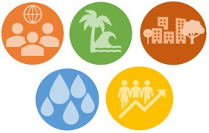
3.1.2 | Report GHG emissions for municipal operations and community-wide at minimum every 5 years. | Planning Document | Community Development | East Central Florida Regional  Planning Council | LONG  10-15  Years | $
3.1.3 | Study pathways to achieve net zero GHG by 2050. | Agreements & Resolutions | Community Development | East Central Florida Regional  Planning Council | LONG  10-15  Years | $$
3.1.4 | Engage local businesses and industries to reduce GHG emissions through outreach, education, and advisory services. | Education & Outreach | Community Development | North Brevard Economic Development Zone | SHORT  0-5  Years | $$ | 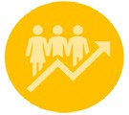
3.2 | Objective: Reduce energy consumption
3.2.1 | Collect and report annual, city-wide energy consumption. | Planning Document | Community Development | Florida Power and Light | ONGOING  0-15  Years | $

Action |  | Implementation Tool | Acting Agency |  | Estimated Time- frame | Estimated Cost | Focus Area  Co-benefits
 |  | Implementation Tool | Lead | Support | Estimated Time- frame | Estimated Cost | Focus Area  Co-benefits
Energy & Infrastructure
Goal 3: Reduce energy consumption and transition to clean energy
3.2 | Objective: Reduce energy consumption
3.2.2 | Study current municipal energy consumption and implement energy efficiency practices. | Planning Document / Infrastructure Improvements | Public Works | -- | MEDIUM  5-10  Years | $$$
3.2.3 | Implement building code provisions that support energy efficiency improvements, renewable energy, and EV readiness. | Land Development Regulations | Community Development | -- | SHORT  0-5  Years | $
3.2.4 | Develop an educational campaign to reduce household energy consumption. | Partnership | Community Development | Florida Power and Light | SHORT  0-5  Years | $
3.3 | Objective: Make progress towards obtaining electricity from renewable energy sources
3.3.1 | Develop a renewable energy study for municipal operations. | Planning Document | Public Works | Community Development | SHORT  0-5  Years | $$
3.3.2 | Install a municipal solar and battery storage demonstration project. | Infrastructure Improvements | Public Works | Florida Power and Light | LONG  10-15  Years | $$
3.3.3 | Develop incentives to increase renewable energy installations for new projects and retrofits. | Incentives | Community Development | North Brevard Economic Development Zone | MEDIUM  5-10  Years | $

Action |  | Implementation Tool | Acting Agency |  | Estimated Time- frame | Estimated Cost | Focus Area  Co-benefits
 |  | Implementation Tool | Lead | Support | Estimated Time- frame | Estimated Cost | Focus Area  Co-benefits
Energy & Infrastructure
Goal 3: Reduce energy consumption and transition to clean energy
3.3 | Objective: Make progress towards obtaining electricity from renewable energy sources
3.3.4 | Determine viability of renewable energy installations for all municipal facilities. | Planning Document | Public Works | Community Development | MEDIUM  5-10  Years | $$
3.3.5 | Partner with Florida Power and Light on opportunities to expand and promote renewable energy for residential and commercial use. | Partnership | Community Development | Florida Power and Light | SHORT  0-5  Years | $
3.3.6 | Prioritize future EV charging stations based at City facilities are powered by renewable energy through the use of battery storage systems. | Infrastructure Improvements | Public Works | Community Development | MEDIUM  5-10  Years | $$
Goal 4: Continue to improve and adopt innovative infrastructure to improve quality of life
4.1 | Objective: Achieve a 75% diversion rate from recycling, composting, reducing consumption, and reusing materials
4.1.1 | Develop and implement a Sustainable Waste Management Plan. | Planning Document / Partnership | Public Works | Brevard County | MEDIUM  5-10  Years | $$
4.1.2 | Study feasibility of implementing a Com- mercial Food Waste Collection Program. | Partnership | Public Works | Brevard County  / Community Groups | MEDIUM  5-10  Years | $$

Action |  | Implementation Tool | Acting Agency |  | Estimated Time- frame | Estimated Cost | Focus Area  Co-benefits
 |  | Implementation Tool | Lead | Support | Estimated Time- frame | Estimated Cost | Focus Area  Co-benefits
Energy & Infrastructure
Goal 4: Continue to improve and adopt innovative infrastructure to improve quality of life
4.1 | Objective: Achieve a 75% diversion rate from recycling, composting, reducing consumption, and reusing materials
4.1.3 | Establish construction & demolition (C&D) recycling standards to serve as a guideline to divert recoverable materials and products from landfills. | Partnership | Public Works | Brevard County  / Community Development | LONG  10-15  Years | $$
4.1.4 | Implement a residential backyard composter program. | Infrastructure Improvements | Public Works | Community Development | MEDIUM  5-10  Years | $$ | 
4.1.5 | Explore the long-term opportunity for a Materials Recovery Facility in Titusville. | Infrastructure Improvements | Public Works | Brevard County | LONG  10-15  Years | $$$
4.2 | Objective: Reduce Citywide Vehicle Miles Traveled (VMT) through multimodal transportation Planning
4.2.1 | Adopt a Complete Street program to formalize the City’s intent to plan, design, and maintain streets for users of all ages and abilities. | Planning Document | Community Development | Public Works / Space Coast TPO | SHORT  0-5  Years | $
4.2.2 | Research viability of micromobility options including car-sharing and bicycle rentals. | Partnership | Community Development | Space Coast TPO /  Public Works / Brevard County | MEDIUM  5-10  Years | $$

Action |  | Implementation Tool | Acting Agency |  | Estimated Time- frame | Estimated Cost | Focus Area  Co-benefits
 |  | Implementation Tool | Lead | Support | Estimated Time- frame | Estimated Cost | Focus Area  Co-benefits
Energy & Infrastructure
Goal 4: Continue to improve and adopt innovative infrastructure to improve quality of life
4.2 | Objective: Reduce Citywide Vehicle Miles Traveled (VMT) through multimodal transportation Planning
4.2.3 | Implement Mobility Plan to install and maintain bicycle and pedestrian infrastructure city-wide. | Planning Document / Infrastructure Improvements | Public Works | Community Development | ONGOING  0-15  Years | $$$
4.2.4 | Educate and encourage residential, municipal, and commercial carpooling initiatives. | Program & Policy | Community Development | Space Coast TPO | SHORT  0-5  Years | $
4.2.5 | Prioritize funding for alternative transportation over capacity improvements for vehicles. | Planning Document / Comprehensive Plan | Community Development | Public Works / Space Coast TPO | SHORT  0-5  Years | $
4.3 | Objective: Develop a Smart Cities Initiative to Boost Urban Innovation
4.3.1 | Develop a strategic EV charging network throughout the City and adopt an EV readiness ordinance. | Land Development Regulations | Community Development | Space Coast TPO | MEDIUM  5-10  Years | $$
4.3.2 | Deploy smart technology solutions at appropriate locations throughout the City including, smart solar-powered trash compactors, air quality sensors, smart irrigation systems, and smart streetlights. | Infrastructure Improvements | Community Development | Public Works | ONGOING  0-15  Years | $$$ | 

Action |  | Implementation Tool | Acting Agency |  | Estimated Time- frame | Estimated Cost | Focus Area  Co-benefits
 |  | Implementation Tool | Lead | Support | Estimated Time- frame | Estimated Cost | Focus Area  Co-benefits
Energy & Infrastructure
Goal 4: Continue to improve and adopt innovative infrastructure to improve quality of life
4.3 | Objective: Develop a Smart Cities Initiative to Boost Urban Innovation
4.3.3 | Partner with the Space Coast TPO on the implementation of the regional Intelligent Transportation System Master Plan and other smart technology including smart traffic lights, Smart phone applications to improve public transportation services. | Partnership | Public Works | Space Coast TPO  / Brevard County | ONGOING  0-15  Years | $$$

Action |  | Implementation Tool | Acting Agency |  | Estimated Time- frame | Estimated Cost | Focus Area  Co-benefits
 |  | Implementation Tool | Lead | Support | Estimated Time- frame | Estimated Cost | Focus Area  Co-benefits
Water
Goal 5: Reduce gross potable water consumption and continue provisions to provide safe and reliable drinking water.
5.1 | Objective: Reduce per capita daily water consumption
5.1.1 | Continue and expand rebate opportunities for water efficient fixtures and water-saving technology. | Program & Policy | Public Works | Community Groups | ONGOING  0-15  Years | $$$
5.1.2 | Implement an educational home leak detection repair program. | Program & Policy | Public Works | Community Groups | MEDIUM  5-10  Years | $$
5.1.3 | Explore additional opportunities for implementing water conservation programs and initiatives. | Planning Document | Public Works | Community Development | ONGOING  0-15  Years | $$ | 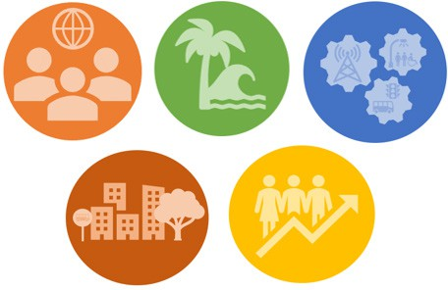
5.2 | Objective: Reduce water consumption of City Operations
5.2.1 | Explore opportunities to reduce indoor and outdoor potable water use at city facilities. | Program & Policy | Public Works | -- | MEDIUM  5-10  Years | $$ | 
5.2.2 | Study municipal water usage to identify high consumption operations within the City and strategically target water conservation efforts at city facilities. | Planning Document | Public Works | -- | SHORT  0-5  Years | $$
5.2.3 | Incorporate low-flow fixtures and fittings to future improvements to City-owned facilities kitchens and restrooms. | Infrastructure Improvements | Public Works | -- | ONGOING  0-15  Years | $$

Action |  | Implementation Tool | Acting Agency |  | Estimated Time- frame | Estimated Cost | Focus Area  Co-benefits
 |  | Implementation Tool | Lead | Support | Estimated Time- frame | Estimated Cost | Focus Area  Co-benefits
Water
Goal 5: Reduce gross potable water consumption and continue provisions to provide safe and reliable drinking water.
5.3 | Objective: Maintain clean and reliable sources of drinking water
5.3.1 | Continue to upgrade/replace water mains based on Water Master Plan. | Infrastructure Improvements | Public Works | -- | ONGOING  0-15  Years | $$$
5.3.2 | Promote the use of reusable water bottles by installing clean and reliable hydration stations. | Infrastructure Improvements | Public Works | Community Development | MEDIUM  5-10  Years | $$
5.3.3 | Continue to provide accessible and regular water quality testing analysis. | Program & Policy | Public Works | Community Development | ONGOING  0-15  Years | $ | 
5.4 | Objective: Ensure adequate water supply as the City continues to grow
5.4.1 | Develop a plan and protocols for future water quality threats and water hazard mitigation. | Planning Document / Program & Policy | Public Works | Community Development | SHORT  0-5  Years | $$
5.4.2 | Continue to review and update drought contingency policies in the event of future emergencies, as necessary. | Program & Policy | Public Works | Community Development | ONGOING  0-15  Years | $

Action |  | Implementation Tool | Acting Agency |  | Estimated Time- frame | Estimated Cost | Focus Area  Co-benefits
 |  | Implementation Tool | Lead | Support | Estimated Time- frame | Estimated Cost | Focus Area  Co-benefits
Water
Goal 5: Reduce gross potable water consumption and continue provisions to provide safe and reliable drinking water.
5.5 | Objective: Continue education programs for water conservation
5.5.1 | Continue to provide water conservation outreach and initiatives in neighborhoods with older plumbing and infrastructure or well water. | Education & Outreach | Public Works | Community Groups | ONGOING  0-15  Years | $
5.5.2 | Develop and partner with local organizations on an enhanced public education campaign to encourage water conservation with a focus on peak water use times. | Education & Outreach | Public Works | Community Development / Community Groups | MEDIUM  5-10  Years | $

Action |  | Implementation Tool | Acting Agency |  | Estimated Time- frame | Estimated Cost | Focus Area  Co-benefits
 |  | Implementation Tool | Lead | Support | Estimated Time- frame | Estimated Cost | Focus Area  Co-benefits
Smart Growth
Goal 6: Utilize Smart Growth policies to promote sustainable land use
6.1 | Objective: Increase the number of buildings using sustainable practices
6.1.1 | Implement LEED or equivalent designation for all new city facilities. | Infrastructure Improvements | Public Works | Community Development | ONGOING  0-15  Years | $$$ | 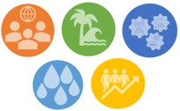
6.1.2 | Create a green building toolkit for new construction and existing buildings. | Education & Outreach | Community Development | Community Groups | SHORT  0-5  Years | $$
6.1.3 | Adopt green building standards and incentives for new construction, affordable housing, and infill/redevelopment. | Land Development Regulations | Community Development | Community Groups | SHORT  0-5  Years | $$
6.2 | Objective: Increase the number of residents living within Complete Neighborhoods
6.2.1 | Promote the use of Compact and Complete Communities principles for all new development and redevelopment efforts. | Program & Policy | Community Development | Space Coast TPO | SHORT  0-5  Years | $
6.2.2 | Develop Small Area Plans for key corridors of the City to concentrate development. | Planning Document | Community Development | Community Groups | LONG  10-15  Years | $$

Action |  | Implementation Tool | Acting Agency |  | Estimated Time- frame | Estimated Cost | Focus Area  Co-benefits
 |  | Implementation Tool | Lead | Support | Estimated Time- frame | Estimated Cost | Focus Area  Co-benefits
Smart Growth
Goal 6: Utilize Smart Growth policies to promote sustainable land use
6.3 | Objective: Promote policies and programs that will reduce household spending on housing and transportation combined
6.3.1 | Measure location efficiency through the combined cost of housing and transportation and encourage affordable housing in areas where transportation costs are lower due to accessible public transit. | Planning Document | Community Development | Space Coast TPO | MEDIUM  5-10  Years | $$ | 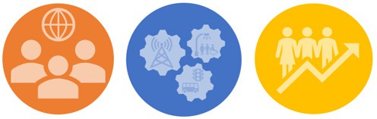
6.3.2 | Develop appropriate strategies for new civic and commercial development in low- and moderate-income neighborhoods. | Program & Policy | Community Development | North Brevard Economic Development Zone | SHORT  0-5  Years | $
6.4 | Objective: Increase housing units at all price points
6.4.1 | Amend Land Development Regulations (LDRs) to allow for a larger range of housing options in development and higher densities. | Land Development Regulations | Community Development | Community Groups | SHORT  0-5  Years | $
6.4.2 | Support initiatives and/or developments that provide permanent supportive housing for low-income households, and target populations such as seniors, veterans, and homeless. | Program & Policy | Community Development | Community Groups | SHORT  0-5  Years | $

Action |  | Implementation Tool | Acting Agency |  | Estimated Time- frame | Estimated Cost | Focus Area  Co-benefits
 |  | Implementation Tool | Lead | Support | Estimated Time- frame | Estimated Cost | Focus Area  Co-benefits
Smart Growth
Goal 6: Utilize Smart Growth policies to promote sustainable land use
6.5 | Objective: Increase access to pedestrian and bicycle infrastructure
6.5.1 | Provide safe and comfortable sidewalks, bikeways and crosswalks that are unobstructed and barrier free for people with disabilities, including wheelchair users and people with low vision. | Infrastructure Improvements | Public Works | Space Coast TPO | ONGOING  0-15  Years | $$
6.5.2 | Prioritize safe pedestrian and bicycle infrastructure in high injury corridors through a Vision Zero Action Plan. | Planning Document | Community Development | Public Works | MEDIUM  5-10  Years | $$

Action |  | Implementation Tool | Acting Agency |  | Estimated Time- frame | Estimated Cost | Focus Area  Co-benefits
 |  | Implementation Tool | Lead | Support | Estimated Time- frame | Estimated Cost | Focus Area  Co-benefits
Sustainable Economy
Goal 7: Promote a diverse and resilient local economy and workforce
7.1 | Objective: Demonstrate City Leadership in Sustainability
7.1.1 | Develop a sustainable purchasing policy with a list of standard recommended consumable products for compliance with the policy. | Program & Policy | Support Services | Community Development | SHORT  0-5  Years | $ | 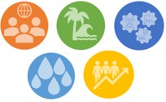
7.1.2 | Strengthen procurement standards that encourage purchases of local goods and services first. | Program & Policy | Support Services | -- | SHORT  0-5  Years | $
7.1.3 | Develop a greater alliance and partnership with local high schools, universities, technical colleges, training centers, etc. | Partnership | Community Development | Support Services | SHORT  0-5  Years | $
7.2 | Objective: Advance equitable employment
7.2.1 | Provide workforce training opportunities and resources for residents seeking employment. | Education & Outreach | Community Development | Community Groups | ONGOING  0-15  Years | $
7.2.2 | Provide resources for local small businesses including access to high-speed internet, networking opportunities, trainings, etc. | Partnership | Community Development | Chamber of Commerce | ONGOING  0-15  Years | $$

Action |  | Implementation Tool | Acting Agency |  | Estimated Time- frame | Estimated Cost | Focus Area  Co-benefits
 |  | Implementation Tool | Lead | Support | Estimated Time- frame | Estimated Cost | Focus Area  Co-benefits
Sustainable Economy
Goal 7: Promote a diverse and resilient local economy and workforce
7.3 | Objective: Support a local circular economy
7.3.1 | Encourage land use and economic development policies that support neighborhood retail and Titusville-based startups, to build a local, circular economy. | Program & Policy | Community Development | North Brevard Economic Development  Zone / Chamber of Commerce | MEDIUM  5-10  Years | $
7.3.2 | Develop a strategic plan for a Circular Titusville including feasibility for projects including a Circular Titusville Community Grant Program, Circular Titusville Ambassador program. | Planning Document | Community Development | Community Groups | MEDIUM  5-10  Years | $$
7.3.3 | Empower citizens to reduce material consumption and reuse/recycle materials and goods through marketing, demon- stration projects, and social media campaigns. | Education & Outreach | Community Development | Community Groups | MEDIUM  5-10  Years | $
7.4 | Objective: Promote Green Businesses and Ecotourism
7.4.1 | Develop sustainable financial incentive programs to prioritize the proliferation of green businesses within the CRA. | Program & Policy | CRA | Community Development | MEDIUM  5-10  Years | $

Action |  | Implementation Tool | Acting Agency |  | Estimated Time- frame | Estimated Cost | Focus Area  Co-benefits
 |  | Implementation Tool | Lead | Support | Estimated Time- frame | Estimated Cost | Focus Area  Co-benefits
Sustainable Economy
Goal 7: Promote a diverse and resilient local economy and workforce
7.4 | Objective: Promote Green Businesses and Ecotourism
7.4.2 | Develop a Green Business Voluntary Program to assist and promote, recognize, and help develop local businesses committed to improving sustainability in Titusville | Program & Policy | Community Development | Chamber of Commerce | SHORT  0-5  Years | $
7.4.3 | Encourage cleantech and low-carbon technology startups and other sustainable and circular R&D and innovation within the City. | Program & Policy | Community Development | North Brevard Economic Development Zone | ONGOING  0-15  Years | $$$

