
City of Titusville
Community Redevelopment Agency
Annual Report
Fiscal Year 2024
Prepared by
City of Titusville
Community Development
& Finance Departments


Downtown Community Redevelopment Agency
CRA Board Members:
Andrew Conners, Chairperson
Herman Cole, Vice Chairperson
Greg Aker
Jim Ball
Megan Moscoso
Jo Lynn Nelson
Sarah Stoeckel
CRA Staff:
Scott Larese, Executive Director, Community Redevelopment Agency
Richard Broome, City Attorney
Kevin Cook, P.E., Public Works Director
Teri Butler, Finance Director
Jenna Ryan, Finance Manager
Wanda Wells, City Clerk
Brad Parrish, Community Development Department Director
Introduction
The City of Titusville’s Community Redevelopment Agency (CRA) was created by the State of Florida in 1982, and the Community Redevelopment Plan was adopted in 1984. Since its creation, the Titusville Community Redevelopment Agency has played an integral role in the revitalization of the Downtown area and the surrounding community. The Downtown area has faced many challenges similar to those in other areas of Florida and the nation. The vision of Titusville’s Downtown was established by residents who attended workshops in the 1980’s, 1990’s, 2000’s, and as recently as FY 2022 and determined a set of goals and priorities that have evolved over the years. The original vision of the Redevelopment Plan still stands as a foundation for redevelopment in the Downtown and surrounding neighborhoods.
To provide residents and visitors with a memorable experience, the City envisions the addition of new mixed-use buildings on infill lots, renovated historic buildings, new open space amenities, enhanced streetscape conditions, new public facilities such as water and sewer infrastructure, and low impact development (LID) techniques for storm water. Development standards will be aimed at increasing the area’s capacity to accommodate new growth while preserving the historic character of the community. By combining these features with a smarter approach to growth, the City will realize a downtown that will attract sustainable growth and create a unique sense of place in which all residents can be proud.
The Downtown CRA encompasses approximately 300 acres of land on the eastern edge of the City and is over a mile and half from its northernmost area at the municipal waterfront park and marina complex, to its southern terminus at Grace Street. The CRA includes the Historic Downtown area and a number of small neighborhoods. The CRA is bounded by the Indian River waterfront on the east and north and by the Florida East Coast Railroad tracks on the west. The CRA parallels the Indian River and includes over 1.9 miles of waterfront as shown on the following map.
- 2 -

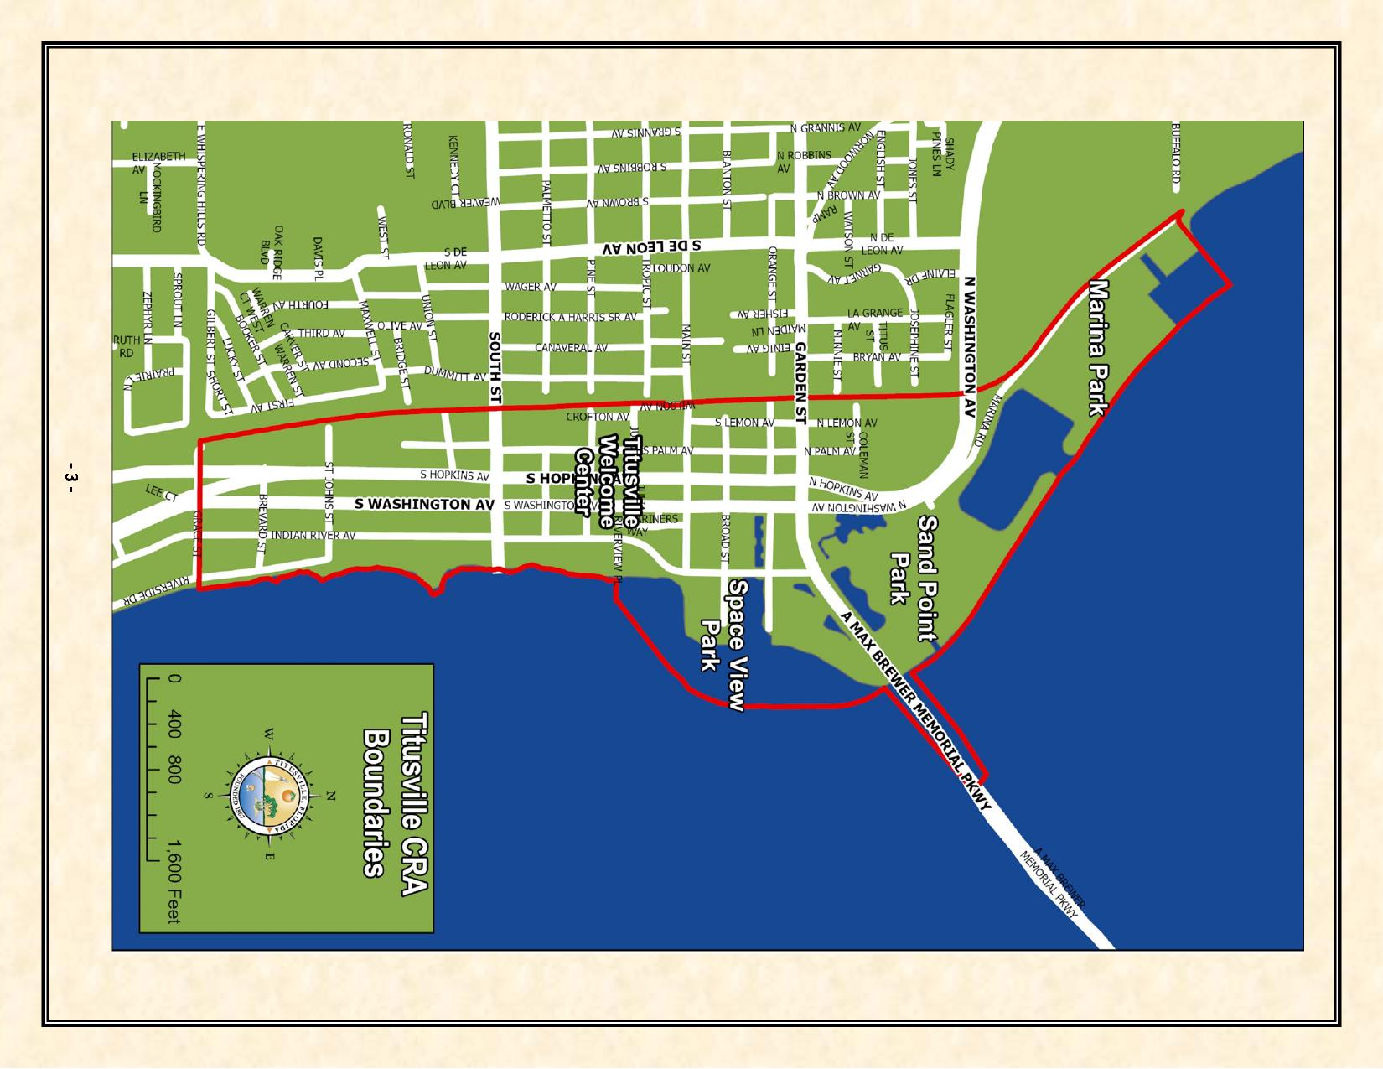
totivaro^{'-:i*' 93 I 441}4
adt %co cats. 3_{,001 I} ex

Assessed Real Property Values & Tax Increment Fund Revenue History
The original base year real property value for the Titusville Downtown CRA in 1982 was $20,495,020. The Titusville Downtown CRA assessed property value in the reporting year of FY 2024 was $136,915,020 which is an increase of $9,674,865 in value from the FY 2023 assessed property value.
A history of the Titusville CRA Tax Increment Revenue per year from FY2005–2006 is found in Table-1 below. Prior to FY 2005–2006 the Downtown CRA had a steady but low tax increment since its inception in 1982. Since FY 2009, the CRA’s tax increment revenue has been more volatile due to the impacts of both new development and economic conditions.
Table 1: Tax Increment Revenues by Year (Audited)
FY 2005-2006 $ 286,787 FY 2006-2007 $ 589,533 FY 2007-2008 $ 922,899 FY 2008-2009 $ 876,391 FY 2009-2010 $ 792,703 FY 2010-2011 $ 724,997 FY 2011-2012 $ 655,653 FY 2012-2013 $ 631,488 FY 2013-2014 $ 699,901 FY 2014-2015 $ 712,212 FY 2015-2016 $ 766,683 FY 2016-2017 $ 793,838 FY 2017-2018 $ 867,986 FY 2018-2019 $ 919,020 FY 2019-2020 $ 961,910 FY 2020-2021 $ 979,345 FY 2021-2022 $ 982,381 FY 2022-2023 $ 1,038,731 FY 2023-2024 $ 1,088,637
The Tax Increment Financing (TIF) revenues for the Downtown CRA increased substantially in the fiscal year 2006 - 2007 due to the completion of the Harbor Pointe condominium complex. The first building was added to the tax rolls in fiscal year 2006-2007. This revenue allowed the CRA to complete projects that were not possible with revenues from previous years.
The three remaining Harbor Pointe buildings were added to the tax rolls in fiscal year 2007 - 2008. Due to the economic downturn, increased foreclosures nationwide, and the end of the NASA Space Shuttle Program, the revenue in fiscal years 2008 - 2009 to 2012-2013 decreased. The reduction in revenues during those years resulted in a greater percentage of revenues being dedicated to debt service, thereby limiting redevelopment projects that were being undertaken by the CRA during those years. After bottoming out in FY2012-2013, tax increment revenues have increased each year since to where they have surpassed the FY2007-2008 high.
In 2011, the CRA authorized issuance of a Public Improvement Revenue Note in an amount not to exceed $2,535,000 to finance roadway and landscaping improvements in conjunction with the FDOT U.S. 1 project. In February 2013, the CRA approved partial repayment of the loan for $850,000. The
- 4 -

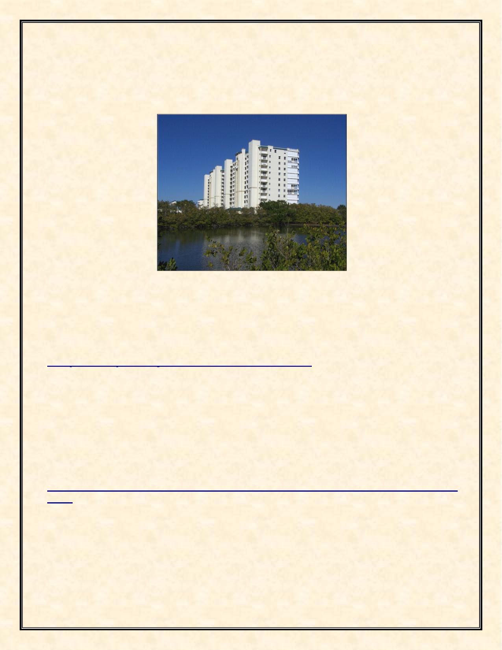
repayment funds were the result of lower than anticipated projects costs. The CRA’s action produced a total savings of $1.27 million. The CRA also paid off the Commons Project Bond at a cost of approximately $95,000. The loan repayments reduced the annual debt service in FY2014-2015 from 34% to 19% of the Annual Revenues, thus providing more opportunities for capital projects in the future. The percentage of annual debt service to annual tax increment values has continued to decline due to a combination of the increase in tax increment values and debt payments.
Harbor Pointe Condominiums on Indian River Avenue
Fiscal Year 2024 Capital and Non-Capital Projects
The Downtown CRA has continued with existing projects during the 2023 - 2024 fiscal year as well as started new projects as shown below.
Completed Capital Projects and Their Estimated Cost:
+ Commercial Interior Building Renovation, Commercial Beautification, and Commercial Mixed Use Grant Programs (operational – see detailed grant payouts in the narrative below),
+ Approved and completed the construction of the Space View Park Walkway Pier
($1,027,957)
+ Sidewalk Infill ($87,796)
+ Water Resources Utilities Infrastructure Slip Lining ($137,018)
Capital Projects Started but not Completed in the Fiscal Year and Their Estimated Cost:
+ Indian River Force Main Improvements upgraded and replaced 8,000 feet of sewer force
main ($97,000)
+ Approved a stormwater infrastructure project that will be a low impact development (LID)
demonstration project creating a bioswale and creating pervious parking ($127,322)
+ Approved New Sidewalk Project – ($207,127)
+ Aluminum Streetlight Poles - Whiteway Lighting Project Study ($60,000)
+ Tree Box Filters ($130,000)
More details about these projects follow.
- 5 -


Commercial Interior Building Renovation, Commercial Beautification, and Permit and Impact Fee Incentive Grant Programs
In FY 2016 – 2017 the CRA created a Commercial Interior Renovation Incentive Grant Program to assist property owners and commercial tenants of older buildings to bring their structures up to current Americans with Disabilities Act (ADA), the Florida Fire Protection Code, and the Florida Building Code standards. The Commercial Interior Building Renovation Incentive Grant Program helps to expand and improve under-used buildings to increase commercial and mixed-use intensity, bring buildings up to code, assist small businesses in the CRA to grow and prosper, and to promote job creation in the district. This grant program offers financial assistance in the form of a reimbursable, fifty present (50%) matching grant up to a maximum of $50,000 to the property owner or business owner for eligible expenses associated with the renovation and rehabilitation of the following interior elements of commercial and mixed-use building space:
+ ADA requirements
+ Florida Fire Protection Code requirements
+ Florida Building Code requirements including:
- Interior plumbing to meet code
- Interior electrical system including lighting to meet code
- HVAC system to meet code
During fiscal year 2017-2018 the CRA expanded its matching Building Grants Incentive Programs by drafting and approving a new Permit & Impact Fee Incentive Grant Program, revising the Commercial Interior Renovation Grant Program and reactivating and revising its Commercial Beautification Grant Program. The Permit & Impact Fee Program provides a maximum $50,000 matching one-to-one grant to help offset the cost of permits and impact fees for new construction in the CRA. The Commercial Interior Renovation Grant Program was revised to provide an additional $50,000 matching one-to-one grant for interior building renovations that provide residential and nonresidential mixed-use as an incentive for residential units to be added to the CRA and spur housing in the downtown. The Commercial Beautification Grant Program provides a $40,000 matching one-to-one grant for façade and exterior improvements to buildings in the CRA to improve the appearance of the CRA/downtown and to eliminate blight. The Grant Programs were further revised to provide payment of seventy-five (75%) of the grant award at project completion and the remaining twenty-five (25%) of the grant award with occupancy of the building at one (1) year after completion of the improvements as an incentive for building owners to have their buildings occupied and not sit empty. The expanded grant program became operational in FY 2019. In FY 2023, grease traps were added as an eligible expense to the Commercial Interior Renovation Grant to meet Florida Building Code requirements. In FY 2023, the CRA approved advisability to study the current grant programs and recommend changes in FY 2024. In FY 2024, the CRA approved changes to the Grant Program including eliminating the 2-year waiting period for approval project funding, creating consistency by changing the Exterior Grant maximum to $50,000, including a contingency coverage in the grant application not to exceed the maximum grant program amount, and projects of $5,000 or less, 60% is paid by the City of Titusville CRA and 40% by the applicant.
A total of five (5) CRA Building Grants were awarded in the fiscal year for a total of $127,003.63. Four (4) Commercial Beautification Grants were awarded, and one (1) Commercial Interior Renovation Grant was awarded in FY 2024.
A total of thirteen (13) grant payouts were made during the fiscal year for a total of $241,220.04. The grant payouts were for nine (9) Commercial Beautification Façade Grants for $146,781.92, three (3) Commercial Interior grants for $44,428.12, and one (1) Commercial Mixed-Use grant which provided residential units in the downtown area.
- 6 -

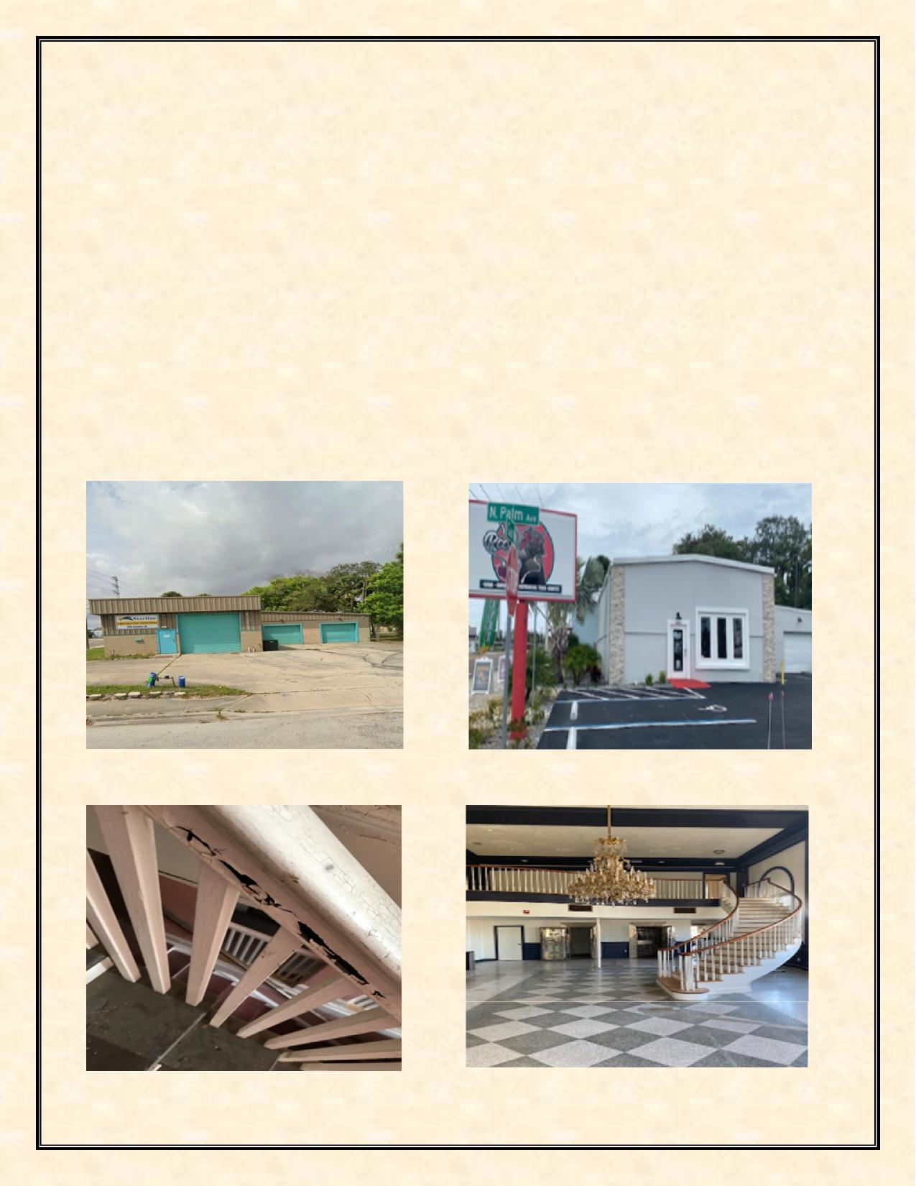
Since these are fifty (50%) matching reimbursable grants with a maximum cap, the grant program leverages more than double the grant amount of investment in the CRA. A CRA Grant Return on Investment History Report completed in FY 2019 found that for completed grant projects and for grant projects under construction the return on investment was $14.71 for every $1 of CRA grant money awarded. Considering only completed grant projects since 2008, the ROI was $3.14 for $1 of CRA grant money. The reason for the large difference between completed project and both completed and under construction is that there are two (2) major construction projects taking place in the CRA, the Launch Now project with an estimated cost of $6 million of construction and the Beachwave project with an estimated cost of $3 million. The Beachwave project was completed in FY 2021. The Launch Now project was completed in FY 2024.
The return-on-investment study shows how the grant program is helping to prevent deterioration of older historic properties in the CRA; stimulate interest and investment in the District; encourage the development of business and job growth; and encourage the utilization of existing business stock and new construction in the CRA.
The expanded Grant Programs implements the City of Titusville’s CRA Plan policy 1.1.1.1, goal 4.1, policy 4.3.1.1, objective 4.1.1, objective 4.1.2, and policy 4.1.1.3.s.
Photos of Commercial Grants in FY 2024:
400 Garden Street Vacant Building – Before 400 Garden Street Roots Kava Lounge - After
.
310 S. Washington – Launch Now – Before 310 S. Washington – Launch Now – After
- 7 -


300 S. Washington – Launch Now – Before 300 S. Washington – Launch Now – After
St. Gabriel’s Episcopal Church – After Sunrise Bakery – After
Space View Park Connecting Pedestrian Pier
The CRA approved a budget amendment in September 2019, to fund a feasibility study for a pedestrian pier to connect Space View Mercury Park to Space View Gemini Park. The parks are separated by an inlet that requires visitors to back track to visit both parks. The pier meets the CRA’s Plan goal of connecting the City’s parks and providing a waterfront attraction for residents and visitors to view rocket launches. In January 2020, a Request for Qualifications (RFQ) was advertised to conduct a Feasibility and Conceptual Design Study. Taylor Engineering, Jacksonville, Florida, was selected in March 2020 to do the study. A contract with Taylor Engineering was signed in July 2020. In February of 2021, Taylor Engineering presented the Feasibility Study and Conceptual Design to the CRA. Based on the presentation, the CRA recommended moving forward with a contract for a final design. In May 2021, the CRA meeting the CRA and City Council approved an award of contract for Taylor Engineering to provide a final design of the Space View Park Connecting Pedestrian Pier. Taylor Engineering worked on final design and bid plans during the Fiscal Year 2022. In August 2023, the contract for the Space View Park Connection Pedestrian Pier was awarded to Rush Marine. Construction was started and completed in FY 2024. The total cost was approximately $1,027,957.
The Space View Park Connecting Pedestrian Pier implements the City of Titusville’s CRA Plan objective 3.4.1, objective ,4.2.2, policy 4.2.2.2, and objective 5.4.1.
- 8 -

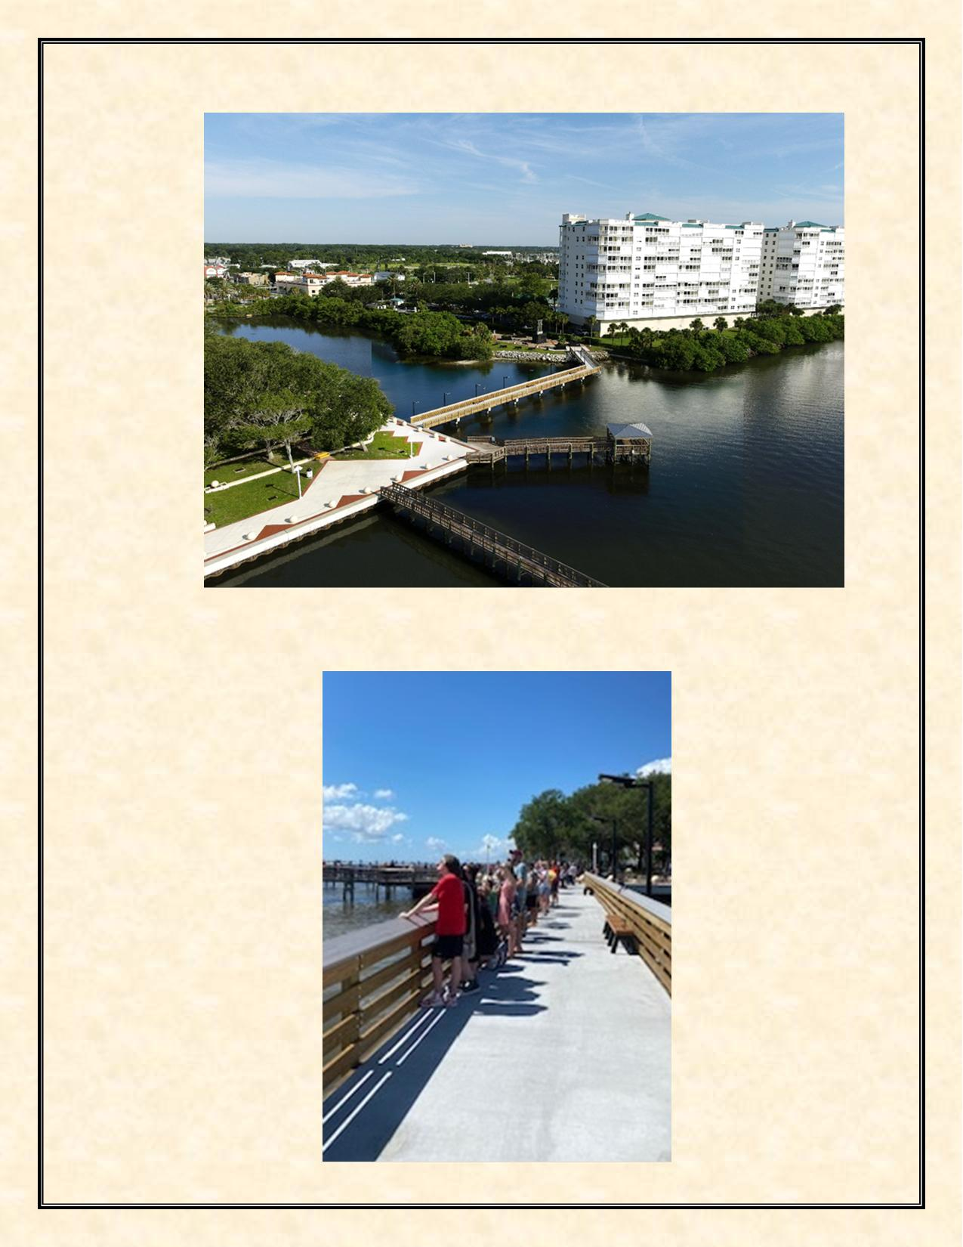
Aerial Photography of the completed Space View Pier
Boeing Starliner Launch on June 5, 2024, from the Space View Pier
- 9 -

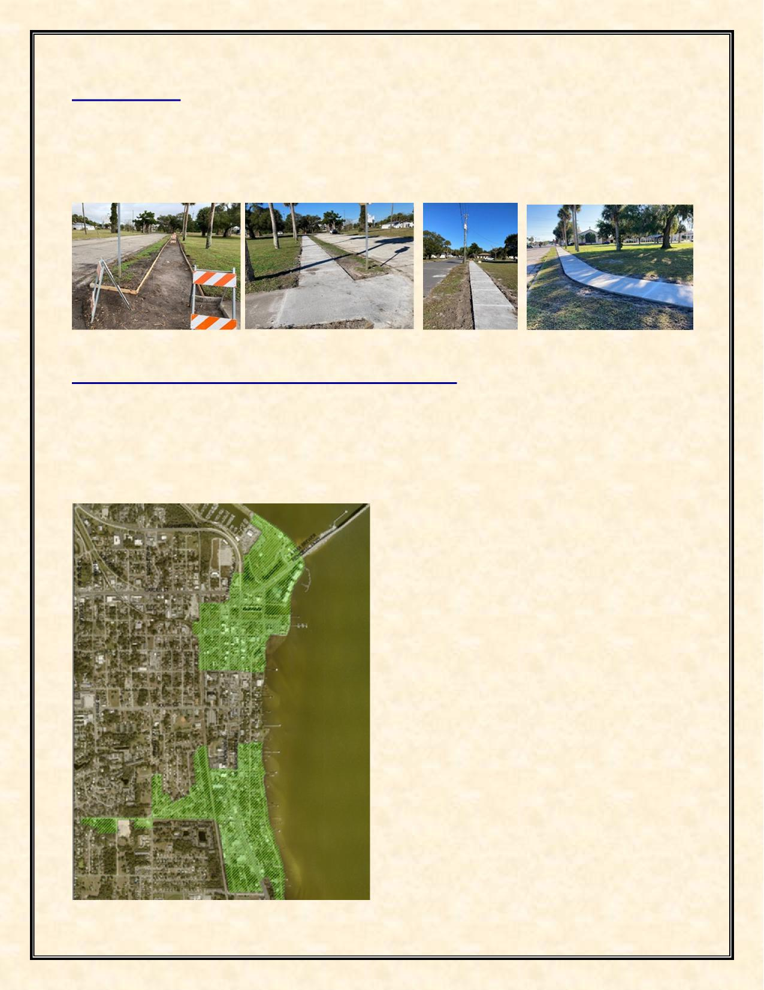
Sidewalk Infill
The CRA provided for sidewalk infill based on an Americans with Disabilities Act (ADA) study. This
project was completed in FY 2024 for a total of approximately $66,541.09.
The Sidewalk Infill project implements the City of Titusville’s CRA Plan objective 6.1.1, policy 6.1.1.3, goal 7.2, and policy 7.2.1.3.
Water Resources Utilities Infrastructure Slip Lining
The Community Redevelopment Agency spent $137,018 in gravity sewer main and manhole rehabilitation by using cured in place slip ling technology. The total cost of the project within the CRA was approximately $1,525,813. The majority of the funds utilized were American Rescue Plan Act of 2021 (ARPA) funds. The map below indicates the locations of the areas within the Community Redevelopment Agency District included in this process.
The Water Resources Utilities Infrastructure Slip Lining project implements the City of Titusville’s CRA Plan goal 6.2, objective 6.4.1, objective 6.4.2, and policy 6.4.2.2.
- 10 -

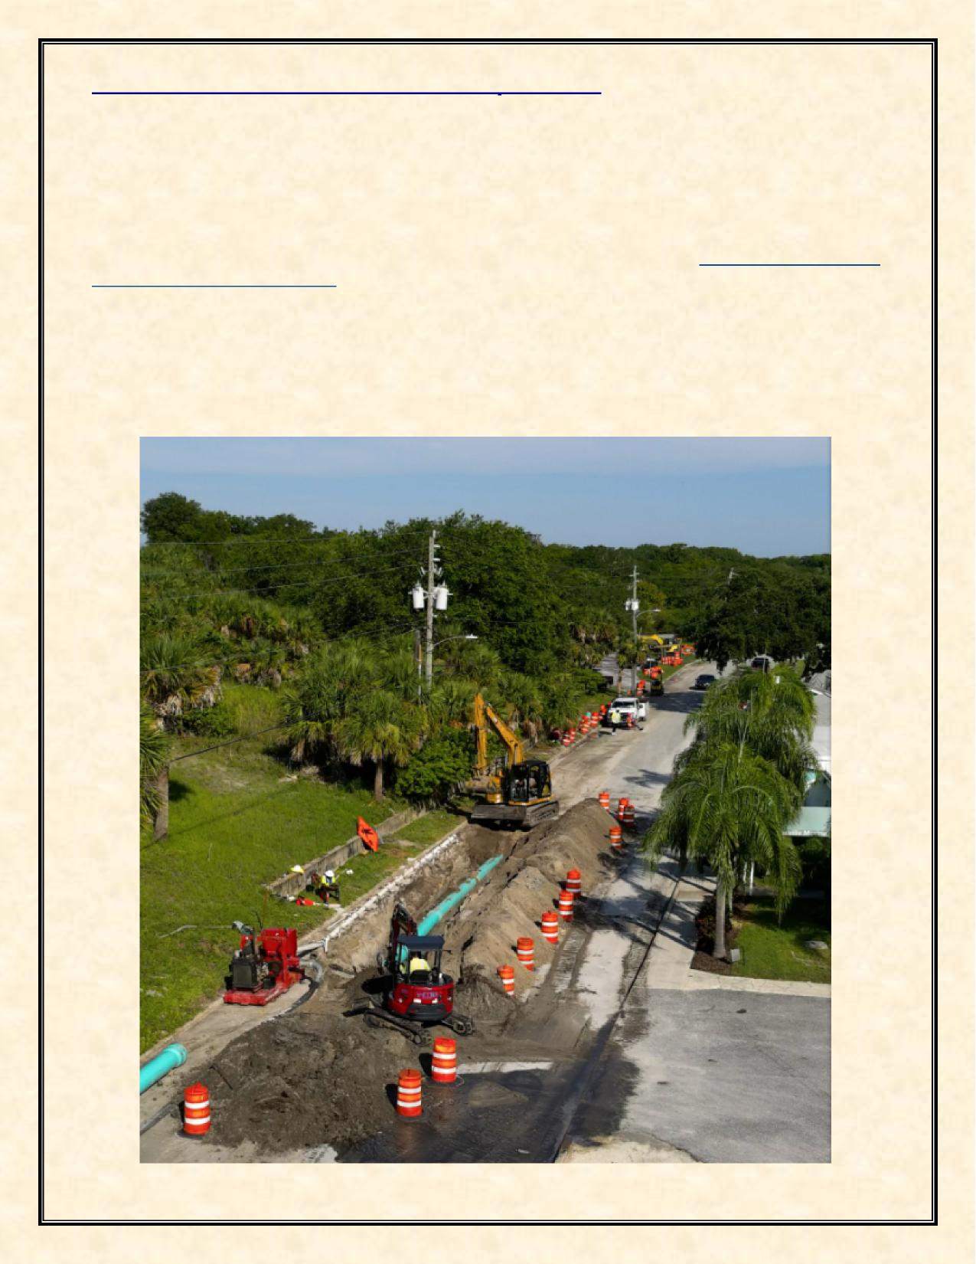
Indian River Force Main Infrastructure Improvement
Construction for the Indian River Force Main Project started August 2023. The project includes replacing a 12-inch sewer line with a new 16-inch sewer line of approximately 8,000 feet of existing sewer force main from South Street to the Osprey Water Reclamation Facility on Buffalo Road in north Titusville. A majority of the replacement is in the CRA. The force main replacement started at the intersection of South Street and Indian River Avenue and will continue north under the Max Brewer Causeway, U S Highway 1, and even a portion of the FEC railroad, ending at the Osprey Facility. A map of the project and road closures (as they are scheduled) can be found at Indian River Ave Sewer Line Replacement (arcgis.com). Titusville’s Public Works Department is working with the contractor to minimize the effect of the closures on residents, and closures will be limited to block segments at any one time. This project is still in progress and scheduled for completion is FY 2025. This project is being funded by utilizing a Clean Water State Revolving Fund loan with an estimated cost of approximately $8.9 million.
The Indian River Force Main Infrastructure Improvement project implements the City of Titusville’s CRA Plan goal 6.2, objective 6.2.1, objective 6.4.1, and objective 6.4.2.
- 11 -

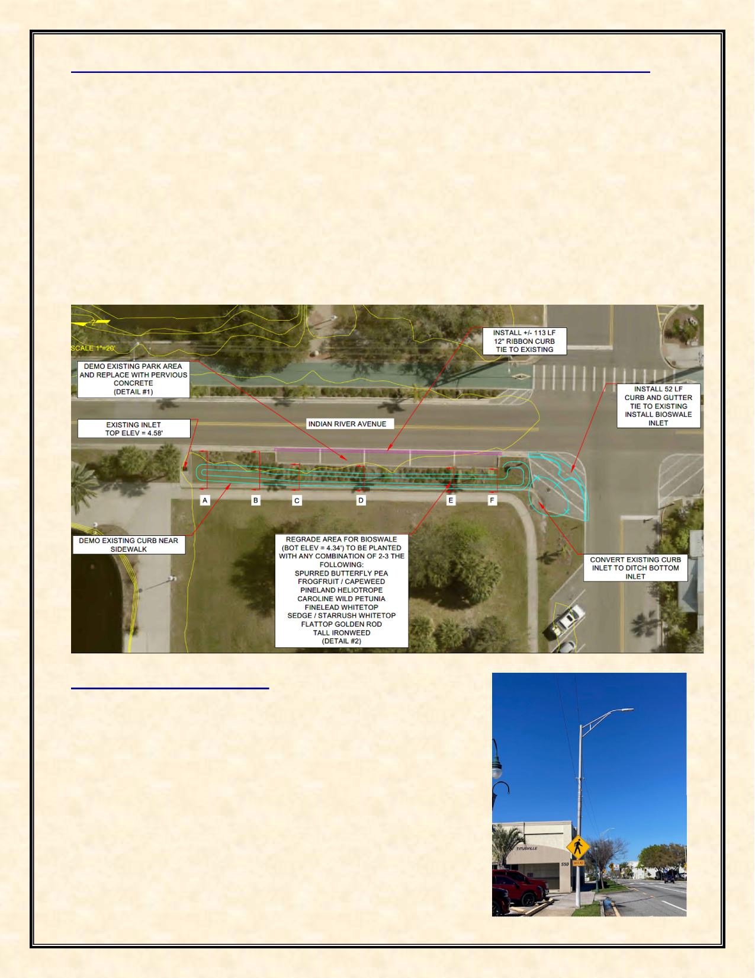
Low Impact Development (LID) Demonstration Project – Indian River Avenue
The CRA approved the funding of a low impact development demonstration (LID) project along Indian River Avenue. On Indian River Avenue, just south of the Space View Park pond, there is one stormwater inlet that discharges directly to the river without any treatment. This project will create a bioswale, turn the five parking spaces next to the bioswale into pervious pavement parking spaces, and raise the elevation of that inlet. This will allow stormwater in that area the space to percolate into the ground in the swale and the pervious parking spaces prior to discharging to the lagoon while still allowing an overflow option to prevent flooding of the roadway. This project was funded in FY 2024 for an estimate of $127,322 and currently in design.
The LID Indian River Avenue project implements the City of Titusville’s CRA Plan objective 6.4.1, policy 6.4.1.2, policy 6.4.1.5, objective 6.4.2, and policy 6.4.2.4.
Whiteway Lighting Project
Whiteway Replacement – The CRA approved the consultant DRMP, Inc. to develop a design scope to replace aluminum highway light poles located on US-1 (Washington Avenue and Hopkins Avenue). Replacement work is expected to begin in FY 2025. This project’s estimated cost is $60,000. The CRA share cost on this project is projected to be $9,600.
The Whiteway Lighting project implements the City of Titusville’s CRA Plan objective 4.2.2, policy 5.2.1.1, policy 6.1.1.3, policy 6.1.1.4, and policy 6.1.1.7.
- 12 -

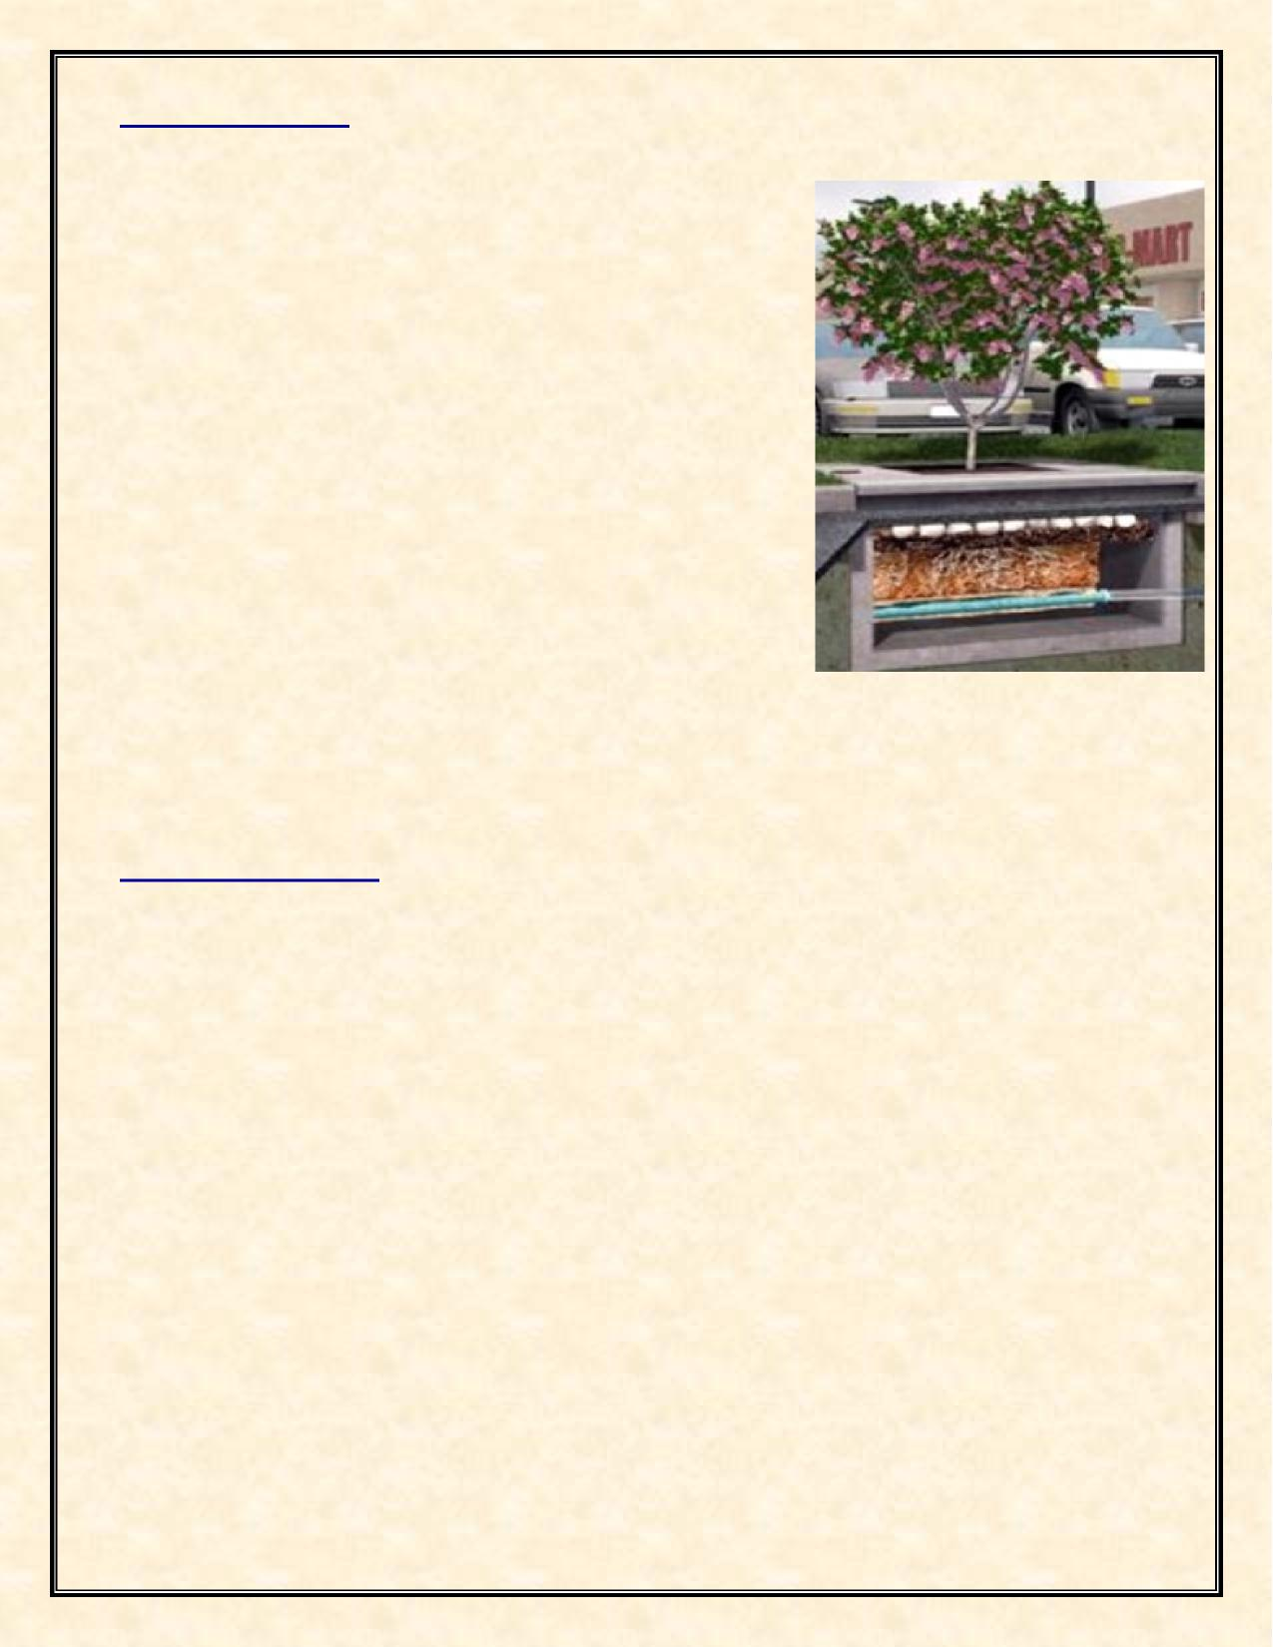
Tree Box Filters
A tree filter project is proposed in the downtown Commons Area to treat stormwater. Tree box filters are widely deployed as stormwater treatment Best Management Practices (BMPs), normally in stand-alone applications; however, they can also be used as pretreatment for infiltration, rainwater harvesting, and detention. Tree box filters are highly adaptable for most developments due to a small footprint, shallow elevation, and no driving head requirements. Where infiltration is not feasible, tree box filters are an ideal solution. Following Low Impact Development (LID) principles of decentralized design, total pollutant load into the Indian River Lagoon is minimized, enabling a sustainable system that is not compromised by high loading rates. Plant selection allows tree box filters to be seamlessly integrated into the landscape and adds aesthetic value. The CRA approved the installation of twenty (20) tree box projects within the CRA. The estimated cost for the CRA for this project is $130,000. Grant funds have been applied for the tree box filter project. This project is in progress and installation is scheduled in FY 2025.
The tree box filter project implements the City of Titusville’s CRA Plan goal 6.4, objective 6.4.1, policy 6.4.1.2, policy 6.4.1.3, policy 6.4.1.6, objective 6.4.2, and policy 6.4.2.4.
Non-Capital Projects
The Non-Capital Projects that occurred over the fiscal year are as follows:
+ Streetscape Landscaping and Facilities Maintenance
+ Community Policing
+ Historic Preservation Activities
+ Land Use Development Review Activities
+ Funded and Installed two (2) Downtown Directory Kiosks
+ Funded and Installed Streetlight Pole Banners
+ Funded and Installed Downtown Parking signs
+ Funded and Installed two (2) Safety Cameras in parks in the CRA District.
+ Installation of LID Baffle Box in Sand Point Park
+ CRA Community Outreach Meetings
- 13 -

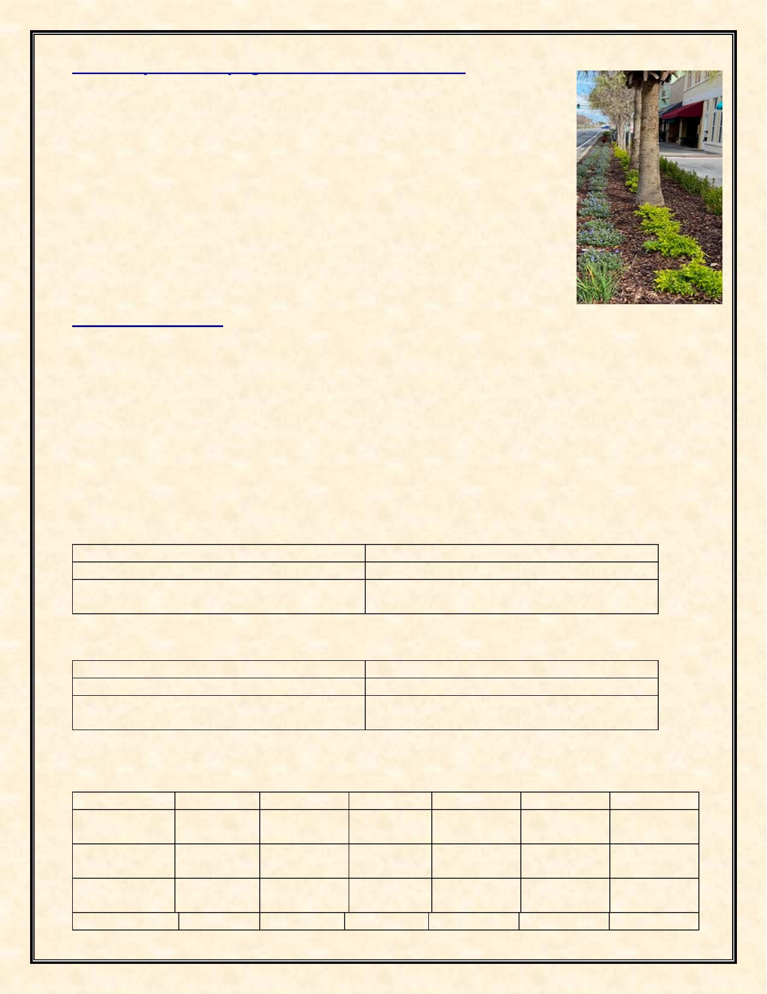
Streetscape Landscaping and Facilities Maintenance
The CRA continued its funding of the general maintenance of the plantings, lighting and street furniture funded by the CRA along the US-1 corridor (Washington Avenue & Hopkins Avenue) and in the Titusville Downtown Commons area. The maintenance provided by the CRA along the US-1 corridor is at a higher level of maintenance than provided by the Florida Department of Transportation and helps to protect the CRA’s investment. The CRA also continues to fund the cost of irrigation and utilities along US 1. Landscaping and facilities maintenance in the CRA was approximately $159,097 for FY 2024.
The streetscape landscaping and facilities maintenance program implements the City of Titusville’s CRA Plan objective 4.2.2, policy 4.2.2.2, policy 4.2.2.3, goal 5.2, policy 5.2.1.2, and policy 5.2.1.3.
Community Policing
In June 2014, the CRA initiated a Community Policing program. The program consists of law enforcement officers deployed on an overtime basis during varying days and times. Increased activities in the CRA District include business contacts, directed patrols, traffic details, community relations, neighborhood patrols and anti-burglary details. This is thought to be a more cost-effective method to provide coverage as needed, rather than one full-time officer who would have less flexibility to address issues as they arise. The Community Policing program cost for FY 2024 was $30,665.
Program accomplishments for the fiscal year are listed below. As the community policing initiative augments the Titusville Police Department’s regular presence in the CRA, only those activities conducted during the community policing details are provided.
CRA Police Details totaled 484 hours for the fiscal year 2024.
Property Checks | 3,994
Traffic Stops | 1,467
Suspicious Persons/Vehicles/Incidents & Unwanted/Trespass | 967
CRA Police Details totaled 750 hours for the fiscal year 2023.
Property Checks | 4,869
Traffic Stops | 1,205
Suspicious Persons/Vehicles/Incidents & Unwanted/Trespass | 988
Total incident statistics in the redevelopment district for the fiscal year not part of the CRA Police details were as follows:
 | FY 2024 | FY 2023 | FY 2022 | FY 2021 | FY 2020 | FY 2019
Vehicle Burglaries | 8 | 9 | 11 | 18 | 16 | 41
Residential Burglaries | 0 | 2 | 4 | 0 | 2 | 2
Commercial Burglaries | 1 | 8 | 4 | 0 | 10 | 11
 | FY 2024 | FY 2023 | FY 2022 | FY 2021 | FY 2020 | FY 2019
- 14 -


Traffic Stops | 1,467 | 1,205 | 1,157 | 1,269 | 1,140 | 748
Traffic Accidents without injury | 101 | 120 | 137 | 138 | 122 | 165
Traffic  Accidents with injury | 41 | 38 | 43 | 52 | 54 | 29
Burglary Comparison between the CRA and Citywide:
 | FY 2024 | FY 2023 | FY 2022 | FY 2021 | FY 2020
CRA District | 9 | 19 | 18 | 28 | 28
City Wide | 305 | 368 | 326 | 402 | 555
Calls for Service between the CRA and Citywide:
 | FY 2024 | FY 2023 | FY 2022 | FY 2021
CRA District | 15,345 | 9,965 | 7,934 | 8,683
City Wide | 113,696 | 109,402 | 95,623 | 114,392
The incident statistics show that the Community Policing details had a continued emphasis on reducing vehicle burglaries, residential burglaries and enforcing traffic laws during the fiscal year. The statistics show a positive trend in the reduction of crime in the CRA.
The community policing program implements the City of Titusville’s CRA Plan objective 7.1.1, policy 7.1.1.2, policy 7.1.1.4, policy 7.1.1.8, and objective 7.1.2.
Historic Preservation Activities
The CRA District is home to many of the City’s historic resources. The preservation of these historic resources in the Community Redevelopment District adds to the City’s pride and creates pedestrian and visitor appeal, which provides economic development for the City. Historic Preservation activities that directly involved the CRA District included the award of a State of Florida Division of Historical Resources Small Matching Grant in July 2022 in the amount of $40,000 to fund the creation of Architectural Style and Design Guidelines for use by the City Historic Preservation Board when doing design review of designated historic structures and for property owners of historic and potentially historic structures to use when making renovations to their properties.
The City’s Explore Historic Titusville booklet, mobile phone app and web site (http://history.titusville.com), which provides walking/driving tours/audio recordings of historic resources of the City from the area’s first indigenous inhabitants to the Space Program, was awarded a Florida Preservation 2022 award for Preservation Communication/Media. The majority of the historical and historic landmarks in the booklet, app and web site walking/driving tour are found in the Redevelopment District. The Explore Historic Titusville is an ongoing positive activity generator in the CRA District. This program is funded by the Historic Preservation budget.
This program implements the City of Titusville’s CRA Plan goal 3.1, objective 3.1.1, policy 3.1.1.1, policy 3.1.1.3, and policy 3.1.1.5.
- 15 -

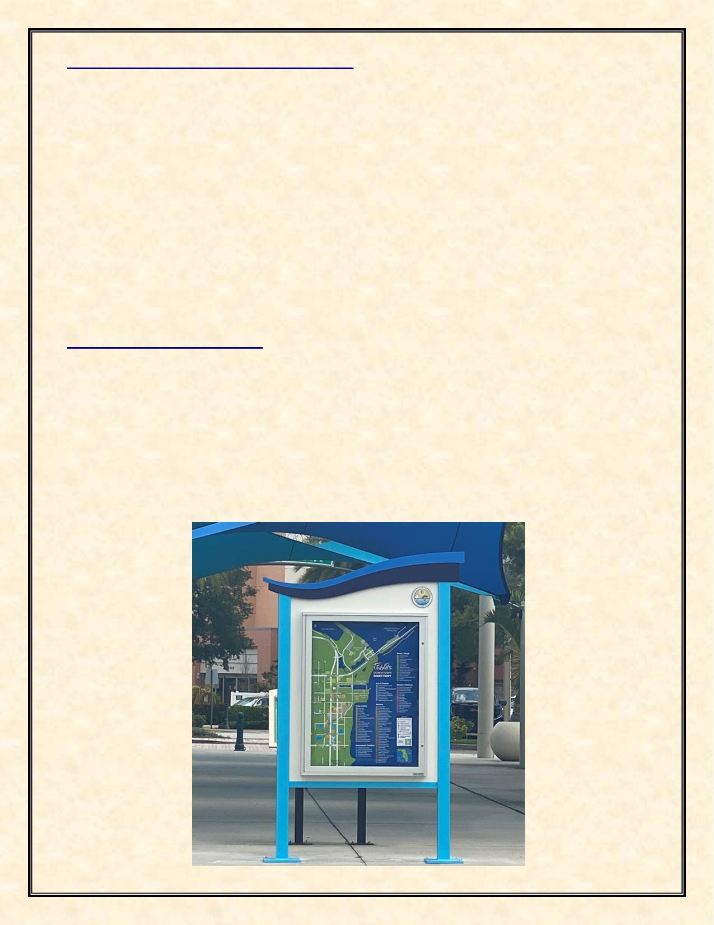
Land Use Development Review Activities
One of the duties of the CRA Agency is to provide input and recommendations to the City Council on land use decisions occurring in the redevelopment district. A summary of the land use activities that the CRA was involved in during FY 2024 as follows:
- CUP #3-2024 – A conditional use permit (CUP) was approved with conditions allowing a
Vehicle for Hire permit for a tow truck service to operate at 1210 South Hopkins Avenue, Unit
B. This conditional use was approved with the condition that a solid, opaque fence made of material other than chain link shall be provided around the perimeter of any vehicle storage
areas.
- The CRA provided input and approved Comprehensive Plan Amendments including changes to
the Downtown Mixed Use zoning district to include a density pool. This update will help with
redevelopment in the CRA by calculating density by the redevelopment district area instead of per parcel.
These activities implement the City of Titusville’s CRA Plan objective 8.1.1, polity 8.1.1.1, and policy 8.1.1.4.
Downtown Directory Kiosks
The CRA approved and installed two (2) new downtown directory kiosks that have the same design theme and colors utilized throughout the City for branding purposes. The new directory maps in the kiosks are a new updated design with colors in line with the Titusville Palette. The City of Titusville CRA is continuing efforts to market our local businesses, our trails, and amenities. These improvements and enhancements address the redevelopment strategy of reinforcing the CRA branding and marketing and reinforcing connections. The total cost for this project in FY 2024 was approximately $22,958.
This project implements the City of Titusville’s CRA Plan policy 3.2.1.2, policy 3.4.1.3, policy 3.4.1.5, objective 4.1.2, objective 4.2.2, and policy 4.2.2.2.
- 16 -


Streetlight Pole Banners
In FY 2024 the Community Redevelopment Agency approved the purchase of 176 streetlight pole banners for branding within the CRA District. The banners have 8 themes featuring history, nature, space, and amenities for branding. The banners were purchased in FY 2024 for $6,739 and will be installed in FY 2025.
This project implements the City of Titusville’s CRA Plan goal 3.1, objective 3.4.1, policy 3.4.1.3, objective 4.2.2, and goal 5.2.
Safety Cameras
As part of a Titusville Police Department (TPD) crime prevention initiative, calls for service data analysis was conducted of the CRA in FY 2024. During this data analysis hot spots were identified in 2 parks within the Community Redevelopment Agency District. The CRA Board approved the funding and installation of two (2) Flock Safety Cameras in these parks to deter crime, solve crime, and increase public safety overall. The cost for these cameras in FY 2024 was $19,458.
This project implements City of Titusville’s CRA Plan objective 4.2.2, goal 5.1, objective 6.3.1, policy 7.1.1.1, policy 7.1.1.4, and policy 7.1.1.8.
- 17 -

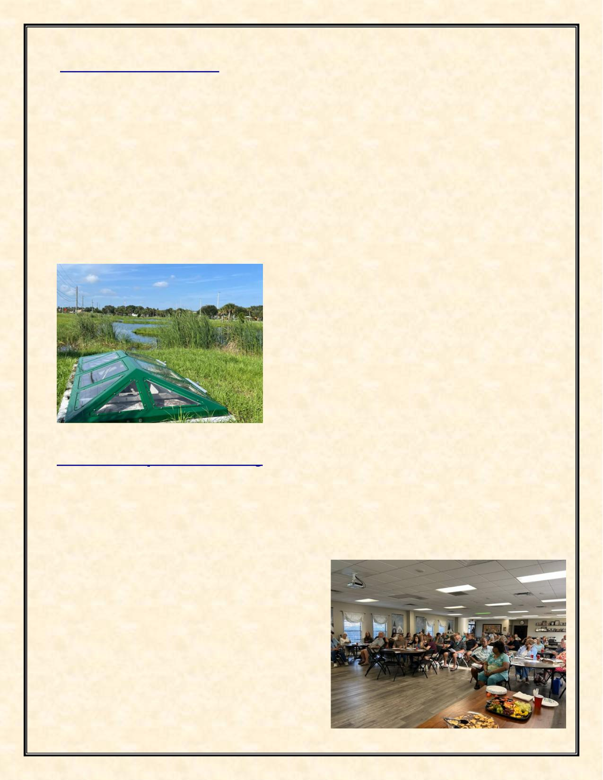
Sand Point Park Baffle Box
In FY 2024 the CRA approved the installation of a baffle box demonstration project located within Sand Paint Park within the CRA near the Indian River Lagoon. A Baffle Box is a structure with a series of settling chambers whose primary function is to remove sediment, debris, trash, and their associated pollutants from stormwater. The box is then vacuum cleaned, and the material is properly disposed of, preventing the sediment, debris and trash from ever entering the Lagoon. This box also includes a filtration media used to remove total nitrogen (TN), total phosphorus (TP), total suspended solids (TSS), and pathogens from the water before it enters the Indian River Lagoon. What makes this box different from the 12 other boxes the City already has installed is that this box has an observation top instead of the regular top. This top allows the citizens to see inside the box and observe the treatment process in action. It is a great educational tool to help inform citizens about all of the projects that are being implemented to help improve the health of the Indian River Lagoon. This project was funded by the Brevard County’s Save our Indian River Lagoon Plan and the Florida Department of Environmental Protection.
This project implements the City of Titusville’s CRA Plan objective 5.4.1, objective 6.1.1, objective 6.3.1, objective 6.4.1, and objective 6.4.1.3.
Sand Point Park Demonstration Baffle Box
CRA Community Outreach Meeting
On January 29, 2024, a CRA Community Outreach meeting was held to discuss proposed updates to the Goals, Objectives and Policies or the Downtown in the Titusville Comprehensive Plan at St. Gabriel’s Episcopal Church in downtown. Staff and the attendees also discussed and promoted the CRA Commercial Grants available in the CRA. This meeting was a positive event with attendees sharing ideas and concepts for the future. These meetings are ongoing. The
cost for this program was approximately $250.
This program implements the City of Titusville’s CRA Plan goal 4.3, objective 4.3.1, policy 4.3.1.1, and policy 4.3.2.2.
- 18 -

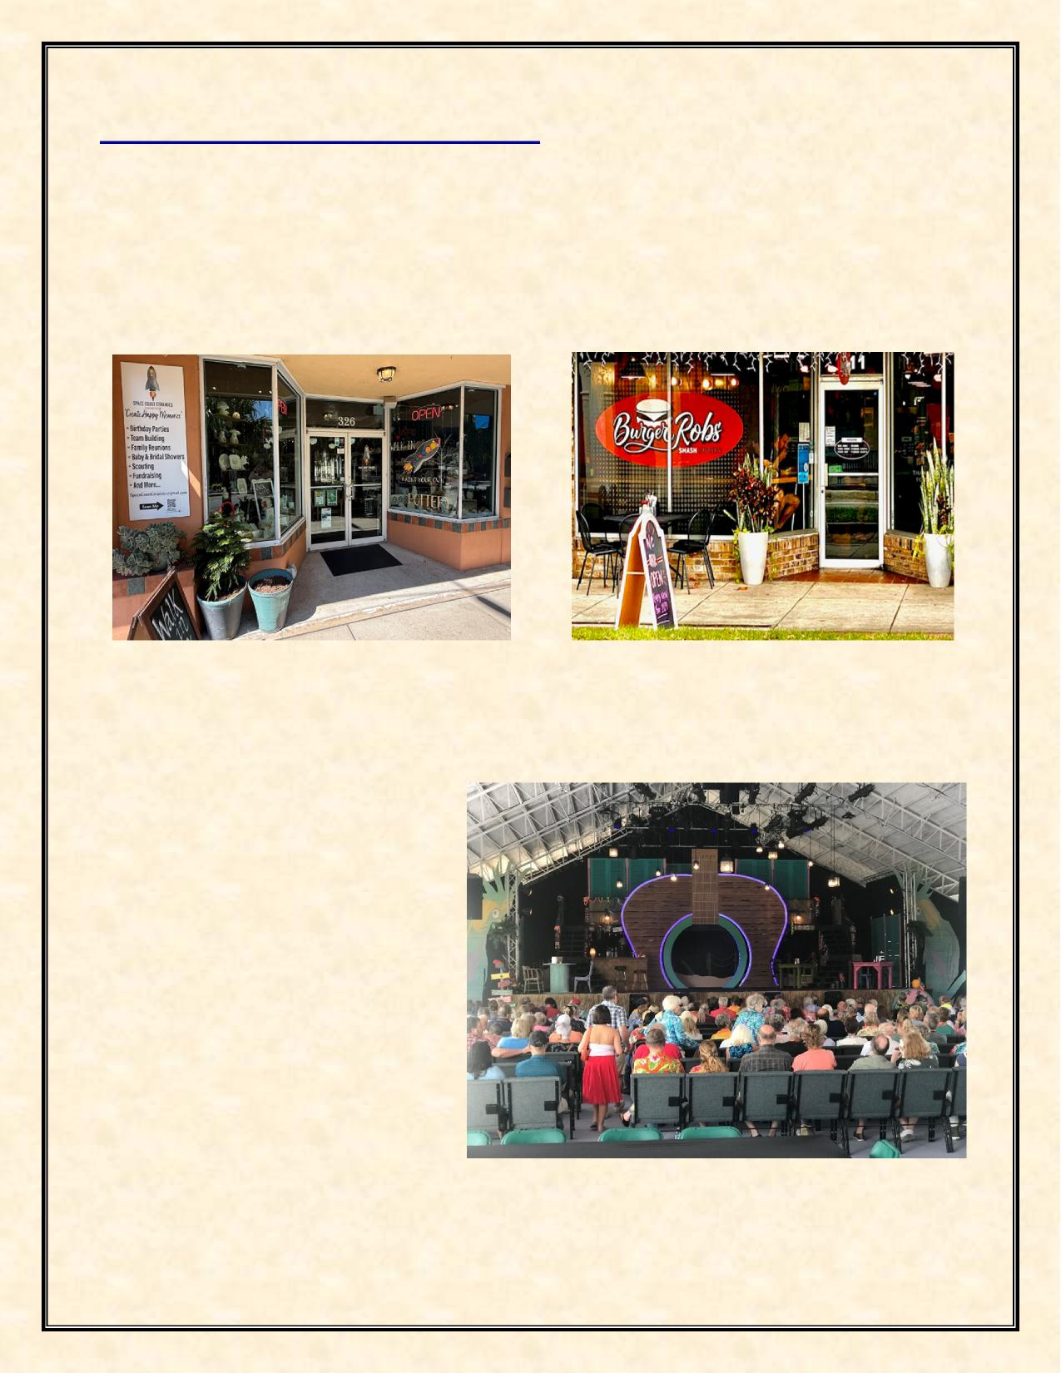
New Construction & Businesses
A goal of the City’s CRA Plan is to encourage private sector investment in the CRA. New building construction and major renovation work to existing buildings helps the City in combating blight. It also encourages others to invest in the CRA. A total of approximately thirty-four (34) new Business Tax Receipts (BTR) were approved in the CRA District during the fiscal year. The following are examples of new businesses and major renovation and construction activity that has occurred in FY 2024 in the CRA District:
Space Coast Ceramics Burger Robs
Stage 2
The Titusville Playhouse located in the CRA District built an outdoor concert and stage venue in FY 2024, named Stage 2. The completion of Stage 2, a covered pavilion seating 300, more than doubled the operating capacity of Titusville Playhouse, enabling two stage productions to run simultaneously. The project represents an investment of more than $1.2 million by Titusville Playhouse in its downtown performing arts center. Construction of the venue was assisted with a $400,000 grant from Florida’s Division of Arts and Culture.
- 19 -

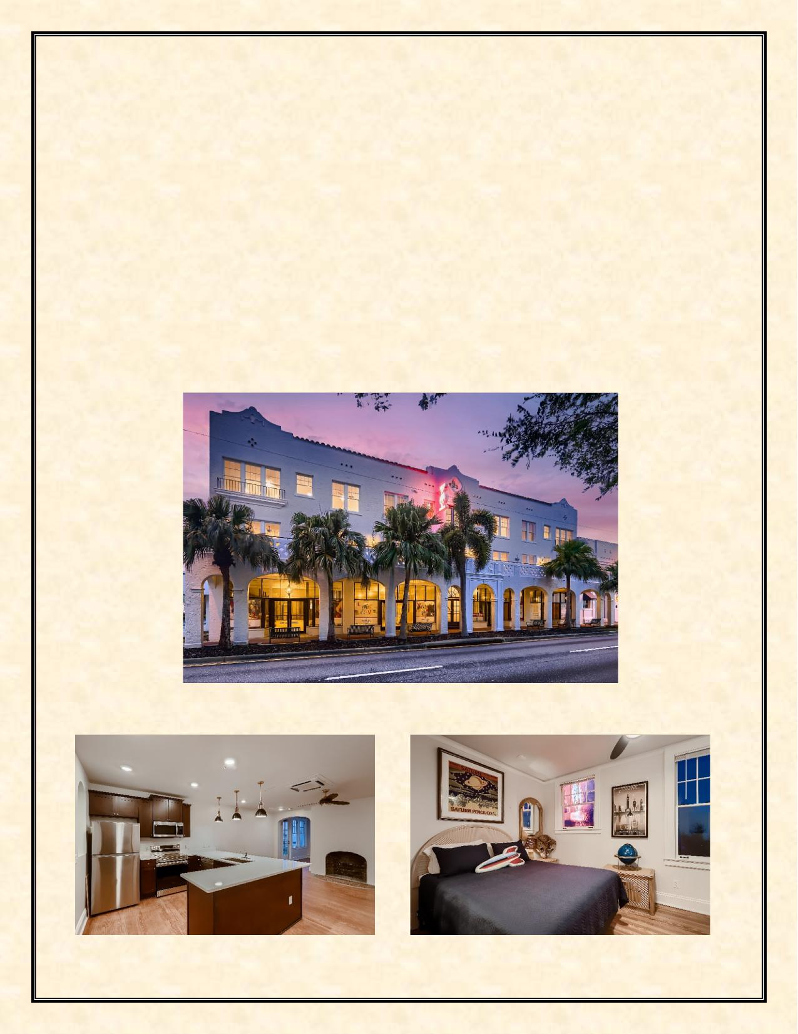
Launch Now Mixed-Use Development
The two buildings at 300-310 South Washington Street, both originally constructed in 1924, are contributing buildings to the National Registry of Historic Places in Titusville and a designated site within the Community Redevelopment Agency District. The buildings are over 2200 square feet and rest on .739/acre. Due to neglect, the buildings were nearly vacant in 2017. Launch Now, LLC closed on the property in 2017 and proposed the revitalization and rehabilitation of the properties to promote the economic, cultural, education, aesthetic and general welfare of the community. By protecting, enhancing and upgrading these important historical buildings, history has been acknowledged while building for the future with the explicit goals of increasing the occupancy rates, economic vitality, and property values within the CRA. The renovation of the buildings into a mixed use of commercial and residential uses was completed in FY 2024. This project includes twenty (20) boutique style apartments upstairs, and commercial, retail and office space on the ground floor. This project received $140,000 in matching grant funding from the Titusville CRA, and approximately $450,000 from the North Brevard Economic Development Zone to assist in the rehabilitation and revitalization of these historic properties. This completed project was over a $6 million investment in historic downtown Titusville and the CRA.
- 20 -


Summary of Redevelopment Plan Goals Achievement
State legislation requires a summary indicating to what extent, if any, the community redevelopment agency has achieved the goals set out in its redevelopment plan. As noted above an update to the 2015 Redevelopment Plan Update was prepared in FY 2022 and adopted in Fiscal Year 2023. A summary of the plans, goals, and achievements is as follows.
Administration of the CRA
Administration of the CRA includes effectively utilizing Tax Increment Financing (TIF) for the administration and operation of the Community Redevelopment Agency. During FY 2024, this goal has been met through the many Capital and Non-Capital Improvement Projects completed and still in progress in addition to CRA Grants awarded for qualified commercial projects. The CRA continues collaboration with other agencies such as the North Brevard Economic Development Zone, Space Coast Transit, Titusville Area Chamber of Commerce, Florida Department of Transportation, and others to foster redevelopment in the downtown. In FY 2024, the CRA maintained the professional level of staffing with the replacement CRA Planner earning the FRA-RP designation through training and testing utilizing the Florida Redevelopment Association Academy. Administration of the CRA goals includes keeping compliant with CRA legal requirements by posting the budget, advertising requirements, hosting Community Redevelopment Agency documents online for public access, internal auditing, adhering, and executing the updated adopted CRA Plan, etc. The CRA has increased the transparency of Community Redevelopment Agency operations by hosting Community Outreach workshops and visiting businesses within the CRA District.
Housing
The housing goal involves promoting, encouraging, and incentivizing residential development and occupancy within the CRA. The CRA worked to attain this goal with the Launch Now development with the assistance of the CRA Grant Program. Launch Now provides twenty (20) new boutique apartment units in a mixed-use building in the heart of the Historic Downtown. The Launch Now project with the assistance of CRA Building Program grants was completed in fiscal year 2024. A second residential development with 384 total multifamily units known as Horizon at Sand Point is in the Building Permit stage and is taking advantage of the increase in residential density and building height in the Uptown Subdistrict of the CRA. The CRA provided design approval of the Horizon development in Fiscal Year 2021. The Horizon at Sand Point developer has acquired additional adjacent property in FY 2022 and revised their site plan during Fiscal Year 2023. Construction is estimated to begin in the Fiscal Year 2025. More residential, including workforce, and low & moderate housing are needed as pointed out in the City’s Strategic Economic Development Plan to make the CRA more vibrant.
Community and Culture
The Community Redevelopment Agency coordinated with the Historic Preservation Board in FY 2023 to create an Architectural Design Guidelines manual to assist in maintaining historic structures downtown. The CRA continues to encourage and support the rehabilitation and adaptive reuse of historic buildings within the Community Redevelopment Area. The CRA held on-going meetings with the Titusville Playhouse Inc regarding the theater’s expansion plans. In FY 2024, the CRA supported the proposed Titusville Playhouse expansions conceptual plans. The Titusville Playhouse has purchased property in the Julia Street – Palm Avenue area and has plans to create an entertainment Arts District in that area with plans to add a new 500 seat theater, a 150-seat black box theater, an outdoor concert and stage venue which was completed in FY 2024, and other ancillary uses including eating and drinking establishments which will add to the vibrancy of the downtown.
The CRA will need to consider additional public infrastructure to help make this area an entertainment district. The CRA has supported the arts by encouraging murals on buildings in the CRA. In addition,
- 21 -


there has been increased tourist activity in the CRA with an increase of rocket launches at the Kennedy Space Center. Based on the increase in launches, improvements were made in Scobie Park including benches and public binoculars for viewing of nature and rocket launches by visitors and residents. The Space View Pier connecting two (2) existing parks separated by water has become a waterfront destination for residents and visitors wanting to view rocket launches and take in the scenic view of the Indian River Lagoon. The Space View Pier Project was completed in FY 2024. The Community Redevelopment Agency held a well-attended community outreach workshop to engage the community and business owners to discuss the future of the downtown area and proposed projects, and available commercial building grants. CRA staff implemented a business retention program in FY 2024.
Economic Development
The CRA has worked in coordination with the City of Titusville’s Economic Development Department, the Titusville Area Chamber of Commerce, and the North Brevard Economic Development Zone, to recruit and retain businesses and encourage private-sector investment in the CRA. The CRA has supported efforts of adaptive reuse and repurposing of underused commercial, historic, and public-owned structures into more intense uses. The goal of the CRA’s Commercial Beautification & Structural Rehabilitation Grant Program is to provide incentives to existing and new property owners to upgrade the exteriors for aesthetics, interiors to meet code requirements, and to incentivize new construction that will ultimately lead to higher occupancy rates, increased property values and is an economic development tool that has proven to be successful. The Community Redevelopment Agency has continued to educate the public about the Community Redevelopment Agency’s business support offerings to build awareness of the business environment and programming available within the CRA by hosting community outreach meetings.
The CRA District is home to many of the City’s historic resources. The preservation of these historic resources in the Community Redevelopment District adds to the City’s pride and created pedestrian and visitor appeal, which provided economic development for the City. The City’s Explore Historic Titusville booklet, mobile phone app and web site (http://history.titusville.com) provides walking/driving tours/audio recordings of historic resources of the City from the area’s first indigenous inhabitants to the Space Program. The booklet and walking/driving tours help to identify the City’s historic resources and will help to provide economic development with visitors touring the city’s historic landmarks and visiting city businesses while touring the City. The majority of the historical and historic landmarks in the booklet, app and web site walking/driving tour are found in the Redevelopment District.
Florida visitors spend billions visiting historic sites (Economic Impacts of Historic Preservation in Florida update 2010, Center for Governmental Responsibility, University of Florida Levin College of Law, page 7). The CRA has continued updating the City of Titusville Welcome Center graphics for visitors and updating the downtown business directory kiosks. In FY 2024 new graphics and downtown business directory kiosks were installed by the CRA. Also in FY 2024, new street banners were purchased by the Community Redevelopment Agency and attached to pedestrian light poles in the district. The new graphics include downtown activities such as music, dining, history, culture, space, and the environment. The installation of banners on a seasonal and on a replacement basis due to weathering and age will be a continuing activity that adds to the vibrancy of the City.
Public Spaces
The Community Redevelopment Agency continues to create safe and accessible public spaces within the CRA. With the completion of Scobie Park improvements with benches and public binoculars for viewing of nature and rocket launches, residents and visitors have places to enjoy being in the gateway to nature and space. The Space View Pier connecting two (2) existing parks separated by water has become a waterfront destination for residents and visitors wanting to view rocket launches and take in the scenic view of the Indian River Lagoon. A 960 square foot Native Vegetation Buffer Zone has been created at Sand Point Park is located in the CRA District. Other Park improvements have included a splash pad,
- 22 -


BMX bicycle track, skateboard facility, and others over the years. In Fiscal Year 2022 in partnership with the North Brevard County Parks and Recreation staff, the CRA installed twelve (12) park benches in Sand Park and two (2) shade structures at the dog park in Marina Park. Long range plans call for a waterfront trail to connect recreational sites to the downtown and to areas to the south. The CRA worked with the Florida Department of Transportation to install a non-motorized vehicle and Pedestrian continuous counter on the Downtown Connector Trail on Indian River Avenue between Orange Avenue and Broad Street located in the CRA in September 2023.
Infrastructure
During the fiscal year the water resources utilities infrastructure slip lining project was completed. This project was a gravity sewer main and manhole rehabilitation by using cured in place slip lining technology. Also completed in FY 2024 was a sidewalk infill project based on an Americans with Disabilities (ADA) study. Construction for the Indian River Force Main Project started August 2023. The project includes replacing a 12-inch sewer line with a new 16-inch sewer line of approximately 8,000 feet of existing sewer force main from South Street to the Osprey Water Reclamation Facility on Buffalo Road in north Titusville. The force main replacement started at the intersection of South Street and Indian River Avenue and will continue north under the Max Brewer Causeway, U S Highway 1, and even a portion of the FEC railroad, ending at the Osprey Facility. The CRA approved the engineering firm for Project Manager and approved the award of contract for the construction of the Space View Park Pier in Fiscal Year 2023. The Space View Pier connects two (2) existing parks separated by water and has become a waterfront destination for residents and visitors wanting to view rocket launches and take in the scenic view of the Indian River Lagoon. The Community Redevelopment Agency continued in 2024 to partner with the City of Titusville Public Works and Water Resources to upgrade critical areas to protect the Indian River Lagoon utilizing proposed tree box filters, baffle boxes, slip lining sewer and stormwater lines, and native vegetation. Streetscaping of side streets will become a major goal of the new Plan that was adopted in FY 2023.
Public Health & Safety
Community Policing is an ongoing endeavor in the CRA. Special details to combat homeless and panhandling issues, traffic issues like speeding on S. Washington Avenue and S. Hopkins Avenue, burglaries, prostitution solicitation issues, etc. will be needed to continue to make the CRA a safe place to live, work, visit, invest, and play. Cameras were installed in FY 2022 in three (3) strategic areas of the CRA as a pilot project will help the Police Department in solving traffic incidents and crimes, and thus help in reducing criminal activities. Future expansion of the cameras in the CRA is being studied. The Police Department has also used mail-outs and banner signs to promote various crime prevention campaigns such as “Lock It or Lose It”, “Click It or Ticket”, and variable message board signs to promote traffic safety in the redevelopment district. In Fiscal Year 2023 the Police Department implemented the Business Trespass Program which authorizes Titusville police officers to advise any person to leave the business premises if the business has registered for this voluntary program. In FY 2023, it has been determined that calls for service in reference to unwanted persons on registered properties decreased by 30%. In FY 2024, the Police Department continued the Crime Prevention Through Environment Design (CPTED) surveys for CRA businesses. In FY 2024, two (2) flock cameras were installed in public parks in the CRA District. The locations were determined by a study conducted by the Titusville Police Department and Code Enforcement and presented to the CRA Board.
Regulatory Environment
In Fiscal Year 2024 the Community Redevelopment Agency has approved and adopted a Comprehensive Plan update to help with redevelopment in the CRA by counting density by redevelopment district area and not per property, known as the Downtown Density Pool. The proposed Downtown Density Pool is an incentive for increased housing and development in the CRA. The Community Redevelopment Agency continues to encourage and incentive Low Impact
- 23 -

Development (LID). LID is a comprehensive land planning and engineering design approach that reduces runoff and utilizes infiltration techniques before the runoff reaches the stormwater facility and protecting the Indian River Lagoon.
Financial Audit Information
The financial information for the Titusville CRA on the following pages is as reported by the independent auditing firm of James Moore & Company, 121 Executive Circle, Daytona Beach, Florida, 32114. The data was taken from the City of Titusville’s Comprehensive Annual Financial Report, Fiscal Year ended September 30, 2024. The financial statement provides information on the Agency’s assets, liabilities, income, and operating expenses as of the end of fiscal year 2023 – 2024 in accordance with Chapter 163, Part III, Florida Statutes. Total expenditures from the Redevelopment Trust Fund in the fiscal year were $1,881,586.
An audit report of the CRA’s FY2023 - 2024 expenditures by the James Moore & Company is also included in this financial section of the Annual Report.
The total amount of funds expended for affordable housing for low income and middle-income persons and families was zero (0) in the CRA. It should be noted that the CRA adopted a new Redevelopment Plan in October 2022 which provides for new CRA Housing Policies regarding providing for low and moderate and workforce housing in the CRA district. In FY 2024, the Community Redevelopment Agency approved Comprehensive Plan Amendments including changes to the Downtown Mixed Use zoning district to include a density pool. This update is a redevelopment tool to incentivize development for multi-family dwellings and affordable housing in the CRA district. The CRA currently has a grant incentive for interior improvements such as ADA, Plumbing, Electrical, and HVAC to existing buildings to be brought up to code for mixed use buildings and or the conversion of commercial buildings to mixed use that can be used to help provide for low and moderate and workforce housing units. The Building Permit and Impact Fee Grant program can also be utilized to assist in the development of new low- and moderate-income housing in the redevelopment district. The CRA can also provide incentives such as tax increment reimbursement to potential low and moderate housing projects in the CRA district on a case-by-case basis.
- 24 -

TITUSVILE COMMUNITY REDEVELOPMENT AGENCY
FINANCIAL STATEMENTS
SEPTEMBER 30, 2024

TITUSVILLE COMMUNITY REDEVELOPMENT AGENCY
TABLE OF CONTENTS
SEPTEMBER 30, 2024
 | Page Number(s)
Independent Auditors’ Report | 1 | − 3
Management’s Discussion and Analysis | 4 | – 6
Basic Financial Statements  Balance Sheet / Statement of Net Position |  | 7
Statement of Revenues, Expenditures, and Changes in Fund Balance / Statement of Activities |  | 8
Notes to Financial Statements | 9 | − 13

Required Supplementary Information
Schedule of Revenues, Expenditures, and Changes in Fund Balance – Budget and
Actual |  | 15
Independent Auditors’ Report on Internal Control Over Financial Reporting and
on Compliance and Other Matters Based on an Audit of Financial Statements
Performed in Accordance with Government Auditing Standards | 16 | – 17
Independent Auditors’ Management Letter Required by Chapter 10.550, Rules of the State of Florida Office of the Auditor General | 18 | – 20
Independent Accountants’ Examination Report |  | 21

- ii -


INDEPENDENT AUDITORS’ REPORT
Report on the Audit of the Financial Statements
Opinions
We have audited the accompanying financial statements of the governmental activities and each major fund of the Titusville Community Redevelopment Agency (the CRA), as of and for the year ended September 30, 2024, and the related notes to the financial statements, which collectively comprise the CRA’s basic financial statements as listed in the table of contents.
In our opinion, the accompanying financial statements present fairly, in all material respects, the respective financial position of the governmental activities and each major fund of the CRA, as of September 30, 2024, and the respective changes in financial position for the year then ended in accordance with accounting principles generally accepted in the United States of America.
Basis for Opinions
We conducted our audit in accordance with auditing standards generally accepted in the United States of America (GAAS) and the standards applicable to financial audits contained in Government Auditing Standards (GAS), issued by the Comptroller general of the United States. Our responsibilities under those standards are further described in the Auditors’ Responsibilities for the Audit of the Financial Statements section of our report. We are required to be independent of the CRA, and to meet our other ethical responsibilities, in accordance with the relevant ethical requirements relating to our audit. We believe that the audit evidence we have obtained is sufficient and appropriate to provide a basis for our audit opinions.
Responsibilities of Management for the Financial Statements
The CRA’s management is responsible for the preparation and fair presentation of the financial statements in accordance with accounting principles generally accepted in the United States of America, and for the design, implementation, and maintenance of internal control relevant to the preparation and fair presentation of financial statements that are free from material misstatement, whether due to fraud or error.
In preparing the financial statements, management is required to evaluate whether there are conditions or events, considered in the aggregate, that raise substantial doubt about the CRA’s ability to continue as a going concern for twelve months beyond the financial statement date, including any currently known information that may raise substantial doubt shortly thereafter.

- 1 -

Auditors’ Responsibilities for the Audit of the Financial Statements
Our objectives are to obtain reasonable assurance about whether the financial statements as a whole are free from material misstatement, whether due to fraud or error, and to issue an auditors’ report that includes our opinions. Reasonable assurance is a high level of assurance but is not absolute assurance and therefore is not a guarantee that an audit conducted in accordance with GAAS and GAS will always detect a material misstatement when it exists. The risk of not detecting a material misstatement resulting from fraud is higher than for one resulting from error, as fraud may involve collusion, forgery, intentional omissions, misrepresentations, or the override of internal control. Misstatements are considered material if there is a substantial likelihood that, individually or in the aggregate, they would influence the judgment made by a reasonable user based on the financial statements.
In performing an audit in accordance with GAAS and GAS, we:
- Exercise professional judgment and maintain professional skepticism throughout the audit.
- Identify and assess the risks of material misstatement of the financial statements, whether due to fraud or error, and design and perform audit procedures responsive to those risks. Such procedures include examining, on a test basis, evidence regarding the amounts and disclosures in the financial statements.
- Obtain an understanding of internal control relevant to the audit in order to design audit procedures that are appropriate in the circumstances, but not for the purpose of expressing an opinion on the effectiveness of the CRA’s internal control. Accordingly, no such opinion is expressed.
- Evaluate the appropriateness of accounting policies used and the reasonableness of significant accounting estimates made by management, as well as evaluate the overall presentation of the financial statements.
- Conclude whether, in our judgment, there are conditions or events, considered in the aggregate, that raise substantial doubt about the CRA’s ability to continue as a going concern for a reasonable period of time.
We are required to communicate with those charged with governance regarding, among other matters, the planned scope and timing of the audit, significant audit findings, and certain internal control–related matters that we identified during the audit.
Required Supplementary Information
Accounting principles generally accepted in the United States of America require that the management’s discussion and analysis and required supplementary information, as listed in the table of contents, be presented to supplement the basic financial statements. Such information is the responsibility of management and, although not a part of the basic financial statements, is required by the Governmental Accounting Standards Board, who considers it to be an essential part of financial reporting for placing the basic financial statements in an appropriate operational, economic, or historical context. We have applied certain limited procedures to the required supplementary information in accordance with auditing standards generally accepted in the United States of America, which consisted of inquiries of management about the methods of preparing the information and comparing the information for consistency with management’s responses to our inquiries, the basic financial statements, and other knowledge we obtained during our audit of the basic financial statements. We do not express an opinion or provide any assurance on the information because the limited procedures do not provide us with sufficient evidence to express an opinion or provide any assurance.

- 2 -

Other Reporting Required by Government Auditing Standards
In accordance with Government Auditing Standards, we have also issued our report dated March 19, 2025, on our consideration of the CRA’s internal control over financial reporting and on our tests of its compliance with certain provisions of laws, regulations, contracts, and grant agreements and other matters. The purpose of that report is solely to describe the scope of our testing of internal control over financial reporting and compliance and the results of that testing, and not to provide an opinion on internal control over financial reporting or on compliance. That report is an integral part of an audit performed in accordance with Government Auditing Standards in considering the CRA’s internal control over financial reporting and compliance.
Daytona Beach, Florida  March 19, 2025 | 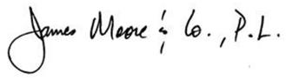

- 3 -

MANAGEMENT’S DISCUSSION AND ANALYSIS
Titusville Community Redevelopment Agency’s (the CRA) management’s discussion and analysis (MD&A) is designed to (a) assist the reader in focusing on significant financial issues, (b) provide an overview of the CRA’s financial activity, (c) identify changes in the CRA’s financial position (its ability to address the next and subsequent year challenges), (d) identify any material deviations from the financial plan (the approved budget), and (e) identify individual fund issues or concerns.
Since the MD&A is designed to focus on current year activities, resulting changes, and currently known facts, it should be read in conjunction with the CRA’s financial statements which follow this section.
Financial Highlights
- The assets of the CRA exceeded its liabilities at September 30, 2024, by $1,250,597 (net position). Of this amount, $497,973 represents the net investment in capital assets, and $752,624 was restricted for redevelopment purposes.
- As of September 30, 2024, the CRA reported ending fund balances of $1,250,597. Fund balance saw a change of $(830,267) when compared to the prior year.
The MD&A is intended to serve as an introduction to the CRA’s basic financial statements, which are comprised of three components: 1) government-wide financial statements, 2) fund financial statements and 3) notes to the financial statements.
Overview of the Financial Statements
This annual report consists of four components: 1) management’s discussion and analysis (this section), 2) government-wide and fund financial statements, 3) notes to the financial statements, and 4) required supplementary information.
Government-wide Financial Statements
Government-wide financial statements provide readers with a broad overview of the CRA’s finances in a manner similar to a private-sector business. The governmental activities of the CRA include reinvesting into the community redevelopment district.
The statement of net position presents information on all of the CRA’s assets and liabilities, with the difference between the two reported as net position. This statement serves a purpose similar to that of the balance sheet of a private-sector business. Over time, increases or decreases in net position may serve as one indicator of whether the financial position of the CRA is improving or deteriorating.
The statement of activities presents information showing how the government’s net position changed during the fiscal year. All changes in net position are reported using the modified cash basis of accounting.
Notes to the Financial Statements
The notes to the financial statements provide additional information that is essential to a full understanding of the data provided in the government-wide and fund financial statements.
- 4 -

Government-wide Financial Analysis
Statement of Net Position
The following is a summary of the CRA’s governmental activities net position for each of the past two years:
ASSETS | Governmental Activities
ASSETS | 2024 | 2023
Current and other assets | $ 800,1 11 | $ 1,595,577
Capital assets | 497,973 | 510,495
Total assets | $ 1,298,084 | $ 2,106,072
LIABILITIES
Current liabilities | $ 47,487 | $ 25,208
Total liabilities | $ 47,487 | $ 25,208
NET POSITION
Net investment in capital assets | $ 497,973 | $ 510,495
Restricted | 752,624 | 1,570,369
Total net position | $ 1,250,597 | $ 2,080,864

Statement of Activities
The following is a summary of the changes in the CRA’s governmental activities net position for each of the past two years:
REVENUES | Governmental Activities
REVENUES | 2024 | 2023
Property taxes | $ 1,088,637 | $ 1,038,731
Other revenues | 80,722 | 46,134
Total revenues | 1,169,359 | 1,084,865
EXPENSES
Community development | 631,272 | 560,764
Capital outlay | 1,250,314 | 243,857
Total expenses | 1,881,586 | 804,621
Net income before transfers | (712,227) | 280,244
Transfers from primary government | - | 216,202
Transfers to primary government | (118,040) | (120,950)
Change in net position | (830,267) | 375,496
Net position, beginning of year | 2,080,864 | 1,705,368
Net position, end of year | $ 1,250,597 | $ 2,080,864

- 5 -

Financial Analysis of the General Fund

The focus of the CRA’s governmental funds is to provide information on near-term inflows, outflows, and balances of spendable resources. Such information is useful in assessing the CRA’s financing requirements. In particular, unassigned fund balance may serve as a useful measure of a government’s net resources available for spending at the end of the fiscal year.
As of the end of the current fiscal year, the CRA’s general fund reported an ending fund balance of $1,250,597, a change of $(830,267), in comparison with the prior year.
At the end of the current fiscal year, the entire fund balance was restricted for community development. As the CRA is focused on reinvestment revenues into the CRA district and does not have significant annual operational costs, the CRA does not maintain specific reserve levels for operations.
General Fund Budgetary Highlights
There were significant amendments between the original and the final CRA budget, which were to provide for spending authority of an additional $1,570,369 in capital expenditures.
Actual expenditures in the general fund were $792,099 less than final budget amounts. The main reason for this is due to the timing of capital project and other one-time expenditures.
Budgetary comparisons between the final budget and actual results can be found on page 15 of this report. Economic Factors and Next Year's Budget
There are many challenges facing local governments today. Property values have continued to increase in recent years, contributing to related growth in the revenues of the CRA. While property values for the subsequent fiscal year have increased, continually changing conditions in the real estate market make the future of the CRA’s finances uncertain.
Requests for Information
This report is designed to provide an overview of the CRA’s finances for those with an interest in this area. Questions concerning any of the information found in this report, or requests for additional information, should be directed to the City of Titusville.

- 6 -

TITUSVILLE COMMUNITY REDEVELOPMENT AGENCY
BALANCE SHEET / STATEMENT OF NET POSITION
SEPTEMBER 30, 2024
ASSETS | Balance Sheet | Adjustments | Statement of  Net Position
ASSETS | General  Fund | Adjustments | Governmental Activities
Equity in pooled cash and investments | $ 800,111 | $ - | $ 800,111
Capital assets:
Non-depreciable | - | 200,000 | 200,000
Depreciable, net | - | 297,973 | 297,973
Total assets | $ 800,111 | $ 497,973 | $ 1,298,084
LIABILITIES
Accounts payable and accrued liabilities | $ 47,487 | $ - | $ 47,487
Total liabilities | 47,487 | - | 47,487
FUND BALANCE / NET POSITION Fund Balance:
Restricted for:
Community redevelopment | 752,624 | (752,624) | -
Net Position:
Net investment in capital assets | - | 497,973 | 497,973
Restricted for:
Community redevelopment | - | 752,624 | 752,624
Total fund balance / net position | 752,624 | 497,973 | 1,250,597
Total liabilities and fund balance / net position | $ 800,111 | $ 497,973 | $ 1,298,084

The accompanying notes to financial statements are an integral part of this statement.
- 7 -

TITUSVILLE COMMUNITY REDEVELOPMENT AGENCY
STATEMENT OF REVENUES, EXPENDITURES AND CHANGES IN FUND BALANCE /
STATEMENT OF ACTIVITIES
FOR THE YEAR ENDED SEPTEMBER 30, 2024
Statement of
Revenues,
Expenditures,
and Changes in Statement of
Fund Balance Total Activities
General Governmental Governmental
Fund Funds Adjustments Activities
Revenues
Taxes | $ 1,088,637 | $ 1,088,637 | $ - | $ 1,088,637
Investment income (loss) | 76,582 | 76,582 | - | 76,582
Miscellaneous | 4,140 | 4,140 | - | 4,140
Total revenues | 1,169,359 | 1,169,359 | - | 1,169,359
Expenditures / expenses
Current:
Community development | 618,750 | 618,750 |  | 618,750
Capital outlay | 1,250,314 | 1,250,314 | - | 1,250,314
Depreciation | - | - | 12,522 | 12,522
Total expenditures / expenses | 1,869,064 | 1,869,064 | 12,522 | 1,881,586
Excess (deficiency) of revenues over expenditures / operating income (loss)
 | (699,705) | (699,705) | (12,522) | (712,227)
Other financing sources (uses)
Transfers in from primary government | - | - | - | -
Transfers out to primary government | (118,040) | (118,040) | - | (118,040)
Total other financing sources (uses) | (118,040) | (118,040) | - | (118,040)
Net change in fund balance / net position | (817,745) | (817,745) | (12,522) | (830,267)
Fund balance / net position, beginning of year | 1,570,369 | 1,570,369 | 510,495 | 2,080,864
Fund balance / net position, end of year | $ 752,624 | $ 752,624 | $ 497,973 | $ 1,250,597

The accompanying notes to financial statements are an integral part of this statement.
- 8 -

TITUSVILLE COMMUNITY REDEVELOPMENT AGENCY
NOTES TO FINANCIAL STATEMENTS
SEPTEMBER 30, 2024
(1) Summary of Significant Accounting Policies:
The financial statements of the Titusville Community Redevelopment Agency (the CRA), have been prepared in conformance with accounting principles generally accepted in the United States of America as applicable to governmental units. The Governmental Accounting Standards Board (GASB) is the accepted body for promulgating governmental accounting and financial reporting principles and the CRA has adopted the GASB Codification. The following is a summary of the CRA’s significant accounting policies:
- Reporting entity-The Titusville Community Redevelopment Agency was created by Ordinance 66-1982 of the City of Titusville, Florida (City) per Chapter 163 Part III of the Florida Statutes. Pursuant to Florida Statute 163.387, the Community Redevelopment Agency has to account for the receipt and expenditure of property tax revenues from the tax increment financing district to support redevelopment in the designated community redevelopment area. Since the City is financially accountable for the activities of the CRA, its governing board is substantially the same (the City Council plus two additional appointed members), and its relationship to the CRA is significant, the CRA is considered to be a blended component unit in the City’s financial statements, where it is also reported as a major special revenue fund.
The CRA has determined there are no component units that meet criteria for inclusion in the CRA’s financial statements.
- Government-wide and fund financial statements-The government-wide financial statements (i.e., the statement of net position and the statement of activities) report information on all of the activities of the CRA. The CRA only has governmental activities and does not engage in any business-type activity. Direct expenses are those that are clearly identifiable with a specific function or segment. General revenues include ad valorem taxes and interest income. Fund financial statements are presented for the CRA’s General Fund. The General Fund, which accounts for all financial operations of the CRA, is considered to be a major fund and is the only fund of the CRA.
- Measurement focus, basis of accounting, and financial statement presentation-The government-wide financial statements are reported using the economic resources measurement focus and the accrual basis of accounting. Revenues are recorded when earned, and expenses are recorded when a liability is incurred, regardless of the timing of related cash flows. Grants and similar items are recognized as revenue when all eligibility requirements imposed by the grantor have been met.
Governmental fund financial statements are reported using the current financial resources measurement focus and the modified accrual basis of accounting. Revenues are recognized when they are both measurable and available. Revenues are considered to be available when they are collectible within the current period or soon enough thereafter to pay liabilities of the current period. For this purpose, the CRA considers property revenues to be available if they are collected within 60 days of the end of the current period. Grants, other intergovernmental revenues, charges for services, licenses and interest associated with the current fiscal period are all considered to be susceptible to accrual and so have been recognized as revenues of the current fiscal period. Expenditures generally are recorded when a liability is incurred. However, expenditures related to long-term agreements are recorded only when payment is due.
- Budgets and budgetary accounting-The governing board of the CRA adopts an annual operating budget, which is prepared on a modified accrual basis and can be amended by the board throughout the year. At the fund level, actual expenditures cannot exceed the budgeted amounts. The accompanying budgeted financial statements for the General Fund reflect the final budget authorization amounts, including all amendments.

- 9 -

TITUSVILLE COMMUNITY REDEVELOPMENT AGENCY
NOTES TO FINANCIAL STATEMENTS
SEPTEMBER 30, 2024
(1) Summary of Significant Accounting Policies: (Continued)
- Deposits and investments-The CRA’s cash and cash equivalents include cash on hand, demand deposits and short-term investments that are readily convertible to known amounts of cash. Investments with original maturities of three months or less are considered to be cash equivalents.
- Receivables and payables-Activity between the CRA and the City has been classified as amount due to/from the primary government on the balance sheet and statement of net position. All trade and property tax receivables are reported net of an allowance for uncollectible accounts, which is based upon management's analysis of outstanding balances and historical trends. At September 30, 2024, all of the CRA’s receivables were considered fully collectible.
- Prepaid items-Certain payments to vendors reflect costs applicable to future accounting periods and are recorded as prepaid items in both government-wide and fund financial statements.
- Capital assets- The CRA owns limited capital assets. The majority of capital outlay expenditures made by the CRA are deemed to be on behalf of the City who takes ownership of the assets along with the perpetual maintenance obligation for those assets. Capital assets owned by the CRA, which land and buildings, are reported in the government-wide financial statements. Capital assets are defined as assets with an initial, individual cost of more than $5,000 and an estimated useful life of greater than one year. Such assets are recorded at historical cost or estimated historical cost if purchased or constructed. Donated capital assets are recorded at estimated acquisition value at the date of donation. The costs of normal maintenance and repairs that do not add to the value of the asset or materially extend asset lives are not capitalized, but charged to operating expense as incurred. Major outlays for capital assets and improvements are capitalized as projects are constructed.
Capital assets are depreciated using the straight-line method over the following estimated useful lives:
Assets Years
Buildings 30 years
- Long-term obligations-The CRA does not have any legal indebtedness. Any use of funds for debt service represents payments toward long-term debt issued in the name of the City for which CRA revenues have been pledged.
The CRA does not have any employees. Any employees who provide services to the CRA are employees of the primary government and do so at either no charge to the CRA, or any allocations made to the CRA represent reimbursements by the CRA to the primary government for services rendered (any items recorded to personnel expense accounts are only for ease of tracking the reimbursement amounts). As a result, there is no compensated absences, other post-employment benefits (OPEB), or pension liabilities recorded on the CRA’s financial statements.

- 10 -

TITUSVILLE COMMUNITY REDEVELOPMENT AGENCY
NOTES TO FINANCIAL STATEMENTS
SEPTEMBER 30, 2024
(1) Summary of Significant Accounting Policies: (Continued)
- Fund balance-In the fund financial statements, governmental funds report fund balance classifications that comprise a hierarchy based primarily on the extent to which the CRA is bound to honor constraints on the specific purposes for which amounts in those funds can be spent. Those classifications are as follows:
Nonspendable – amounts not available to be spent or not in spendable form, such as inventory and prepaid items.
Restricted – amounts constrained to specific purposes by their providers (such as grantors and higher levels of government), through constitutional provisions or by enabling legislation.
Committed – amounts constrained to specific purposes based on actions taken by the CRA governing board through ordinance.
Assigned – amounts the CRA intends to use for a specific purpose. Intent can be expressed by the CRA governing board or by an official or body which the Board delegates authority.
Unassigned – amounts that are available for any purpose.
When an expenditure is incurred for purposes for which both restricted and unrestricted resources are available; the CRA considers restricted funds to have been spent first. When expenditure is incurred for which committed, assigned, or unassigned fund balances are available, the CRA considers amounts to have been spent first out of committed funds, then assigned funds and finally, unassigned funds, as needed.
- Deferred outflows/inflows of resources-In addition to assets, the statement of financial position will sometimes report a separate section for deferred outflows of resources. This separate financial statement element represents a consumption of net position that applies to a future period(s) and so will not be recognized as an outflow of resources (expense/expenditure) until then. The CRA has no items that meet this reporting criteria.
- In addition to liabilities, the statement of financial position will sometimes report a separate section for deferred inflows of resources. This separate financial statement element represents an acquisition of net position that applies to a future period and will not be recognized as an inflow of resources (revenue) until that time. The CRA has no items that meet this reporting criteria.
- Net position flow assumption-Sometimes the CRA will fund outlays for a particular purpose from both restricted and unrestricted resources. In order to determine amounts reported as restricted and unrestricted net position, it is the CRA’s policy to consider restricted net position to have been used before unrestricted net position is applied.
- Use of estimates-Management uses estimates and assumptions in preparing financial statements in accordance with generally accepted accounting principles. Those estimates and assumptions affect the reported amounts of assets and liabilities, the disclosure of contingent assets and liabilities, and the reported revenue and expenses. Actual results could vary from the estimates assumed in preparing the financial statements.

- 11 -

TITUSVILLE COMMUNITY REDEVELOPMENT AGENCY
NOTES TO FINANCIAL STATEMENTS
SEPTEMBER 30, 2024
(2) Reconciliation of Government-Wide and Fund Financial Statements:
- Explanation of certain differences between the governmental fund balance sheet and the government-wide statement of net position-Following the governmental fund balance sheet is a reconciliation between fund balance – total governmental funds and net position – governmental activities as reported in the government-wide statement of net position. A detailed explanation of these differences is as follows: capital assets used in governmental activities are not financial resources and, therefore, not reported in the governmental funds.
- Explanation of certain differences between the governmental fund statement of revenues, expenditures, and changes in fund balances and the government-wide statement of activities-Following the governmental fund statement of revenues, expenditures, and changes in fund balances, there is a reconciliation between net changes in fund balances - total governmental funds and changes in net position of governmental activities as reported in the government-wide statement of activities. A detailed explanation of these differences is as follows: governmental funds report capital outlays as expenditures, however, in the statement of activities the cost of these assets is allocated over their estimated useful lives and reported as depreciation expense.
(3) Deposits and Investments:
The CRA is subject to the investment policy of the primary government and maintains interest-bearing banking accounts for substantially all CRA funds. Additional accounts are held for various other purposes, or to segregate cash balances for amounts which are restricted or held on behalf of others. State statutes authorize the CRA to invest excess funds in time deposits, or obligations of the principal and interest of which are unconditionally guaranteed by, the United States Government, commercial paper, corporate bonds, repurchase agreements and/or the State Board of Administration (SBA) Local Government Surplus Trust Fund Investment Pool or other investment vehicles authorized by local ordinance.
As of September 30, 2024, all CRA deposits were covered by private bank acquired insurance, Securities Investor Protection Corporation (SIPC) insurance, private broker/dealer acquired insurance, Federal Depository Insurance Corporation (FDIC) insurance, and/or the State of Florida collateral pool established under the Florida Security for Public Deposits Act (the Act). The Act established guidelines for qualification and participation by banks and savings associations, procedures for administration of the collateral requirements and characteristics of eligible collateral. Under the Act, the qualified depository must pledge at least 50% of the average daily balance for each month of all public deposits in excess of any applicable deposit insurance. Additional collateral, up to 125% may be required if deemed necessary.
All of the CRA’s deposits are held with public depositories and as of September 30, 2024, the CRA’s deposits and investments were not subject to any substantial interest rate, credit, or concentration risks.

- 12 -

TITUSVILLE COMMUNITY REDEVELOPMENT AGENCY
NOTES TO FINANCIAL STATEMENTS
SEPTEMBER 30, 2024
(4) Capital Assets: | September 30, 2024, is as follows:  Beginning Ending  Balance Increases Decreases Balance
Capital asset activity for the fiscal year ended
Governmental activities:
Capital assets, not being depreciated −
Land | $ 200,000 | $ - $ | - $ 200,000
Total capital assets, not being depreciated | 200,000 | - | - 200,000
Capital assets, being depreciated − Buildings and improvements | 376,710 | - | - 376,710
Less accumulated depreciation for− Buildings and improvements | (66,215) | (12,522) | - (78,737)
Total capital assets, being depreciated, net | 310,495 | (12,522) | - 297,973
Governmental activities capital assets, net | $ 510,495 | $ (12,522) $ | - $ 497,973

Depreciation expense of $12,522 was charged to the community development function.
- Commitments and Contingencies:
The CRA is engaged in various liability claims incidental to the conduct of its general government operations at September 30, 2024. The outcomes of established claims are included in these financial statements. In the opinion of the CRA and the primary government’s legal counsel, no legal proceedings are pending or threatened against the CRA which are not covered by applicable insurance which would inhibit its ability to perform its operations or materially affect its financial condition.
The CRA is exposed to various risks of loss related to torts; theft of, damage to, and destruction of assets; errors and omissions; injuries to employees; and natural disasters, all of which is satisfactorily insured by limited risk, high deductible commercial general liability insurance. Commercial insurance policies are also obtained for other risks of loss, including employee health and accident insurance. Settled claims resulting from these risks have not exceeded commercial insurance coverage in any of the past three years.
- Recent Accounting Pronouncements:
The Governmental Accounting Standards Board (“GASB”) has issued pronouncements that have effective dates that may impact future financial statements. The Shelter has considered the new pronouncements that altered accounting principles generally accepted in the United States of America, and other than as disclosed in the notes to the financial statements, does not believe that any other new or modified principles will have a material impact on the Shelter’s reported financial position or operations in the near term.
- GASB issued Statement No. 102, Certain Risk Disclosures, in December 2023. GASB Statement No. 102 amends GASB Statement No. 62 regarding the disclosure of a government’s vulnerability to risks related to certain concentrations and constraints that limit its ability to acquire resources or control spending. The provisions for GASB 102 are effective for fiscal years beginning after June 15, 2024.
- GASB issued Statement No. 103, Financial Reporting Model Improvements, in April 2024. The objective of GASB 103 improve key components of the financial reporting model to enhance its effectiveness in providing information that is essential for decision making and assessing a government’s accountability. The effective date for implementation is fiscal years beginning after June 15, 2025, and all reporting periods thereafter.

- 13 -

REQUIRED SUPPLEMENTARY INFORMATION

- 14 -

TITUSVILLE COMMUNITY REDEVELOPMENT AGENCY
SCHEDULE OF REVENUES, EXPENDITURES AND CHANGES IN FUND BALANCE
BUDGET AND ACTUAL - GENERAL FUND
FOR THE YEAR ENDED SEPTEMBER 30, 2024
Revenues | Budgeted Amounts |  | Actual | Variance with  Final Budget -  Positive  (Negative)
Revenues | Original | Final | Actual | Variance with  Final Budget -  Positive  (Negative)
Taxes | $ 1,096,547 | $ 1,096,547 | $ 1,088,637 | $ (7,910)
Investment income (loss) | - | - | 76,582 | 76,582
Miscellaneous | - | - | 4,140 | 4,140
Total revenues | 1,096,547 | 1,096,547 | 1,169,359 | 72,812
Expenditures
Current:
Community Development | 385,098 | 656,078 | 618,750 | 37,328
Capital outlay | 593,409 | 1,892,798 | 1,250,314 | 642,484
Total expenditures | 978,507 | 2,548,876 | 1,869,064 | 679,812
Excess (deficiency) of revenues over expenditures
Excess (deficiency) of revenues over expenditures | 118,040 | (1,452,329) | (699,705) | 752,624
Other financing sources (uses) Transfers out to primary government | (118,040) | (118,040) | (118,040) | -
Total other financing sources (uses) | (118,040) | (118,040) | (118,040) | -
Net change in fund balances | - | (1,570,369) | (817,745) | 752,624
Fund balances, beginning of year | 1,570,369 | 1,570,369 | 1,570,369 | -
Fund balances, end of year | $ 1,570,369 | $ - | $ 752,624 | $ 752,624

- 15 -


INDEPENDENT AUDITORS’ REPORT ON INTERNAL CONTROL OVER FINANCIAL
REPORTING AND ON COMPLIANCE AND OTHER MATTERS BASED ON AN AUDIT OF
FINANCIAL STATEMENTS PERFORMED IN ACCORDANCE WITH GOVERNMENT
AUDITING STANDARDS
To the Governing Board,
Titusville Community Redevelopment Agency:
We have audited, in accordance with auditing standards generally accepted in the United States of America and the standards applicable to the financial audits contained in Government Auditing Standards issued by the Comptroller General of the United States (Government Auditing Standards), the financial statements of the governmental activities and each major fund of the Titusville Community Redevelopment Agency (the CRA), as of and for the year ended September 30, 2024, and the related notes to the financial statements, which collectively comprise the CRA’s basic financial statements and have issued our report thereon dated March 19, 2025.
Report on Internal Control over Financial Reporting
In planning and performing our audit of the financial statements, we considered the CRA’s internal control over financial reporting (internal control) as a basis for designing audit procedures that are appropriate in the circumstances for the purpose of expressing our opinion on the financial statements, but not for the purpose of expressing an opinion on the effectiveness of the CRA’s internal control. Accordingly, we do not express an opinion on the effectiveness of the CRA’s internal control.
A deficiency in internal control exists when the design or operation of a control does not allow management or employees, in the normal course of performing their assigned functions, to prevent, or detect and correct misstatements on a timely basis. A material weakness is a deficiency, or a combination of deficiencies, in internal control, such that there is a reasonable possibility that a material misstatement of the CRA’s financial statements will not be prevented, or detected and corrected on a timely basis. A significant deficiency is a deficiency, or a combination of deficiencies, in internal control that is less severe than a material weakness, yet important enough to merit attention by those charged with governance.
Our consideration of internal control over financial reporting was for the limited purpose described in the first paragraph of this section and was not designed to identify all deficiencies in internal control over financial reporting that might be material weaknesses or significant deficiencies. Given these limitations, during our audit we did not identify any deficiencies in internal control over financial reporting that we consider to be material weaknesses. However, material weaknesses or significant deficiencies may exist that have not been identified.
Report on Compliance and Other Matters
As part of obtaining reasonable assurance about whether the CRA’s financial statements are free from material misstatement, we performed tests of its compliance with certain provisions of laws, regulations, contracts, and grant agreements, noncompliance with which could have a direct and material effect on the financial statements. However, providing an opinion on compliance with those provisions was not an objective of our audit and, accordingly, we do not express such an opinion. The results of our tests disclosed no instances of noncompliance or other matters that are required to be reported under Government Auditing Standards.

- 16 -

Purpose of this Report
The purpose of this report is solely to describe the scope of our testing of internal control and compliance and the results of that testing, and not to provide an opinion on the effectiveness of the entity’s internal control or on compliance. This report is an integral part of an audit performed in accordance with Government Auditing Standards in considering the entity’s internal control and compliance. Accordingly, this communication is not suitable for any other purpose.
Daytona Beach, Florida  March 19, 2025 | 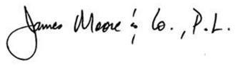

- 17 -

INDEPENDENT AUDITORS’ MANAGEMENT LETTER REQUIRED
BY CHAPTER 10.550, RULES OF THE STATE OF FLORIDA
OFFICE OF THE AUDITOR GENERAL
To the Governing Board,
Titusville Community Redevelopment Agency:
Report on the Financial Statements
We have audited the basic financial statements of the Titusville Community Redevelopment Agency (the CRA), as of and for the fiscal year ended September 30, 2024, and have issued our report thereon dated March 19, 2025.
Auditors’ Responsibility
We conducted our audit in accordance with auditing standards generally accepted in the United States of America; the standards applicable to financial audits contained in Government Auditing Standards, issued by the Comptroller General of the United States; and Chapter 10.550, Rules of the Florida Auditor General.
Other Reporting Requirements
We have issued our Independent Auditors’ Report on Internal Control over Financial Reporting and Compliance and Other Matters Based on an Audit of Financial Statements Performed in Accordance with Government Auditing Standards; and Independent Accountants’ Report on an examination conducted in accordance with AICPA Professional Standards, AT-C Section 315, regarding compliance requirements in accordance with Chapter 10.550, Rules of the Auditor General. Disclosures in those reports, which are dated March 19, 2025, should be considered in conjunction with this management letter.
Prior Audit Findings
Section 10.554(1)(i)1., Rules of the Auditor General, requires that we determine whether or not corrective actions have been taken to address findings and recommendations made in the preceding annual financial audit report. No findings were noted in the preceding financial audit report or second preceding financial audit report.
Official Title and Legal Authority
Section 10.554(1)(i)4., Rules of the Auditor General, requires that the name or official title and legal authority for the primary government and each component unit of the reporting entity be disclosed in this management letter, unless disclosed in the notes to the financial statements. The legal authority for the CRA is disclosed in Note 1 of the basic financial statements.

- 18 -

Financial Condition and Management
Sections 10.554(1)(i)5.a. and 10.556(7), Rules of the Auditor General, require us to apply appropriate procedures and communicate the results of our determination as to whether or not the CRA has met one or more of the conditions described in Section 218.503(1), Florida Statutes, and to identify the specific conditions met. In connection with our audit, we determined that the CRA, did not meet any of the conditions described in Section 218.503(1), Florida Statutes.
Pursuant to Sections 10.554(1)(i)5.b. and 10.556(8), Rules of the Auditor General, we applied financial condition assessment procedures for the CRA. It is management’s responsibility to monitor the CRA’s financial condition, and our financial condition assessment was based in part on representations made by management and the review of financial information provided by same.
Section 10.554(1)(i)2., Rules of the Auditor General, requires that we communicate any recommendations to improve financial management. In connection with our audit, we did not have such recommendations.
Property Assessed Clean Energy (PACE) Programs
The following items have been provided to us to comply with state reporting requirements and have not been audited by us. We did not audit the following information within this section, nor were we required to perform any procedures to verify the accuracy or the completeness of the information provided by management. We do not express an opinion, a conclusion, nor provide any form of assurance on this data.
As required by Section 10.554(1)(i)6.a., Rules of the Auditor General, the District did not have a property assessed clean energy (PACE) program that finances qualifying improvements authorized pursuant to Section 163.081 or Section 163.082, Florida Statutes, operated within the District’s geographical boundaries during the fiscal year under audit.
Special District Component Units
Section 10.554(1)(i)5.c., Rules of the Auditor General, requires, if appropriate, that we communicate the failure of a special district that is a component unit of a county, municipality, or special district, to provide the financial information necessary for proper reporting of the component unit within the audited financial statements of the county, municipality, or special district in accordance with Section 218.39(3)(b), Florida Statutes. In connection with our audit, we did not note any special district component units that failed to provide the necessary information for proper reporting in accordance with Section 218.39(3)(b), Florida Statutes. In connection with our audit, we did not note any special district component units; therefore, we did not note any such component units that failed to provide the necessary information, nor is any specific special district information required to be reported.
Specific Special District Information – Titusville Community Redevelopment Agency
The required reporting items in accordance with Section 218.39(3)(c), Florida Statutes for the CRA have been reported in the separately-issued audited financial statements of the CRA.
The following items have been provided to us to comply with state reporting requirements and have not been audited by us. We did not audit the following information within this section, nor were we required to perform any procedures to verify the accuracy or the completeness of the information provided by management. We do not express an opinion, a conclusion, nor provide any form of assurance on this data.

- 19 -

As required by Section 218.39(3)(c), Florida Statutes, and Section 10.554(1)(i)6, Rules of the Auditor General, the CRA reported the following unaudited data:
a) The total number of district employees compensated in the last pay period of the district’s fiscal year: 3 (City employees dedicated to CRA functions).
b) The total number of independent contractors to whom nonemployee compensation was paid in the last month of the district’s fiscal year: -0-.
c) All compensation earned by or awarded to employees, whether paid or accrued, regardless of contingency: $117,995 paid to City to reimburse for City employee services provided.
d) All compensation earned by or awarded to nonemployee independent contractors, whether paid or accrued, regardless of contingency: $-0-.
e) Each construction project with a total cost of at least $65,000 approved by the district that is scheduled to begin on or after October 1 of the fiscal year being reported, together with the total expenditures for such project as:
- Sidewalk Infill $66,541
- Utilities Infrastructure - Slip Lining $137,018
- Spaceview Park Pier $1,027,957
f) A budget variance based on the budget adopted under Section 189.016(4), Florida Statutes, before the beginning of the fiscal year being reported if the district amends a final adopted budget under Section 189.016(6), Florida Statutes, as follows: the district’s original budget totaled $1,096,547 and was amended by the total amount of $1,570,369 for final budgeted expenditures of $2,666,916.
Additional Matters
Section 10.554(1)(i)3., Rules of the Auditor General, requires us to communicate noncompliance with provisions of contracts or grant agreements, or abuse, that have occurred, or are likely to have occurred, that have an effect on the financial statements that is less than material but warrants the attention of those charged with governance. In connection with our audit, we did not have any such findings.
Purpose of this Letter
Our management letter is intended solely for the information and use of the Legislative Auditing Committee, members of the Florida Senate and Florida House of Representatives, the Florida Auditor General, Federal and other granting agencies, the CRA’s governing board and applicable management, and is not intended to be and should not be used by anyone other than these specified parties.
Daytona Beach, Florida  March 19, 2025 | 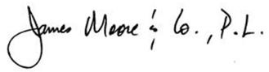

- 20 -

INDEPENDENT ACCOUNTANTS’ EXAMINATION REPORT
To the Governing Board,
Titusville Community Redevelopment Agency:
We have examined the Titusville Community Redevelopment Agency’s (the CRA) compliance with Section 218.415, Florida Statutes, Local Government Investment Policies, and Sections 163.387(6) and (7), Florida Statutes, Redevelopment Trust Fund (collectively, the “Statutes”), for the year ended September 30, 2024. Management is responsible for the CRA’s compliance with those requirements. Our responsibility is to obtain reasonable assurance by evaluation the CRA’s policies against the statutes, to determine the CRA’s compliance and performing other procedures to obtain sufficient appropriate audit evidence to express an opinion that conveys the results of our evaluation based on our examination.
Our examination was conducted in accordance with attestation standards for a direct examination established by the American Institute of Certified Public Accountants. Those standards require that we obtain reasonable assurance by evaluating the CRA’s policies against the Statutes, and performing procedures to obtain sufficient appropriate evidence to express an opinion that conveys the result of our measurement or evaluation of the CRA’s compliance for the year ended September 30, 2024. The nature, timing, and extent of the procedures selected depend on our judgment, including an assessment of risks of material noncompliance with those requirements, whether due to fraud or error. We believe that the evidence we obtained is sufficient and appropriate to provide a reasonable basis for our opinion.
We are required to be independent of the CRA, and to meet our other ethical responsibilities, in accordance with relevant ethical requirements relating to our examination engagement.
In our opinion, the CRA complied with the aforementioned requirements for the year ended September 30, 2024, in all material respects.

Daytona Beach, Florida  March 19, 2025 | 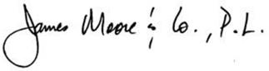

- 21 -

