City of Titusville
Community Redevelopment Agency

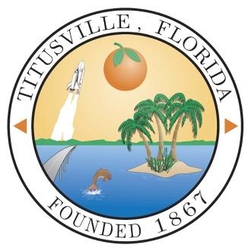

Annual Report
FY 2022 - 2023

Prepared by
City of Titusville
Community Development
& Finance Departments

Downtown Community Redevelopment Agency

CRA Board Members:

Daniel Diesel, Chairperson
Joe Robinson, Vice Chairperson
Greg Aker
Jim Ball
Herman Cole
Jo Lynn Nelson
Sarah Stoeckel

CRA Staff:

Scott Larese, Executive Director, Community Redevelopment Agency
Richard Broome, City Attorney
Kevin Cook, P.E., Public Works Director
Teri Butler, Finance Director
Jenna Ryan, Finance Manager
Wanda Wells, City Clerk
Brad Parrish, Community Development Department Director

Introduction

The City of Titusville’s Community Redevelopment Agency (CRA) was created by the State of Florida in 1982, and the Community Redevelopment Plan was adopted in 1984. Since its creation, the Titusville Community Redevelopment Agency has played an integral role in the revitalization of the Downtown area and the surrounding community. The Downtown area has faced many challenges similar to those in other areas of Florida and the nation. The vision of Titusville’s Downtown was established by residents who attended workshops in the 1980’s, 1990’s, 2000’s, and as recently as FY 2022 and determined a set of goals and priorities that have evolved over the years. The original vision of the Redevelopment Plan still stands as a foundation for redevelopment in the Downtown and surrounding neighborhoods.

In an effort to provide residents and visitors with a memorable experience, the City envisions the addition of new mixed-use buildings on infill lots, renovated historic buildings, new open space amenities, enhanced streetscape conditions, new public facilities such as water and sewer infrastructure, and low impact development (LID) techniques for storm water. Development standards will be aimed at increasing the area’s capacity to accommodate new growth while preserving the historic character of the community. By combining these features with a smarter approach to growth, the City will realize a downtown that will attract sustainable growth and create a unique sense of place in which all residents can be proud.

The Downtown CRA encompasses approximately 300 acres of land on the eastern edge of the City and is over a mile and half from its northernmost area at the municipal waterfront park and marina complex, to its southern terminus at Grace Street. The CRA includes the Historic Downtown, or core area and a number of small neighborhoods. The CRA is bounded by the Indian River waterfront on the east and north and by the Florida East Coast Railroad tracks on the west. The CRA parallels the Indian River and includes over 1.9 miles of waterfront as shown on the following map.

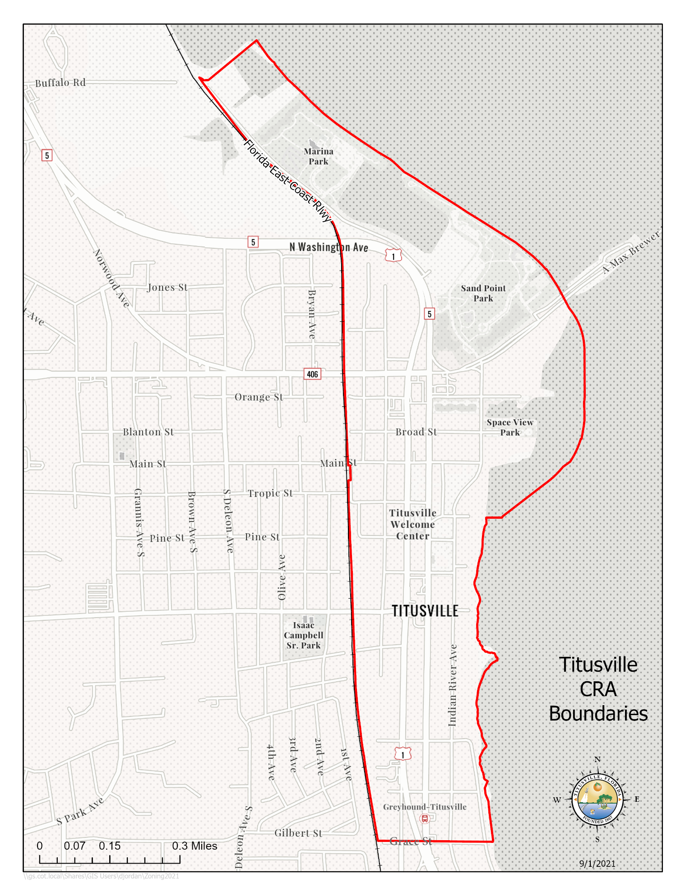
Assessed Real Property Values & Tax Increment Fund Revenue History

The original base year real property value for the Titusville Downtown CRA in 1982 was $20,495,020. The Titusville Downtown CRA assessed property value in the reporting year of FY 2023 was $127,240,155, which is an increase of $10,821,218 in value from the FY 2022 assessed property value.

A history of the Titusville CRA Tax Increment Revenue per year from FY2005–2006 is found in Table-1 below. Prior to FY 2005–2006 the Downtown CRA had a steady but low tax increment since its inception in 1982. Since FY 2009, the CRA’s tax increment revenue has been more volatile due to the impacts of both new development and economic conditions.

Table 1: Tax Increment Revenues by Year (Audited)

FY 2005-2006 $ 286,787
FY 2006-2007 $ 589,533
FY 2007-2008 $ 922,899
FY 2008-2009 $ 876,391
FY 2009-2010 $ 792,703
FY 2010-2011 $ 724,997
FY 2011-2012 $ 655,653
FY 2012-2013 $ 631,488
FY 2013-2014 $ 699,901
FY 2014-2015 $ 712,212
FY 2015-2016 $ 766,683
FY 2016-2017 $ 793,838
FY 2017-2018 $ 867,986
FY 2018-2019 $ 919,020
FY 2019-2020 $ 961,910
FY 2020-2021 $ 979,345
FY 2021-2022 $ 982,381
FY 2022-2023 $ 1,046,182 check against the audit report

The Tax Increment Financing (TIF) revenues for the Downtown CRA increased substantially in the fiscal year 2006 - 2007 due to the completion of the Harbor Pointe condominium complex. The first building was added to the tax rolls in fiscal year 2006-2007. This revenue allowed the CRA to complete projects that were not possible with revenues from the previous years.

The three remaining Harbor Pointe buildings were added to the tax rolls in fiscal year 2007 - 2008. Due to the economic downturn, increased foreclosures nationwide, and the end of the NASA Space Shuttle Program, the revenue in fiscal years 2008 - 2009 to 2012-2013 decreased. The reduction in revenues during those years resulted in a greater percentage of revenues being dedicated to debt service, thereby limiting redevelopment projects that were being undertaken by the CRA during those years. After bottoming out in FY2012-2013, tax increment revenues have increased each year since to where they have surpassed the FY2007-2008 high.

In 2011, the CRA authorized issuance of a Public Improvement Revenue Note in an amount not to exceed $2,535,000 to finance roadway and landscaping improvements in conjunction with the FDOT U.S. 1 project. In February 2013, the CRA approved partial repayment of the loan for $850,000. The repayment funds were the result of lower than anticipated projects costs. The CRA’s action produced a total savings of $1.27 million. The CRA also paid off the Commons Project Bond at a cost of approximately $95,000. The loan repayments reduced the annual debt service in FY2014-2015 from 34% to 19% of the Annual Revenues, thus providing more opportunities for capital projects in the future. The percentage of annual debt service to annual tax increment values has continued to decline due to a combination of the increase in tax increment values and debt payments.

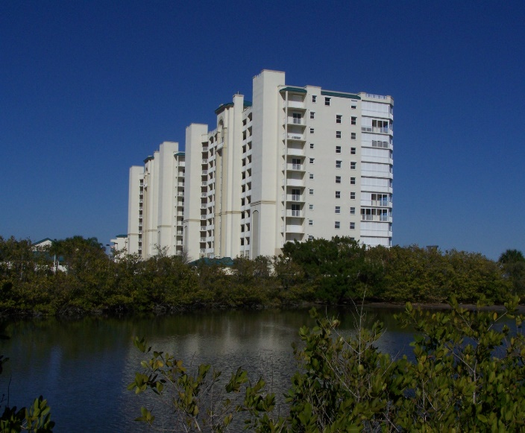
Harbor Pointe Condominiums on Indian River Avenue

Fiscal Year 2022-2023 Capital and Non-Capital Projects

The Downtown CRA has continued with existing projects during the 2022 - 2023 fiscal year as well as started new projects as shown below.

Completed Capital Projects and Their Estimated Cost:

- Commercial Interior Building Renovation, Commercial Beautification, and Permit & Fee Grant Programs (operational – see detailed grant payouts in the narrative below),
- Street Resurfacing ($61,405)

Capital Projects Started but not Completed in the Fiscal Year and Their Estimated Cost:
- Approved the award of contract for the construction of the Spaceview Park Walkway Pier ($998,656)
- Indian River Force Main Improvements upgrading and replacing 8,000 feet of sewer force main ($97,000)
- Water Resources Utilities Infrastructure ($47,000)
- Additional groundcover landscaping at US-1 intersections ($33,405)
- Sidewalk Infill ($58,000)
- Aluminum Streetlight Poles - Whiteway Lighting Project Study ($60,00)
- Tree Box Filters ($130,000)
More details about these projects follow.

Commercial Interior Building Renovation, Commercial Beautification, and Permit and Impact Fee Incentive Grant Programs
In FY 2016 – 2017 the CRA created a Commercial Interior Renovation Incentive Grant Program to assist property owners and commercial tenants of older buildings to bring their structures up to current Americans with Disabilities Act (ADA), the Florida Fire Protection Code, and the Florida Building Code standards. The Commercial Interior Building Renovation Incentive Grant Program helps to expand and improve under-used buildings to increase commercial and mixed-use intensity, bring buildings up to code, assist small businesses in the CRA to grow and prosper, and to promote job creation in the district. This grant program offers financial assistance in the form of a reimbursable, fifty present (50%) matching grant up to a maximum of $50,000 to the property owner or business owner for eligible expenses associated with the renovation and rehabilitation of the following interior elements of commercial and mixed-use building space:
- ADA requirements
- Florida Fire Protection Code requirements
- Florida Building Code requirements including:
  - Interior plumbing to meet code
  - Interior electrical system including lighting to meet code
  - HVAC system to meet code

During fiscal year 2017-2018 the CRA expanded its matching Building Grants Incentive Programs by drafting and approving a new Permit & Impact Fee Incentive Grant Program, revising the Commercial Interior Renovation Grant Program and reactivating and revising its Commercial Beautification Grant Program. The Permit & Impact Fee Program provides a maximum $50,000 matching one-to-one grant to help offset the cost of permits and impact fees for new construction in the CRA. The Commercial Interior Renovation Grant Program was revised to provide an additional $50,000 matching one-to-one grant for interior building renovations that provide residential and nonresidential mixed-use as an incentive for residential units to be added to the CRA and spur housing in the downtown. The Commercial Beautification Grant Program provides a $40,000 matching one-to-one grant for façade and exterior improvements to buildings in the CRA to improve the appearance of the CRA/downtown and to eliminate blight. The Grant Programs were further revised to provide payment of seventy-five (75%) of the grant award at project completion and the remaining twenty-five (25%) of the grant award with occupancy of the building at one (1) year after completion of the improvements as an incentive for building owners to have their buildings occupied and not sit empty. The expanded grant program became operational in FY 2019. In FY 2023, grease traps were added as an eligible expense to the Commercial Interior Renovation Grant to meet Florida Building Code requirements.

A total of one (1) CRA Building Grant was awarded in the fiscal year. One (1) Commercial Interior Renovation Grant was awarded for $18,811.50.

A total of eight (8) grant payouts were made during the fiscal year for a total of $151,980.86. The grant payouts were for seven (7) Commercial Beautification Façade Grants for $144,203.01, and one (1) Permit Impact Fee Grant for $7,777.85.

Since these are fifty (50%) matching reimbursable grants with a maximum cap, the grant program leverages more than double the grant amount of investment in the CRA. A CRA Grant Return on Investment History Report completed in FY 2019 found that for completed grant projects and for grant projects under construction the return on investment was $14.71 for every $1 of CRA grant money awarded. Considering only completed grant projects since 2008, the ROI was $3.14 for $1 of CRA grant money. The reason for the large difference between completed project and both completed and under construction is that there are two (2) major construction projects presently taking place in the CRA, the Launch Now project with an estimated cost of $5 million of construction and the Beachwave project with an estimated cost of $3 million. The Beachwave project was completed in FY 2021. The Launch Now project is now slated to be completed in FY 2024.
The return-on-investment study shows how the grant program is helping to prevent deterioration of older historic properties in the CRA; stimulate interest and investment in the District; encourage the development of business and job growth; and encourage the utilization of existing business stock and new construction in the CRA.

Photos of two (2) Beatification Grants in FY 2023:

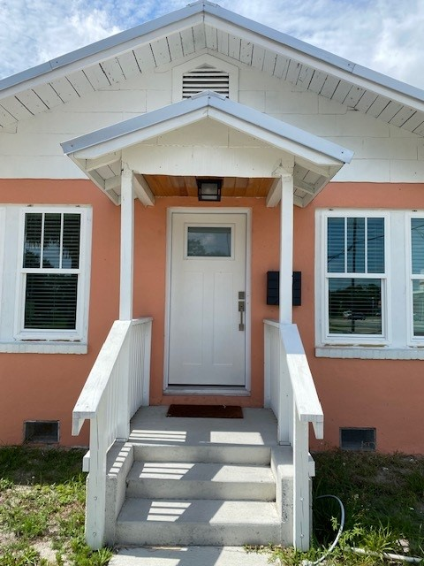
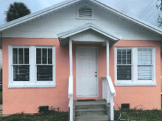

213 Broad Street Beautification Grant – Before 213 Broad Street Beautification Grant - After

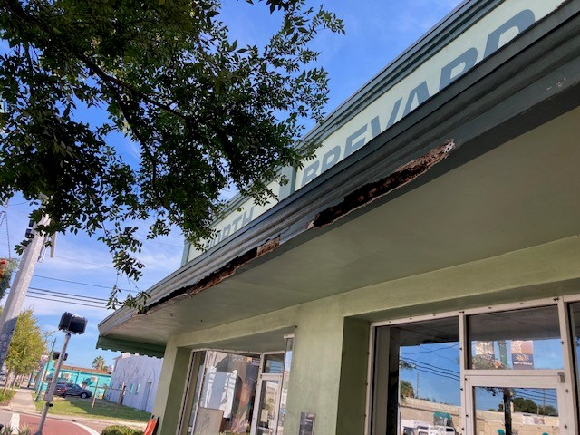
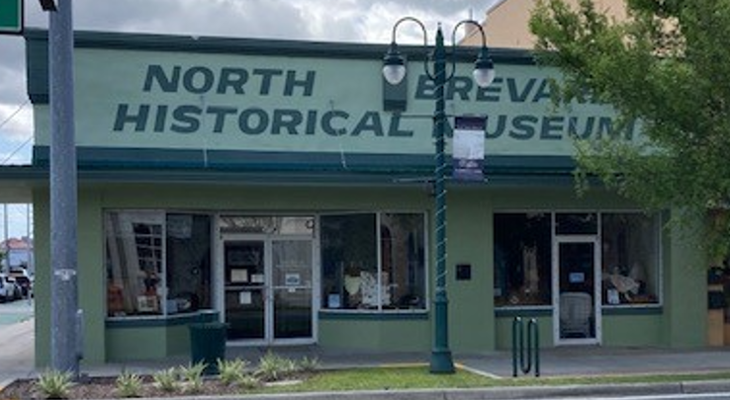

301 S Washington Beautification Grant – Before 301 S Washington Beautification Grant - After

Street Resurfacing
During the fiscal year the CRA resurfaced the following street segments located in the CRA: Julia Street between Hopkins Avenue and Palm Avenue; and Pine Street between Washington Avenue and S. Hopkins Avenue. The streets were resurfaced as part of the City’s annual street paving program to leverage costs. The CRA’s cost to resurface the streets was $61,404.

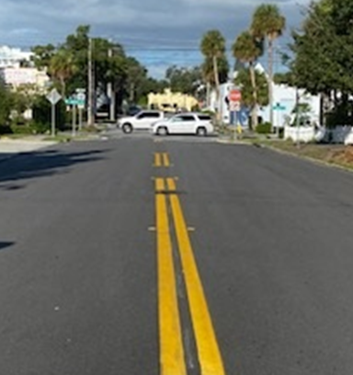
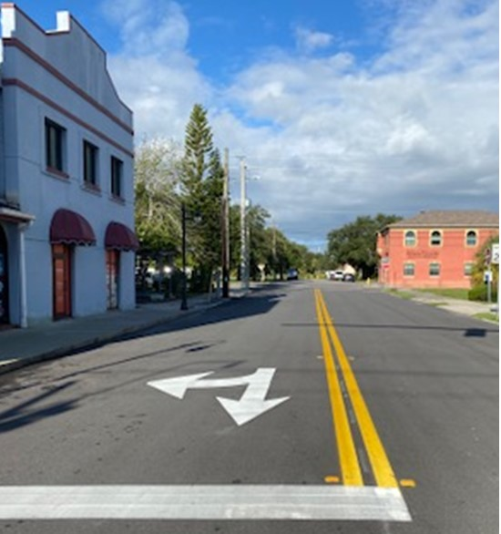

Spaceview Park Connecting Pedestrian Pier
The CRA approved a budget amendment in September 2019, to fund a feasibility study for a pedestrian pier to connect Spaceview Mercury Park to Spaceview Gemini Park. The parks are separated by an inlet that requires visitors to back track to visit both parks. The pier meets the CRA’s Plan goal of connecting the City’s parks and providing a waterfront attraction for residents and visitors to view rocket launches. In January 2020, a Request for Qualifications (RFQ) was advertised to conduct a Feasibility and Conceptual Design Study. Taylor Engineering, Jacksonville, Florida, was selected in March 2020, to do the study. A contract with Taylor Engineering was signed in July 2020. In February of 2021, Taylor Engineering presented the Feasibility Study and Conceptual Design to the CRA. Based on the presentation, the CRA recommended moving forward with a contract for a final design. In May 2021, CRA meeting the CRA and City Council approved an award of contract for Taylor Engineering to provide a final design of the Spaceview Park Connecting Pedestrian Pier at a cost of $92,833. Taylor Engineering worked on final design and bid plans during the Fiscal Year 2022. In August 2023, the contract for the Spaceview Park Connection Pedestrian Pier was awarded to Rush Marine at a cost of $998,626. Construction will begin in FY 2024.

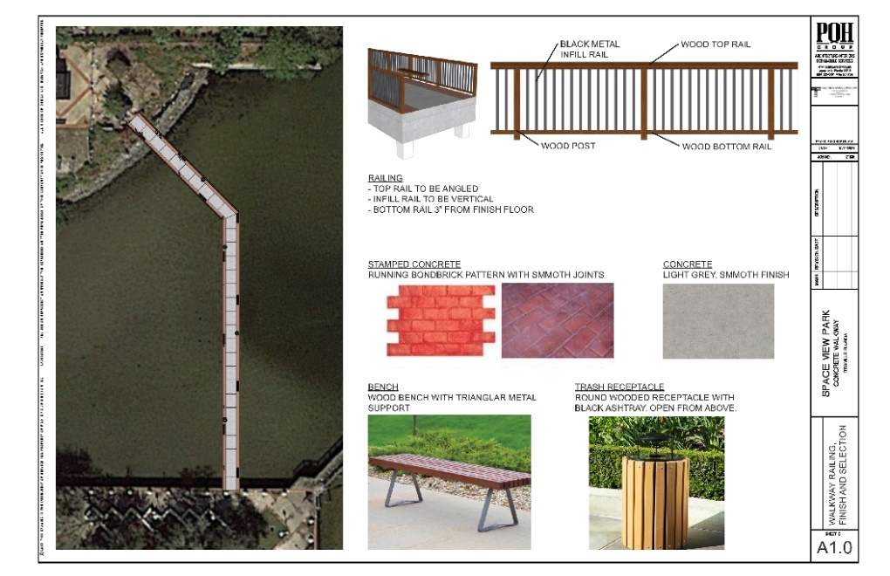

Artist computer rendition of the Connecting Pedestrian Pier

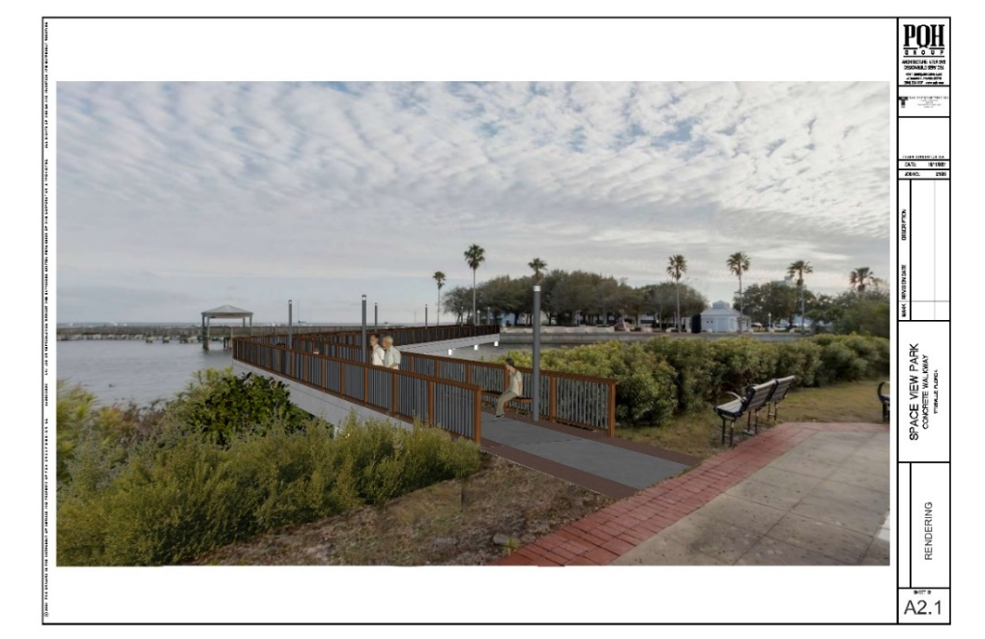
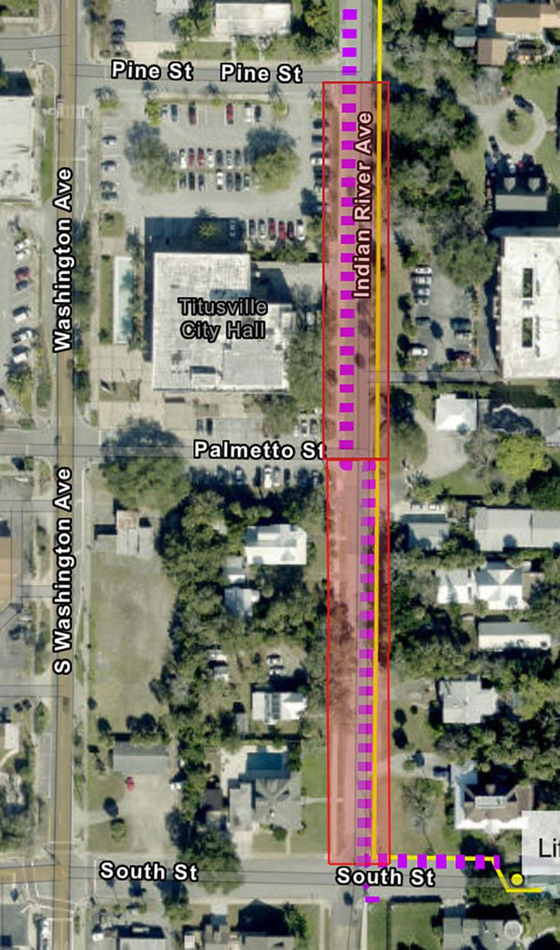
Indian River Force Main Infrastructure Improvements
Construction for the Indian River Force Main Project started August 2023. The project includes replacing a 12-inch sewer line with a new 16-inch sewer line of approximately 8,000 feet of existing sewer force main from South Street to the Osprey Water Reclamation Facility on Buffalo Road in north Titusville. The force main replacement started at the intersection of South Street and Indian River Avenue and will continue north under the Max Brewer Causeway, U S Highway 1, and even a portion of the FEC railroad, ending at the Osprey Facility. A map of the project and road closures (as they are scheduled) can be found at Indian River Ave Sewer Line Replacement (arcgis.com). Titusville’s Public Works Department is working with the contractor to minimize the effect of the closures on residents, and closures will be limited to block segments at any one time. This project is still in progress.

Additional US-1 Landscape Infill at US-1 Intersections
Additional ground landscaping was added to intersections of US-1 (S. Washington Avenue and S. Hopkins Avenue) in the CRA district based on input from citizens. This project is ongoing into FY 2024.

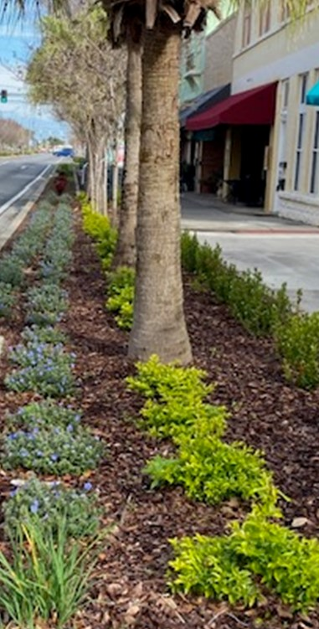
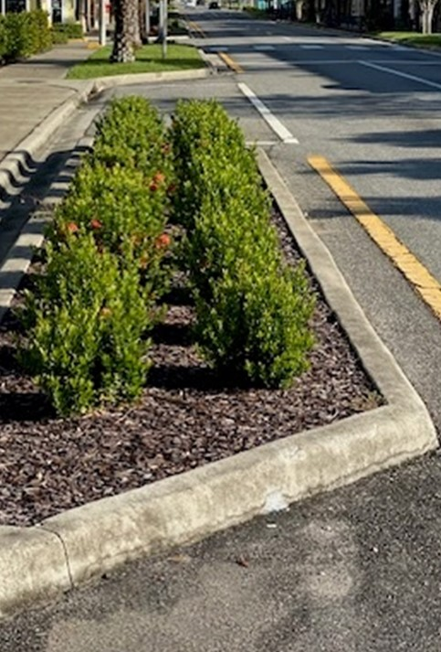

Sidewalk Infill
The CRA provided for sidewalk infill based on an Americans with Disabilities Act (ADA) study. This project is ongoing.

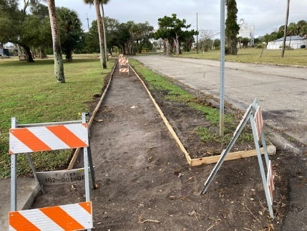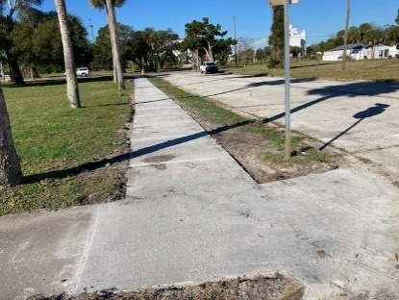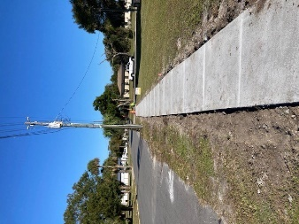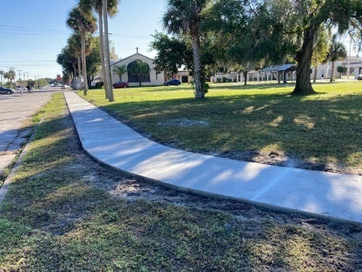

Whiteway Lighting Project
Whiteway Replacement – The CRA approved the consultant DRMP, Inc. to develop a design scope to replace aluminum highway light poles located on US-1 (Washington Avenue and Hopkins Avenue). Replacement work will begin in FY 2024.

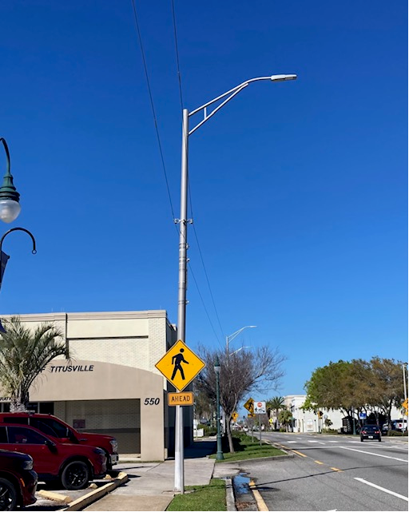
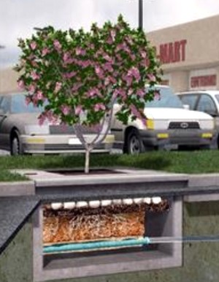
Tree Box Filters
A tree filter project is proposed in the downtown Commons Area to treat stormwater. Tree box filters are widely deployed as stormwater treatment Best Management Practices (BMPs), normally in stand-alone applications; however, they can also be used as pretreatment for infiltration, rainwater harvesting, and detention. Tree box filters are highly adaptable for most developments due to a small footprint, shallow elevation, and no driving head requirements. Where infiltration is not feasible, tree box filters are an ideal solution. Following Low Impact Development (LID) principles of decentralized design, total pollutant load into the Indian River Lagoon is minimized, enabling a sustainable system that is not compromised by high loading rates. Plant selection allows tree box filters to be seamlessly integrated into the landscape and adds aesthetic value.
CRA Community Outreach Meeting
On September 1, 2023, a CRA Community Outreach meeting was held regarding the vision and future for the Downtown and CRA area at the St. Gabriels Episcopal Church. This meeting was a positive event with approximately 63 attendees sharing ideas and concepts for proposed updates to Goals, Objectives and Policies for the Downtown in the Titusville Comprehensive Plan.
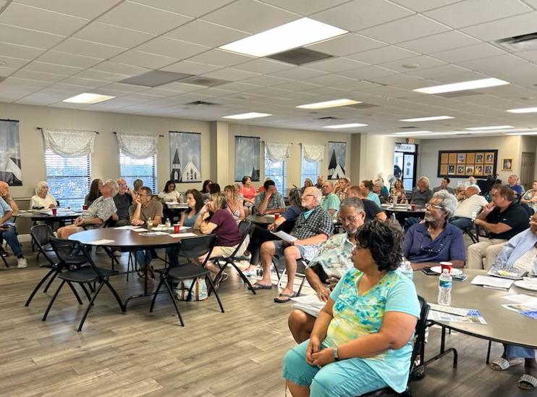

Non-Capital Projects
The Non-Capital Projects that occurred over the fiscal year are as follows:

- Streetscape Landscaping and Facilities Maintenance
- Community Policing
- Historic Preservation Activities
- Land Use Development Review Activities
- Redevelopment Plan Update ($68,232)
- Installation of continuous pedestrian and bicycle counter on Indian River Avenue
- CRA Community Outreach Meetings

Streetscape Landscaping and Facilities Maintenance
The CRA continued its funding of the general maintenance of the plantings, lighting and street furniture funded by the CRA along the US-1 corridor (Washington Avenue & Hopkins Avenue) and in the Titusville Downtown Commons area. The maintenance provided by the CRA along the US-1 corridor is at a higher level of maintenance than provided by the Florida Department of Transportation and helps to protect the CRA’s investment. Maintenance in FY 2022 – FY 2023 included the pressure washing of the following sidewalks in the CRA: S. Washington Avenue from Palmetto Street to Main Street, Stephen House Way, Mariners Way, and the Julia and Nevins Court Yards. The CRA also continues to fund the cost of irrigation and utilities along US 1 and a full-time maintenance worker.

Community Policing
In June 2014, the CRA initiated a Community Policing program. The program consists of law enforcement officers deployed on an overtime basis during varying days and times. Increased activities in the CRA District include business contacts, directed patrols, traffic details, community relations, neighborhood patrols and anti-burglary details. This is thought to be a more cost-effective method to provide coverage as needed, rather than one full-time officer who would have less flexibility to address issues as they arise.

Program accomplishments for the fiscal year are listed below. As the community policing initiative augments the Titusville Police Department’s regular presence in the CRA, only those activities conducted during the community policing details are provided.

CRA Police Details totaled 484 hours for the fiscal year 22/23.
Property Checks | 4,869
Traffic Stops | 1,205
Suspicious Persons/Vehicles/Incidents & Unwanted/Trespass | 988

CRA Police Details totaled 750 hours for the fiscal year 21/22.
Property Checks | 3,400
Traffic Stops | 1,490
Suspicious Persons/Vehicles/Incidents & Unwanted/Trespass | 818

Total incident statistics in the redevelopment district for the fiscal year not part of the CRA Police details were as follows:
 | FY 2023 | FY 2022 | FY 2021 | FY 2020 | FY 2019
Vehicle Burglaries | 9 | 11 | 18 | 16 | 41
Residential Burglaries | 2 | 4 | 0 | 2 | 2
Commercial Burglaries | 8 | 4 | 0 | 10 | 11

 | FY 2023 | FY 2022 | FY 2021 | FY 2020 | FY 2019
Traffic Stops | 1,205 | 1,157 | 1,269 | 1,140 | 748
Traffic Accidents without injury | 120 | 137 | 138 | 122 | 165
Traffic Accidents with injury | 38 | 43 | 52 | 54 | 29

Burglary Comparison between the CRA and Citywide:
 | FY 2023 | FY 2022 | FY 2021 | FY 2020
CRA District | 19 | 18 | 28 | 28
City Wide | 368 | 326 | 402 | 555

Calls for Service between the CRA and Citywide:
 | FY 2023 | FY 2022 | FY 2021
CRA District | 9,965 | 7,934 | 8,683
City Wide | 109,402 | 95,623 | 114,392

The incident statistics show that the Community Policing details had a continued emphasis on reducing vehicle burglaries, residential burglaries and enforcing traffic laws during the fiscal year. The statistics show a positive trend in the reduction of crime in the CRA.

Historic Preservation Activities

The CRA District is home to many of the City’s historic resources. The preservation of these historic resources in the Community Redevelopment District adds to the City’s pride and creates pedestrian and visitor appeal, which provides economic development for the City. Historic Preservation activities that directly involved the CRA District included the award of a State of Florida Division of Historical Resources Small Matching Grant in July 2022 in the amount of $40,000 to fund the creation of Architectural Style and Design Guidelines for use by the City Historic Preservation Board when doing design review of designated historic structures and for property owners of historic and potentially historic structures to use when making renovations to their properties.

The City’s Explore Historic Titusville booklet, mobile phone app and web site (http://history.titusville.com), which provides walking/driving tours/audio recordings of historic resources of the City from the area’s first indigenous inhabitants to the Space Program, was awarded a Florida Preservation 2022 award for Preservation Communication/Media. The majority of the historical and historic landmarks in the booklet, app and web site walking/driving tour are found in the Redevelopment District.

Land Use Development Review Activities
One of the duties of the CRA Agency is to provide input and recommendations to the City Council on land use decisions occurring in the redevelopment district. A summary of the land use activities that the CRA was involved in during FY 2022 – 2023 is as follows:
- ROW #1-2023 – A vacation of right of way was approved with conditions vacating a public right-of-way (ROW) that is located on Broad Street, west of S. Lemon Avenue and east of the FEC Railway.
- Approved the revised site plan, construction phases and parking garage structure for the Horizon at Sand Point development. 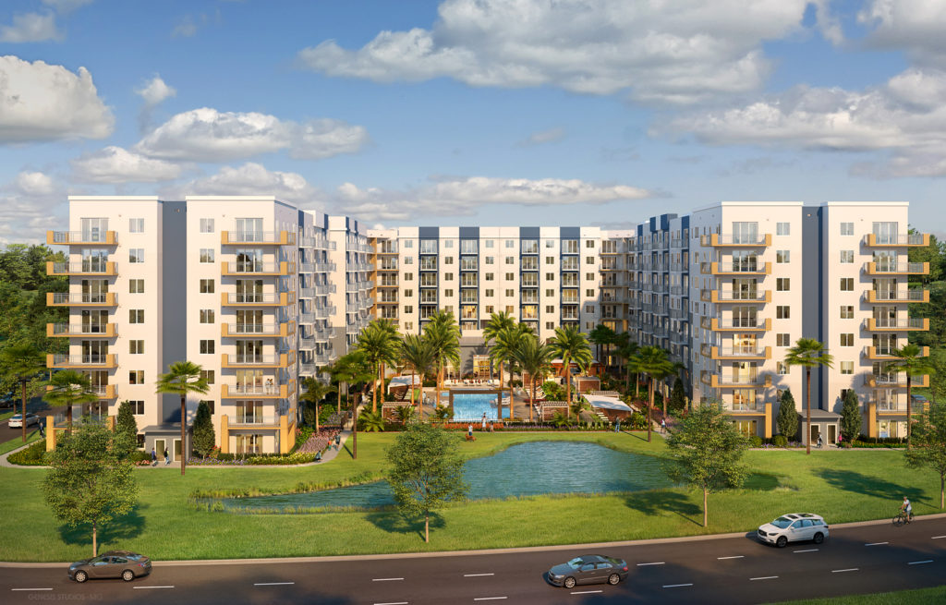
Rendering for the Proposed Horizon at Sand Point Development

Redevelopment Plan Update
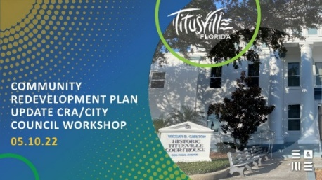
A scope from the consultant S&ME, Inc. was approved by the CRA in December of 2021 to draft a Plan Update ($34,060) and an Initiatives Plan ($34,172) to update the 2015 Redevelopment Plan Update. The 2022 Redevelopment Plan Update was drafted during the fiscal year FY 2022 and adopted in the fiscal year FY 2023.

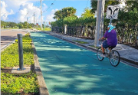
Downtown Connector Trail
Florida Department of Transportation installed a non-motorized vehicle
And Pedestrian continuous counter on the Downtown Connector Trail
on Indian River Avenue between Orange Avenue and Broad Street in September 2023. Trail counts will help the City and CRA to measure useage of the trail and help in planning efforts to maintown Titusville’s Trail Town State designation. A Trail Town is a designation along a long-distance trail that trail users can venture off the trail to enjoy the scenery, services, and heritage of the newarby community and find services they need.

New Construction & Businesses
A goal of the City’s CRA Plan is to encourage private sector investment in the CRA. New building construction and major renovation work to existing buildings helps the City in combating blight. It also encourages others to invest in the CRA. A total of approximately forty-seven (47) new Business Tax Receipts (BTR) were approved in the CRA District during the fiscal year. The following are examples of new businesses and major renovation and construction activity that has occurred in FY 2022 – 2023 in the CRA District:

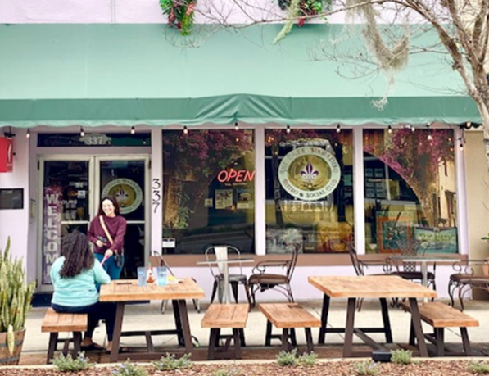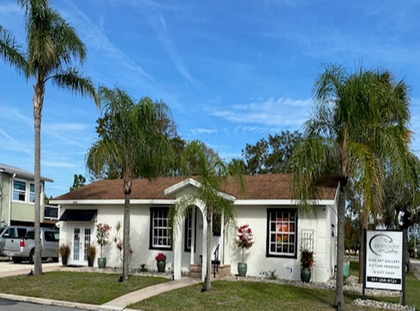
Café Paradiso Downtown Art Gallery

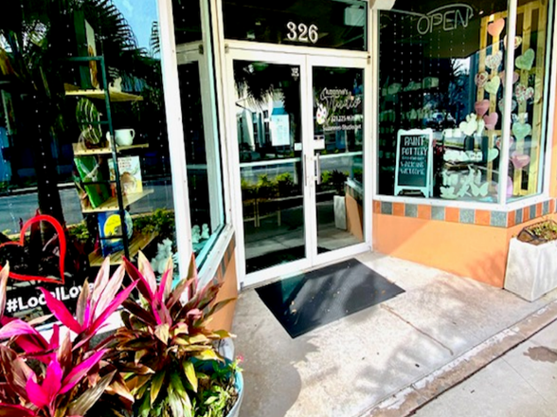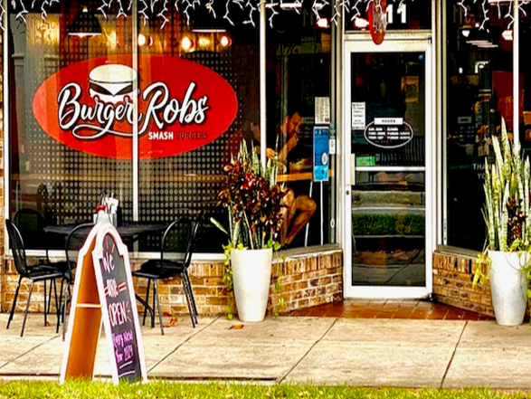
Suzanne’s Pottery Studio Burger Robs

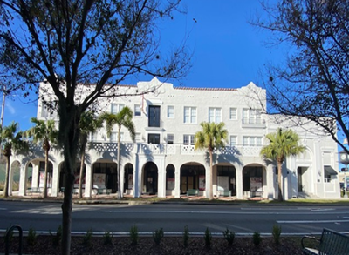
Launch Now Mixed-Use Development – almost complete
Summary of Redevelopment Plan Goals Achievement
State legislation requires a summary indicating to what extent, if any, the community redevelopment agency has achieved the goals set out in its redevelopment plan. As noted above an update to the 2015 Redevelopment Plan Update was prepared in FY 2022 and adopted in Fiscal Year 2023. A summary of the plans, goals, and achievements is as follows.

Administration of the CRA
Administration of the CRA includes effectively utilizing Tax Increment Financing (TIF) for the administration and operation of the Community Redevelopment Agency. During FY 2023, this goal has been met through the many Capital and Non-Capital Improvement Projects completed and still in
progress in addition to CRA Grants awarded for qualified commercial projects. The CRA continues collaboration with other agencies such as the North Brevard Economic Development Zone, Space Coast Transit, Titusville Area Chamber of Commerce, Florida Department of Transportation, etc. to foster redevelopment in the downtown. In FY 2023, the CRA maintained the level of staffing with the replacement of the retired CRA Planner. Training has been provided and is ongoing for the new CRA Planner by utilizing the Florida Redevelopment Association Academy and mentoring from the retired CRA Planner on a part time basis. Administration of the CRA goal includes keeping compliant with CRA legal requirements by posting the budget, advertising requirements, hosting Community Redevelopment Agency documents online for public access, internal auditing, adhering, and executing the updated adopted CRA Plan, etc. The CRA has increased the transparency of Community Redevelopment Agency operations by hosting Community Outreach workshops and visiting businesses within the CRA District.

Housing
The housing goal involves promoting, encouraging, and incentivizing residential development and occupancy within the CRA. The CRA is working to attain this goal with the Launch Now development under construction with the assistance of the CRA Grant Program. Launch Now will provide twenty (20) new boutique apartment units in a mixed-use building in the heart of the Historic Downtown. The Launch Now project with the assistance of CRA Building Program grants is slated to be completed in fiscal year 2024. A second residential development with 384 total multifamily units known as Horizon at Sand Point is in the Building Permit stage and is taking advantage of the increase in residential density and building height in the Uptown Subdistrict of the CRA. The CRA provided design approval of the Horizon development in Fiscal Year 2021. The Horizon at Sand Point developer has acquired additional adjacent property in FY 2022 and revised their site plan during Fiscal Year 2023. Construction is estimated to begin in the Fiscal Year 2024. More residential including workforce, and low & moderate housing is needed as pointed out in the City’s Strategic Economic Development Plan to make the CRA more vibrant.

Community and Culture
The Community Redevelopment Agency coordinated with the Historic Preservation Board in FY 2023 to create an Architectural Design Guidelines manual to assist in maintaining historic structures downtown. The CRA continues to encourage and support the rehabilitation and adaptive reuse of historic buildings within the Community Redevelopment Area. The CRA held on-going meetings with the Titusville Playhouse Inc regarding the theater’s expansion plans. The Titusville Playhouse has purchased property in the Julia Street – Palm Avenue area and has plans to create an entertainment Arts District in that area with plans to add a new 500 seat theater, a 150-seat black box theater, an outdoor concert and stage venue which is almost completed, and other ancillary uses including eating and drinking establishments which will add to the vibrancy of the downtown.

The CRA will need to consider additional public infrastructure to help make this area an entertainment district. The CRA has supported the arts by encouraging murals on buildings in the CRA. In addition, there has been increased tourist activity in the CRA with an increase of rocket launches at the Kennedy Space Center. Based on the increase in launches, improvements were made in Scobie Park including benches and public binoculars for viewing of nature and rocket launches by visitors and residents. The Space View Pier connecting two (2) existing parks separated by water will become a waterfront destination for residents and visitors wanting to view rocket launches and take in the scenic view of the Indian River Lagoon. The Community Redevelopment Agency held a well-attended community outreach workshop to engage the community and business owners to discuss the future of the downtown area and proposed projects, as well as visiting the downtown businesses.

Economic Development
The CRA has worked in coordination with the City of Titusville’s Economic Development Department, the Titusville Area Chamber of Commerce, and the North Brevard Economic Development Zone, to recruit and retain businesses and encourage private-sector investment in the CRA. The CRA has supported efforts of adaptive reuse and repurposing of underused commercial, historic, and public-owned structures into more intense uses. The goal of the CRA’s Commercial Beautification & Structural Rehabilitation Grant Program is to provide incentives to existing and new property owners to upgrade the exteriors for aesthetics, interiors to meet code requirements, and to incentivize new construction that will ultimately lead to higher occupancy rates, increased property values and is an economic development tool that has proven to be successful. The Community Redevelopment Agency has continued to educate the public about the Community Redevelopment Agency’s business support offerings to build awareness of the business environment and programming available within the CRA by hosting community outreach meetings.
The CRA District is home to many of the City’s historic resources. The preservation of these historic resources in the Community Redevelopment District adds to the City’s pride and created pedestrian and visitor appeal, which provided economic development for the City. The City’s Explore Historic Titusville booklet, mobile phone app and web site (http://history.titusville.com) provides walking/driving tours/audio recordings of historic resources of the City from the area’s first indigenous inhabitants to the Space Program. The booklet and walking/driving tours help to identify the City’s historic resources and will help to provide economic development with visitors touring the city’s historic landmarks and visiting city businesses while touring the City. The majority of the historical and historic landmarks in the booklet, app and web site walking/driving tour are found in the Redevelopment District.
Florida visitors spend billions visiting historic sites (Economic Impacts of Historic Preservation in Florida update 2010, Center for Governmental Responsibility, University of Florida Levin College of Law, page 7). The CRA has continued updating the City of Titusville Welcome Center graphics for visitors and updating the downtown business directory kiosks. Street banners attached to pedestrian light poles in the CRA have included downtown activities such as music, dining, history, culture, and the environment. The installation of banners on a seasonal and on a replacement basis due to weathering and age will be a continuing activity that adds to the vibrancy of the City.
Public Spaces
The Community Redevelopment Agency continues to create safe and accessible public spaces within the CRA. With the completion of Scobie Park improvements with benches and public binoculars for viewing of nature and rocket launches, residents and visitors have places to enjoy being in the gateway to nature and space. The Space View Pier connecting two (2) existing parks separated by water will become a waterfront destination for residents and visitors wanting to view rocket launches and take in the scenic view of the Indian River Lagoon. A 960 square foot Native Vegetation Buffer Zone has been created and Sand Point Park is located in the CRA District. Other Park improvements have included a splash pad, BMX bicycle track, skateboard facility, etc. over the years. In Fiscal Year 2022 in partnership with the North Brevard County Parks and Recreation staff, the CRA installed twelve (12) park benches in Sand Park and two (2) shade structures at the dog park in Marina Park. Long range plans call for a waterfront trail to connect recreational sites to the downtown and to areas to the south. The CRA worked with the Florida Department of Transportation to install a non-motorized vehicle and Pedestrian continuous counter on the Downtown Connector Trail on Indian River Avenue between Orange Avenue and Broad Street located in the CRA in September 2023.

Infrastructure
During the fiscal year the CRA resurfaced the following street segments located in the CRA: Julia Street between Hopkins Avenue and Palm Avenue; and Pine Street between Washington Avenue and S. Hopkins Avenue. The streets were resurfaced as part of the City’s annual street paving program to leverage costs. Construction for the Indian River Force Main Project started August 2023. The project includes replacing a 12-inch sewer line with a new 16-inch sewer line of approximately 8,000 feet of existing sewer force main from South Street to the Osprey Water Reclamation Facility on Buffalo Road in north Titusville. The force main replacement started at the intersection of South Street and Indian River Avenue and will continue north under the Max Brewer Causeway, U S Highway 1, and even a portion of the FEC railroad, ending at the Osprey Facility. The CRA approved the engineering firm for Project Manager and approved the award of contract for the construction of the Space View Park Pier in Fiscal Year 2023. The Space View Pier will connect two (2) existing parks separated by water and will become a waterfront destination for residents and visitors wanting to view rocket launches and take in the scenic view of the Indian River Lagoon. The Community Redevelopment Agency continued in 2023 to partner with the City of Titusville Public Works and Water Resources to upgrade critical areas to protect the Indian River Lagoon utilizing proposed tree box filters, baffle boxes, slip lining sewer and stormwater lines, and native vegetation. Streetscaping of side streets will become a major goal of the new Plan that was adopted in FY 2023.

Public Health & Safety
Community Policing is an ongoing endeavor in the CRA. Special details to combat homeless and panhandling issues, traffic issues like speeding on S. Washington Avenue and S. Hopkins Avenue, burglaries, prostitution solicitation issues, etc. will be needed to continue to make the CRA a safe place to live, work, visit, invest, and play. Cameras were installed in FY 2022 in three (3) strategic areas of the CRA as a pilot project will help the Police Department in solving traffic incidents and crimes, and thus help in reducing criminal activities. Future expansion of the cameras in the CRA is being studied. The Police Department has also used mail-outs and banner signs to promote various crime prevention campaigns such as “Lock It or Lose It”, “Click It or Ticket”, and variable message board signs to promote traffic safety in the redevelopment district. In Fiscal Year 2023 the Police Department implemented the Business Trespass Program which authorizes Titusville police officers to advise any person to leave the business premises if the business has registered for this voluntary program. In FY 2023, it has been determined that calls for service in reference to unwanted persons on registered properties decreased by 30%.

Regulatory Environment
In Fiscal Year 2023 the Community Redevelopment Agency has worked on a Comprehensive Plan update to help with redevelopment in the CRA by counting density by redevelopment district area and not per property, known as the Downtown Density Pool. The proposed Downtown Density Pool is an incentive for increased housing and development in the CRA. The Community Redevelopment Agency continues to encourage and incentive Low Impact Development (LID). LID is a comprehensive land planning and engineering design approach that reduces runoff and utilizes infiltration techniques before the runoff reaches the stormwater facility and protecting the Indian River Lagoon.

Financial Audit Information

The financial information for the Titusville CRA on the following pages is as reported by the independent auditing firm of James Moore & Company, 121 Executive Circle, Daytona Beach, Florida, 32114. The data was taken from the City of Titusville’s Comprehensive Annual Financial Report, Fiscal Year ended September 30, 2023. The financial statement provides information on the Agency’s assets, liabilities, income, and operating expenses as of the end of fiscal year 2022 – 2023 in accordance with Chapter 163, Part III, Florida Statutes. Total expenditures from the Redevelopment Trust Fund in the fiscal year were $1,336,082. Check with audit.

An audit report of the CRA’s FY2022 - 2023 expenditures by the James Moore & Company is also included in this financial section of the Annual Report.

The total amount of funds expended for affordable housing for low income and middle-income persons and families was zero (0) in the CRA. It should be noted that the CRA adopted a new Redevelopment Plan in October 2022 which provides for new CRA Housing Policies regarding providing for low and moderate and workforce housing in the CRA district. The CRA currently has a grant incentive for interior improvements such as ADA, Plumbing, Electrical, and HVAC to existing buildings to be brought up to code for mixed use buildings and or the conversion of commercial buildings to mixed use that can be used to help provide for low and moderate and workforce housing units. The Building Permit and Impact Fee Grant program can also be utilized to assist in the development of new low- and moderate-income housing in the redevelopment district. The CRA can also provide incentives such as tax increment reimbursement to potential low and moderate housing projects in the CRA district on a case-by-case basis. The City is also proposing change to its Comprehensive Plan and zoning in the CRA to regulate density on an area wide basis instead of a per parcel basis. This change will help to incentivize the development of multiple family dwellings in the CRA District.

