City of Titusville
Community Redevelopment Agency

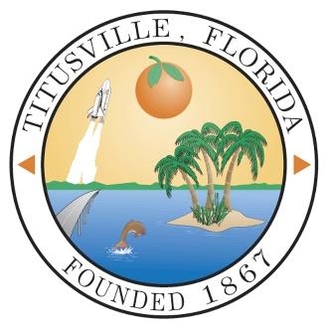

Annual Report
FY 2021 - 2022

Prepared by
City of Titusville
Community Development
& Finance Departments

Downtown Community Redevelopment Agency

CRA Board Members:

Daniel Diesel, Chairperson
Joe Robinson, Vice Chairperson
Greg Aker
Jim Ball
Herman Cole
Jo Lynn Nelson
Sarah Stoeckel

CRA Staff:

Scott Larese, Executive Director, Community Redevelopment Agency
Richard Broome, City Attorney
Kevin Cook, P.E., Public Works Director
Teri Butler, Finance Director
Jenna Ryan, Finance Manager
Wanda Wells, City Clerk
Brad Parrish, Community Development Department Director

Introduction

The City of Titusville’s Community Redevelopment Agency (CRA) was created by the State of Florida in 1982, and the Community Redevelopment Plan was adopted in 1984. Since its creation, the Titusville Community Redevelopment Agency has played an integral role in the revitalization of the Downtown area and the surrounding community. The Downtown area has faced many challenges similar to those in other areas of Florida and the nation. The vision of Titusville’s Downtown was established by residents who attended workshops in the 1980’s, 1990’s, 2000’s, and as recently as FY 2022 and determined a set of goals and priorities that have evolved over the years. The original vision of the Redevelopment Plan still stands as a foundation for redevelopment in the Downtown and surrounding neighborhoods.

In an effort to provide residents and visitors with a memorable experience, the City envisions the addition of new mixed-use buildings on infill lots, renovated historic buildings, new open space amenities, enhanced streetscape conditions, new public facilities such as water and sewer infrastructure, and low impact development (LID) techniques for storm water. Development standards will be aimed at increasing the area’s capacity to accommodate new growth while preserving the historic character of the community. By combining these features with a smarter approach to growth, the City will realize a downtown that will attract sustainable growth and create a unique sense of place in which all residents can be proud.

The Downtown CRA encompasses approximately 300 (299.42) acres of land on the eastern edge of the City and is over a mile and half from its northernmost area at the municipal waterfront park and marina complex, to its southern terminus at Grace Street. The CRA includes the Historic Downtown, or core area and a number of small neighborhoods. The CRA is bounded by the Indian River waterfront on the east and north and by the Florida East Coast Railroad tracks on the west. The CRA parallels the Indian River and includes over 1.9 miles of waterfront as shown on the following map.

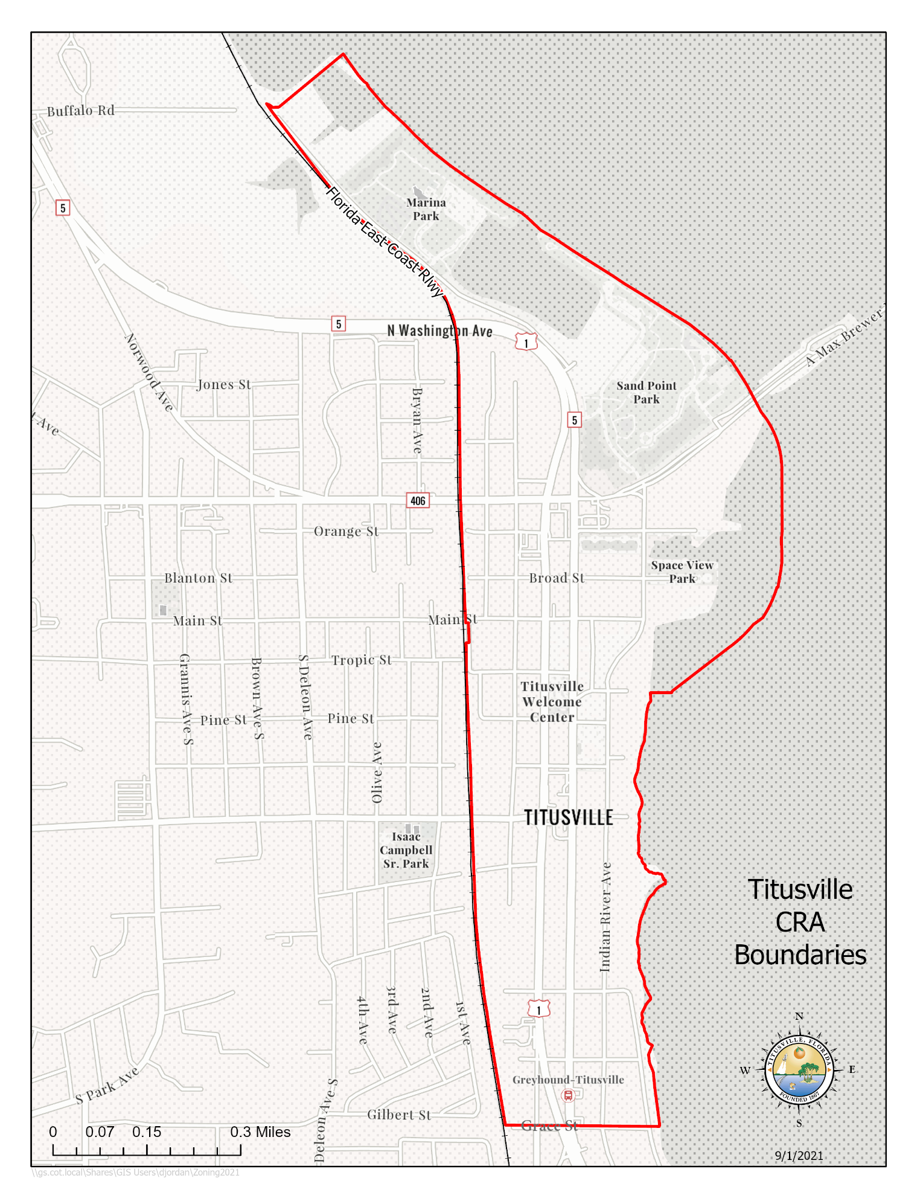
Assessed Real Property Values & Tax Increment Fund Revenue History

The original base year real property value for the Titusville Downtown CRA in 1982 was $20,495,020. The Titusville Downtown CRA assessed property value in the reporting year of FY 2022 was $116,418,937, which is an increase of $10,821,218 in value from the FY 2021 assessed property value.

A history of the Titusville CRA Tax Increment Revenue per year since FY2005–2006 is found in Table-1 below. Prior to FY 2005–2006 the Downtown CRA had a steady but low tax increment since its inception in 1982. Since FY 2009, the CRA’s tax increment revenue has been more volatile due to the impacts of both new development and economic conditions.

Table 1: Tax Increment Revenues by Year (Audited)

FY 2005-2006 $ 286,787
FY 2006-2007 $ 589,533
FY 2007-2008 $ 922,899
FY 2008-2009 $ 876,391
FY 2009-2010 $ 792,703
FY 2010-2011 $ 724,997
FY 2011-2012 $ 655,653
FY 2012-2013 $ 631,488
FY 2013-2014 $ 699,901
FY 2014-2015 $ 712,212
FY 2015-2016 $ 766,683
FY 2016-2017 $ 793,838
FY 2017-2018 $ 867,986
FY 2018-2019 $ 919,020
FY 2019-2020 $ 961,910
FY 2020-2021 $ 979,345
FY 2021-2022 $ 982,381

The Tax Increment Financing (TIF) revenues for the Downtown CRA increased substantially in fiscal year 2006 - 2007 due to the completion of the Harbor Pointe condominium complex. The first building was added to the tax rolls in fiscal year 2006-2007. This revenue allowed the CRA to complete projects that were not possible with revenues from the previous years.

The three remaining Harbor Pointe buildings were added to the tax rolls in fiscal year 2007 - 2008. Due to the economic downturn, increased foreclosures nationwide, and the end of the NASA Space Shuttle Program, the revenue in fiscal years 2008 - 2009 to 2012-2013 decreased. The reduction in revenues during those years resulted in a greater percentage of revenues being dedicated to debt service, thereby limiting redevelopment projects that were being undertaken by the CRA during those years. After bottoming out in FY2012-2013, tax increment revenues have increased each year since to where they have surpassed the FY2007-2008 high.

In 2011, the CRA authorized issuance of a Public Improvement Revenue Note in an amount not to exceed $2,535,000 to finance roadway and landscaping improvements in conjunction with the FDOT U.S. 1 project. In February 2013, the CRA approved partial repayment of the loan for $850,000. The repayment funds were the result of lower than anticipated projects costs. The CRA’s action produced a total savings of $1.27 million. The CRA also paid off the Commons Project Bond at a cost of approximately $95,000. The loan repayments reduced the annual debt service in FY2014-2015 from 34% to 19% of the Annual Revenues, thus providing more opportunities for capital projects in the future. The percentage of annual debt service to annual tax increment values has continued to decline due to a combination of the increase in tax increment values and debt payments.

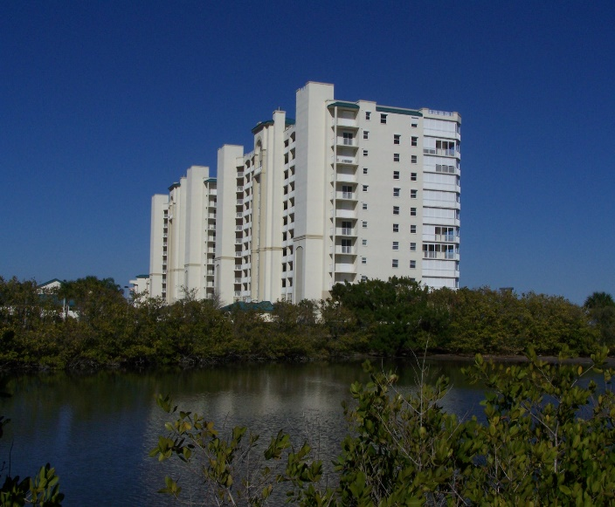
Harbor Pointe Condominiums on Indian River Avenue

Fiscal Year 2021-2022 Capital and Non-Capital Projects

The Downtown CRA has continued with existing projects during the 2021 - 2022 fiscal year as well as started new projects as shown below.

Completed Capital Projects and Their Estimated Cost:
- Commercial Interior Building Renovation, Commercial Beautification, and Permit & Fee Grant Programs (operational – see detailed grant payouts in the narrative below),
- Stormwater Cured In-place Pipe Lining ($130,000)
- Sidewalk Infill ($58,000)
- Julia Street Light Improvements ($60,253)
- Street Resurfacing ($181,385)
- Bicycle Repair Station at Sand Point Park ($1,638.35)
- Twelve (12) six (6) foot aluminum park benches at Sand Point Park ($4,750)
- Two (2) thirty (30) feet by twenty (20) feet cantilevered shade structures at Marina Park ($65,111)
- Three (3) Gridsmart Detection Cameras for Main Street – US-1 intersections ($43,425)
- Light Pole Banners Replaced ($4,004.96)

Capital Projects Started but not Completed in the Fiscal Year and Their Estimated Cost:
- Water Resources Utilities Infrastructure ($47,000)
- Additional groundcover landscaping at US-1 intersections ($33,405)
- Julia Street Resurfacing (between Palm Avenue and S. Hopkins Avenue) ($38,000)
More detail about these projects follows.

Commercial Interior Building Renovation, Commercial Beautification, and Permit and Impact Fee Incentive Grant Programs
In FY 2016 – 2017 the CRA created a Commercial Interior Renovation Incentive Grant Program to assist property owners and commercial tenants of older buildings to bring their structures up to current Americans with Disabilities Act (ADA), the Florida Fire Protection Code, and the Florida Building Code standards. The Commercial Interior Building Renovation Incentive Grant Program helps to expand and improve under-used buildings to increase commercial and mixed use intensity, bring buildings up to code, assist small businesses in the CRA to grow and prosper, and to promote job creation in the district. This grant program offers financial assistance in the form of a reimbursable, fifty present (50%) matching grant up to a maximum of $50,000 to the property owner or business owner for eligible expenses associated with the renovation and rehabilitation of the following interior elements of commercial and mixed use building space:
- ADA requirements
- Florida Fire Protection Code requirements
- Florida Building Code requirements including:
  - Interior plumbing to meet code
  - Interior electrical system including lighting to meet code
  - HVAC system to meet code

During fiscal year 2017-2018 the CRA expanded its matching Building Grants Incentive Programs by drafting and approving a new Permit & Impact Fee Incentive Grant Program, revising the Commercial Interior Renovation Grant Program and reactivating and revising its Commercial Beautification Grant Program. The Permit & Impact Fee Program provides a maximum $50,000 matching one-to-one grant to help offset the cost of permits and impact fees for new construction in the CRA. The Commercial Interior Renovation Grant Program was revised to provide an additional $50,000 matching one-to-one grant for interior building renovations that provide residential and nonresidential mixed-use as an incentive for residential units to be added to the CRA and spur housing in the downtown. The Commercial Beautification Grant Program provides a $40,000 matching one-to-one grant for façade and exterior improvements to buildings in the CRA to improve the appearance of the CRA/downtown and to eliminate blight. The Grant Programs were further revised to provide payment of seventy-five (75%) of the grant award at project completion and the remaining twenty-five (25%) of the grant award with occupancy of the building at one (1) year after completion of the improvements as an incentive for building owners to have their buildings occupied and not sit empty. The expanded grant program became operational in FY 2019.

A total of ten (10) CRA Building Grants were awarded in the fiscal year. Eight (8) of the grants awarded were Commercial Beautification (Façade) Grants and two (2) were Commercial Interior Renovation Grants. The total amount of grant funds awarded was $200,914 with Beautification Grants accounting for $186,637.50 and Interior Renovation Grants accounting for $14,276.50 of the total amount.

Five (5) grant payouts were made during the fiscal year. The grant payouts were for four (4) Commercial Beautification (Façade) grants and one (1) Commercial Interior Renovation grant. The total payout for the grants during the fiscal year was $39,863.32. The breakdown of the payouts was $32,439.07 for the Commercial Beautification (Façade) grants and $7,7424.25 for the Commercial Interior Renovation grants.

Since these are fifty (50%) matching reimbursable grants with a maximum cap, the grant program leverages more than double the grant amount of investment in the CRA. A CRA Grant Return on Investment History Report completed in FY 2019 found that for completed grant projects and for grant projects under construction the return on investment was $14.71 for every $1 of CRA grant money awarded. Considering only completed grant projects since 2008, the ROI was $3.14 for $1 of CRA grant money. The reason for the large difference between completed project and both completed and under construction is that there are two (2) major construction projects presently taking place in the CRA, the Launch Now project with an estimated cost of $5 million of construction and the Beachwave project with an estimated cost of $3 million. The Beachwave project was completed in FY2021. The Launch Now project is now slated to be completed in FY2023.
The return on investment study shows how the grant program is helping to prevent deterioration of older historic properties in the CRA; stimulate interest and investment in the District; encourage the development of business and job growth; and encourage the utilization of existing business stock and new construction in the CRA.

Stormwater Cured In-place Pipe Lining
In July of 2021 the CRA and City Council approved a Budget Amendment in the amount of $130,000 to install stormwater cured in-place pipe liner at two (2) locations in the CRA. The locations were Grace Street between US-1 and S. Hopkins Avenue and Palm Avenue between Main Street and Julia Street. Both locations were in critical need of repair. The cured in-place method is more cost effective and allows the roadways to remain open and usable during the process. The slip lining also allowed for Grace Street to be resurfaced in FY2022 and prevents the excavation of recently paved Palm Avenue in order to repair the pipes. The project was started in FY2021 and was completed in November, 2022.

Sidewalk Infill
The CRA provided for sidewalk infill and Americans with Disabilities Act (ADA) improvements on the east side of S. Lemon Avenue and the north side Broad Street between S. Palm Avenue and S. Lemon Ave. The sidewalk work was designed and completed in-house by the Public Works Department due to issues with soliciting bid proposals. The sidewalks were installed in December of FY 2021 – 2022.

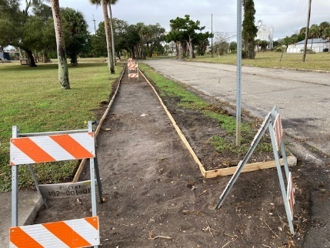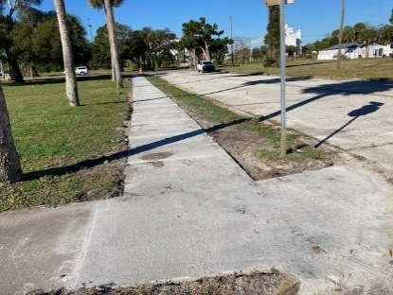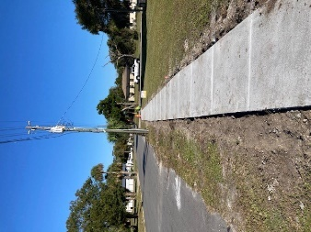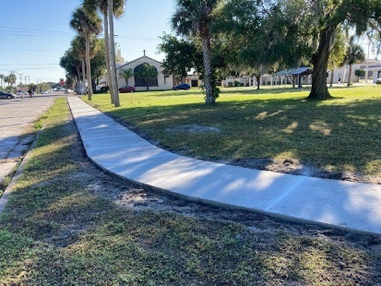

Julia Street Light Improvements
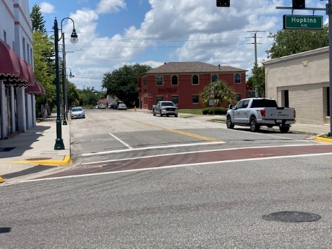
The CRA replaced the three (3) existing purple gothic pedestrian lamp posts on the south side of Julia Street between S. Hopkins Avenue and S. Palm Avenue with two (2) pedestrian lamp posts consistent with those pedestrian lamp posts on S. Washington Avenue and S. Hopkins Avenue. The project included not only lamp posts but also trenching, running conduit, wiring, and power drops. An award of contract was issued to Rush Facilities in the amount of $60,253 to construct the pedestrian lights. The installation of the lights was completed in July. The total resurfacing of Julia Street between S. Palm Avenue and S. Hopkins Avenue was moved to Fiscal Year 2023 due to contractor scheduling.

Street Resurfacing
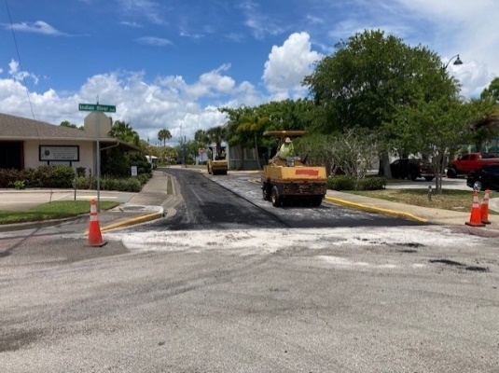
During the fiscal year the CRA resurfaced the following street segments located in the CRA: Grace Street between US-1 & S. Hopkins Avenue; Brevard Street east of S. Washington Avenue; Julia Street west of Palm Avenue; Broad Street east of Indian River Avenue and west of Palm Avenue; Palmetto Street; S. Hopkins Avenue from US-1 to Grace Street; Stephen House Way; and Mariners Way. The streets were resurfaced as part of the City’s annual street paving program to leverage costs. The CRA’s cost to resurface the streets was $181,385.

Bicycle Repair Station at Sand Point Park
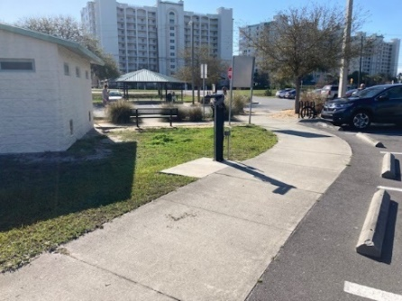
With the closing of the bicycle shop at the Downtown Welcome Center in FY 2020 due to the Covid pandemic and supply and manufacturing shortages, there was a need for self-repair bicycle stations in the downtown and along the Downtown Connector bicycle trail. In FY 2021 the CRA purchase two (2) bicycle repair stations. One of the repair stations was installed at the Downtown Welcome Center and the other was installed at the trail adjacent to Indian River Avenue near the intersection of Broad Street and Indian River Avenue by Space View Park. Due to the popularity of the repair stations and the need for a repair station at Sand Point Park as informed by North Brevard County Parks & Recreation staff, a third bike repair station was ordered and installed at Sand Point Park in February, 2022.

Aluminum Park Benches at Sand Point Park
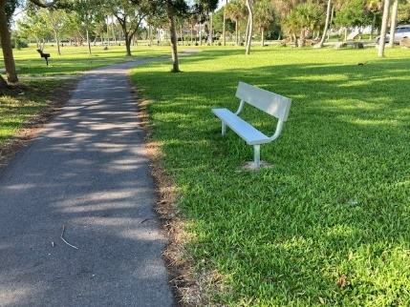
Based on intergovernmental coordination with North Brevard County Parks staff, it was determined that there was a need for park benches in Sand Point Park. The CRA purchased a total of twelve (12) six (6) foot aluminum park benches with back supports for the park. County Parks staff installed the park benches in June of 2022.

Cantilevered Shade Structures at Marina Park
Also based on coordination with Brevard County Parks management staff, it was determined that one of the number one request from Marina Park users was the need for a shade structure at the Dog Park area of Marina Park. The CRA paid for the purchase and installation of two (2) thirty (30) foot by twenty (20) foot cantilevered shade structures to provide shade for both dogs and their owners as recommended from input from dog park users. The shade structures were completed in August.

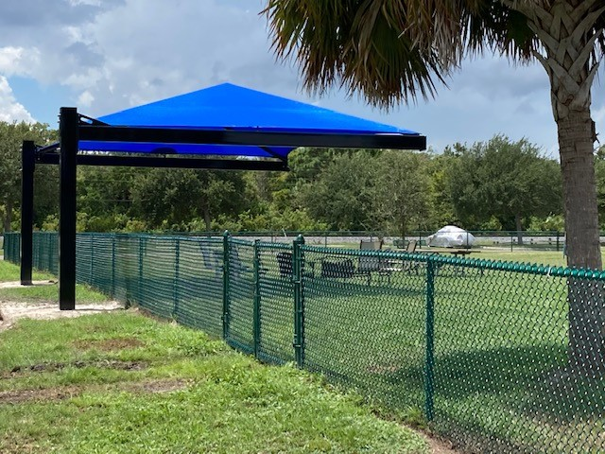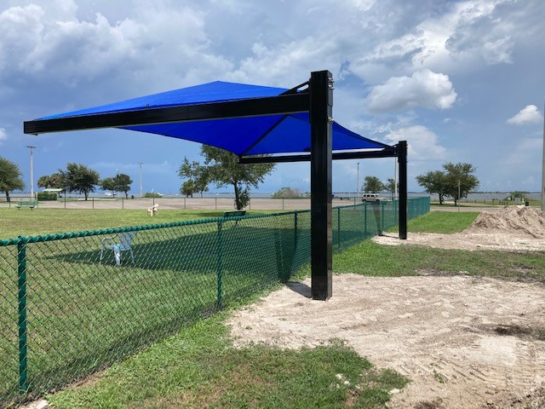

Gridsmart Intersection Detection Cameras
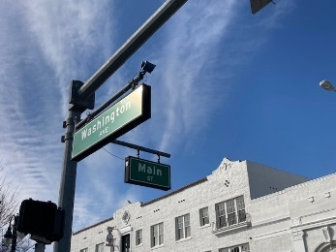
Due to the signal detection system at Main Street and S. Washington Avenue and at Main Street and S. Hopkins Avenue not detecting pedestrians and cyclists using the Downtown Connector Trail on Main Street, three (3) Gridsmart intersection detection cameras were purchased and installed in-house at the intersections mentioned so that trail users and vehicles can be detected and trip the traffic signals at the noted intersections to allow the trail users to cross the busy intersections.

Additional US-1 Landscape Infill at US-1 Intersections
Additional ground landscaping was added to intersections of US-1 (S. Washington Avenue and S. Hopkins Avenue) in the CRA district based on input from citizens who did not favor adding new hanging pedestrian light pole vegetation baskets with faux vegetation. The funds that would have paid for the baskets and faux vegetation was then used to plant additional ground vegetation along the US-1 corridor. This project was completed in FY2023.

Light Pole Banner Replacement
The light pole banners on S. Washington Avenue and S. Hopkins Avenue between South Street and Garden Street were replaced due to the existing banners becoming faded after almost four (4) years of service. One hundred and thirty eight (138) new replacement banners were purchased with six (6) graphics promoting the beaches, bicycle trails, kayaking/water recreation, the historic downtown, rocket launches, and space history. The total cost of the banners was $4,004.96.

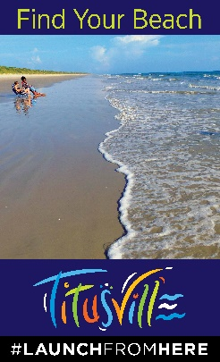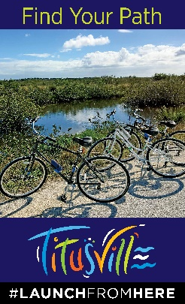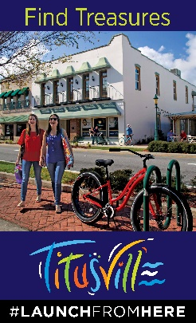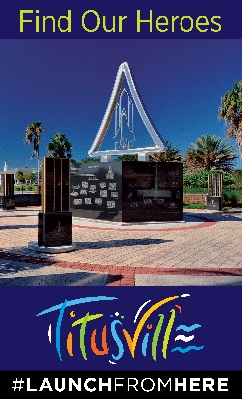

Non-Capital Projects
The Non-Capital Projects that occurred over the fiscal year are as follows:
- Spaceview Park Connecting Pedestrian Pier Feasibility Study/Final Design
- Streetscape Landscaping and Facilities Maintenance
- Community Policing
- Historic Preservation Activities
- Land Use Development Review Activities
- Redevelopment Plan Update

Spaceview Park Connecting Pedestrian Pier Feasibility Study
The CRA approved advisability in July 2019 and a budget amendment in September 2019 to fund a feasibility study for a pedestrian pier to connect Spaceview Mercury Park to Spaceview Gemini Park. The parks are separated by an inlet that requires visitors to back track to visit both parks. If found feasible to construct, the pier will meet the CRA’s Plan goal of connecting the City’s parks and providing a water front attraction for residents and visitors to view rocket launches. In January 2020 a Request for Qualifications (RFQ) was advertised to conduct a Feasibility and Conceptual Design Study. Taylor Engineering, Jacksonville, Florida, was selected in March 2020 to do the study. A contract with Taylor Engineering was signed in July 2020. In February of 2021 Taylor Engineering presented the Feasibility Study and Conceptual Design to the CRA. Based on the presentation, the CRA recommended moving forward to have a contract for a final design of the presented Concept #1. At the May 2021 CRA meeting the CRA and City Council approved an award of contract for Taylor Engineering to provide a final design of the Spaceview Park Connecting Pedestrian Pier at a cost of $92,833. Taylor Engineering worked on final design and bid plans during the fiscal year. The CRA continued to budget for this project so that if approved, the walkway pier will be paid for on a pay as you go basis.

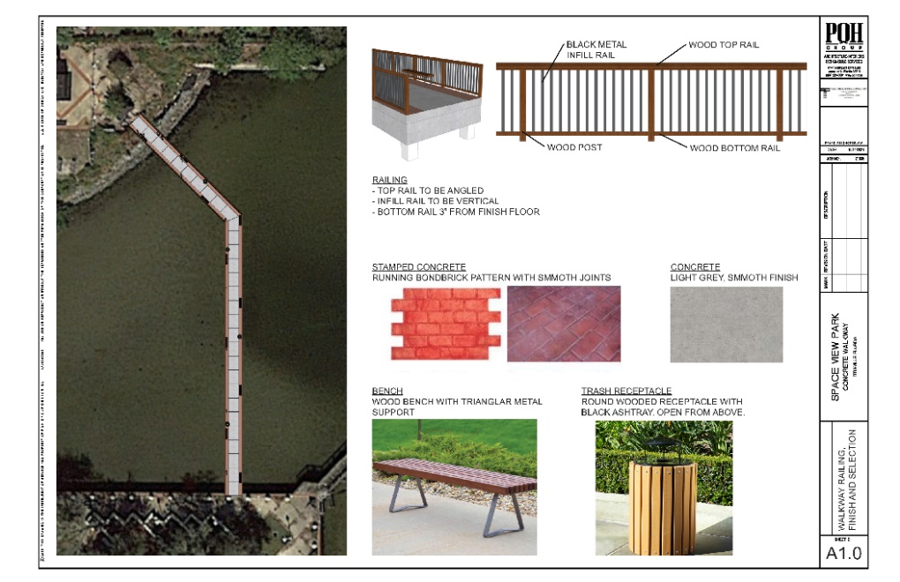

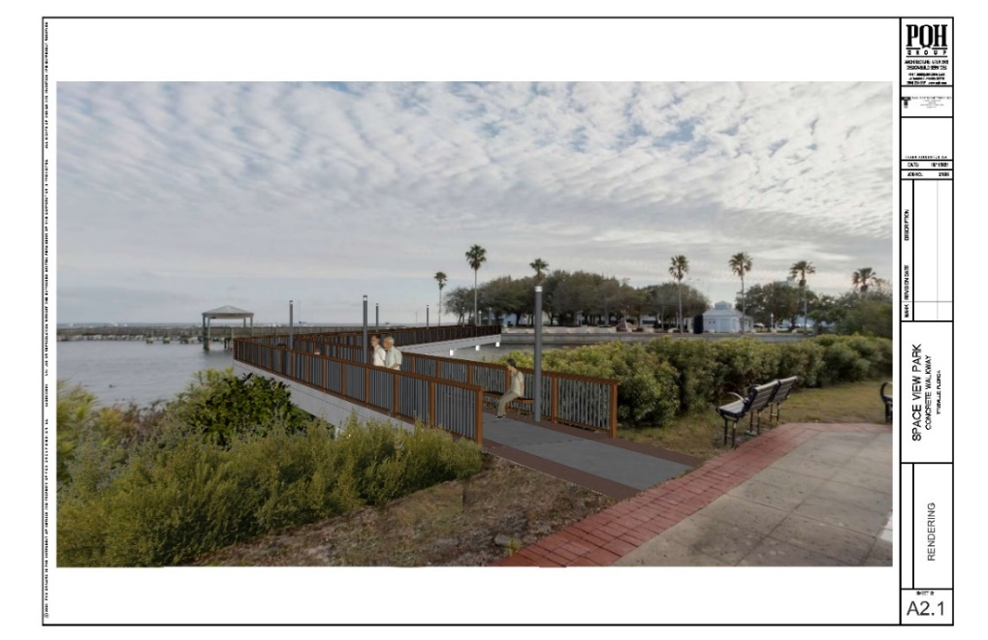
Artist computer rendition of the Connecting Pedestrian Pier

Streetscape Landscaping and Facilities Maintenance
The CRA continued its funding of the general maintenance of the plantings, lighting and street furniture funded by the CRA along the US-1 corridor (Washington Avenue & Hopkins Avenue) and in the Titusville Downtown Commons area. The maintenance provided by the CRA along the US-1 corridor is at a higher level of maintenance than provided by the Florida Department of Transportation and helps to protect the CRA’s investment. Maintenance in FY 2022 included the pressure washing of the following sidewalks in the CRA: S. Washington Avenue from Palmetto Street to Main Street, Stephen House Way, Mariners Way, and the Julia and Nevins Court Yards. The CRA also continues to fund the cost of irrigation and utilities along US 1 and a full time maintenance worker.

Community Policing
In June 2014, the CRA initiated a Community Policing program. The program consists of law enforcement officers deployed on an overtime basis during varying days and times. Increased activities in the CRA District include business contacts, directed patrols, traffic details, community relations, neighborhood patrols and anti-burglary details. This is thought to be a more cost-effective method to provide coverage as needed, rather than one full-time officer who would have less flexibility to address issues as they arise.

Program accomplishments for the fiscal year are listed below. As the community policing initiative augments the Titusville Police Department’s regular presence in the CRA, only those activities conducted during the community policing details are provided. CRA Police Details totaled 750.5 hours for the fiscal year and the details involved 3,189 Property Checks; 1,557 Traffic Stops; and 912 Suspicious Persons/ Vehicles/Incidents.

Total incident statistics in the redevelopment district for the fiscal year not part of the CRA Police details were as follows:

Vehicle Burglaries – 11 (FY2021 – 18) (FY 2020 - 16) (FY2019 - 41)
Residential Burglaries – 4 (FY2021 – 0) (FY2020 - 2) (FY2019 – 2)
Commercial Burglaries – 3 (FY2021 – 4) (FY2020 - 10) (FY2019 – 11)

Traffic Stops – 1,157 (FY2021 - 1,269) (FY2020 - 1,140) (FY2019 – 748)
Traffic Accidents without injuries – 137 (FY2021 – 138) (FY2020 – 122) (FY2019 -165)
Traffic Accidents with injuries – 43 (FY2021 – 52) (FY2020 -54) (FY2019 – 29)

Burglary Comparison between the CRA and Citywide:
CRA District – 18 (FY2021- 28) (FY2020 – 28)
City Wide – 326 (FY2021 – 402) (FY2020 – 555)

Calls for Service between the CRA and Citywide:
CRA – 7,934 (FY2021 - 8,683)
Citywide – 95,623 (FY2021 - 114,392)

The incident statistics show that the Community Policing details had a continued emphasis on reducing vehicle burglaries and enforcing traffic laws during the fiscal year. The statistics show a positive trend in the reduction of crime in the CRA.

Historic Preservation Activities

The CRA District is home to many of the City’s historic resources. The preservation of these historic resources in the Community Redevelopment District adds to the City’s pride and creates pedestrian and visitor appeal, which provides economic development for the City. Historic Preservation activities that directly involved the CRA District included the award of a State of Florida Division of Historical Resources Small Matching Grant in July 2022 in the amount of $40,000 to fund the creation of Architectural Style and Design Guidelines for use by the City Historic Preservation Board when doing design review of designated historic structures and for property owners of historic and potentially historic structures to use when making renovations to their properties.

The City’s Explore Historic Titusville booklet, mobile phone app and web site (http://history.titusville.com), which provides walking/driving tours/audio recordings of historic resources of the City from the area’s first indigenous inhabitants to the Space Program, was awarded a Florida Preservation 2022 award for Preservation Communication/Media. The majority of the history and historic landmarks in the booklet, app and web site walking/driving tour are found in the Redevelopment District.

Land Use Development Review Activities
One of the duties of the CRA Agency is to provide input and recommendations to the City Council on land use decisions occurring in the redevelopment district. A summary of the land use activities that the CRA was involved in during FY 2021 – 2022 is as follows:
- CUP #9-2021 – In December of 2021 the CRA recommended approval to the City Council for a conditional use request to locate a child care facility at 213 S. Palm Avenue;
- Ordinance #13-2022 - In April of 2022 the CRA recommended approval to the City Council regarding a text amendment to include marinas as a permissible land use on the east side of US-1 in the Uptown Subdistrict in the Downtown Mixed Use (DMU) zoning district;
- Ordinance #14-2022 – In April of 2022 the CRA recommended approval of a text amendment to permit car rental agencies with limitations to locate in the Midtown Subdistrict in the DMU zoning district instead of by conditional use approval.
- The CRA recommended approval of a Memorandum of Understanding (MOU) for the Titusville Chamber of Commerce to continue to operate a Fall 2022 Farmers Market Token Program to be funded with American Rescue Plan funds at a location in the CRA district. The program restarted in September, 2022.
Redevelopment Plan Update
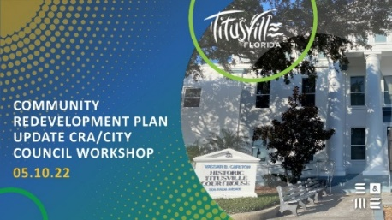
A scope from the consultant S&ME, Inc. was approved by the CRA in December of 2021 to draft a Plan Update ($34,060) and an Initiatives Plan ($34,172) to update the 2015 Redevelopment Plan Update. The 2022 Redevelopment Plan Update was drafted during the fiscal year and adopted in October of 2022, in Fiscal Year 2023.

Scobie Park Improvements
The award of a $40,728.58 Tourist Development Council grant funded the planting of mangroves, the installation of park benches, upland landscaping, a bioswale, a pervious walkway, viewing binoculars, and environmental interpretive signage at Scobie Park. Scobie Park is located near the intersection of Indian River Avenue and Main Street. The project was completed in July, 2022.

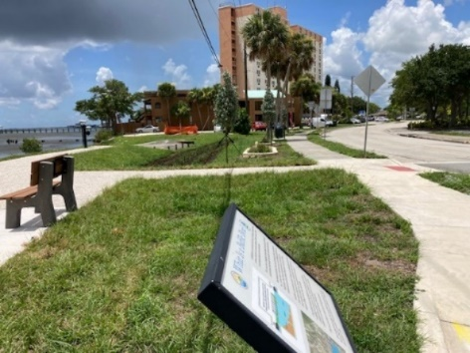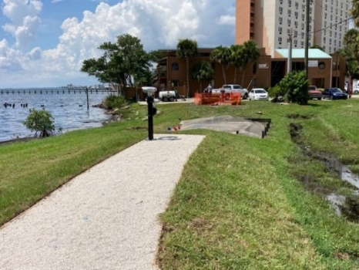

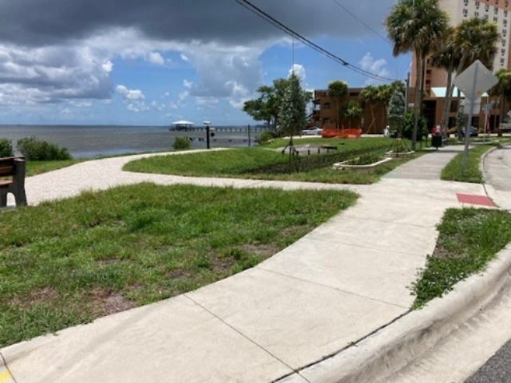

New Construction & Businesses
A goal of the City’s CRA Plan is to encourage private sector investment in the CRA. New building construction and major renovation work to existing buildings helps the City in combating blight. It also encourages others to invest in the CRA. A total of forty five (45) new Business Tax Receipts (BTR) were approved in the CRA District during the fiscal year. Here are some examples of some of the new businesses and major renovation and construction that occurred in FY 2021 – 2022 in the CRA District:

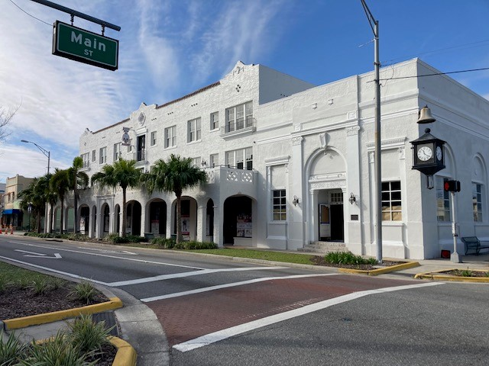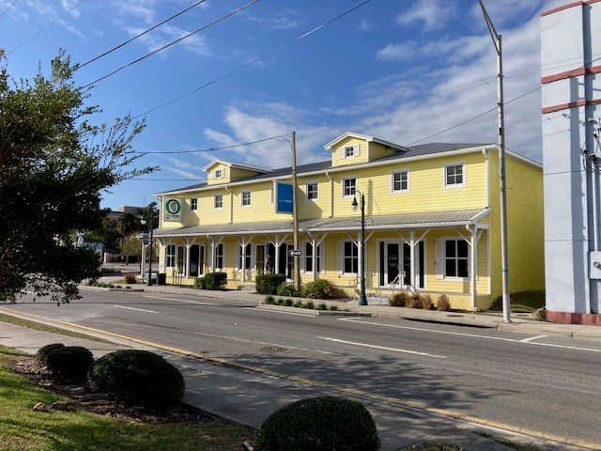
Launch Now Mixed Use Development almost complete Moefit Fitness & Blue Marlin Realty

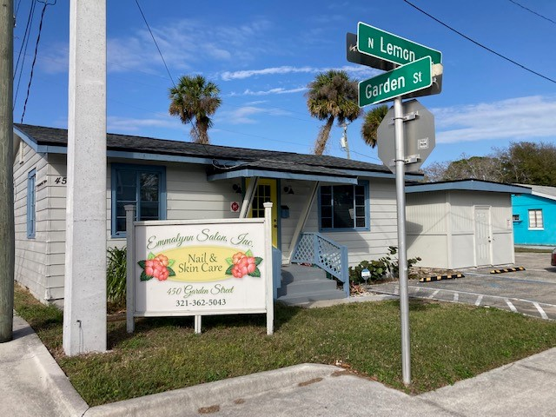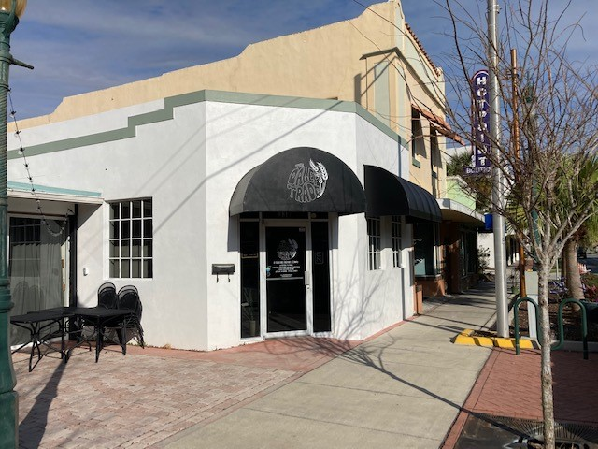
Emmylynn Salon Daley Trade Food & Restaurant

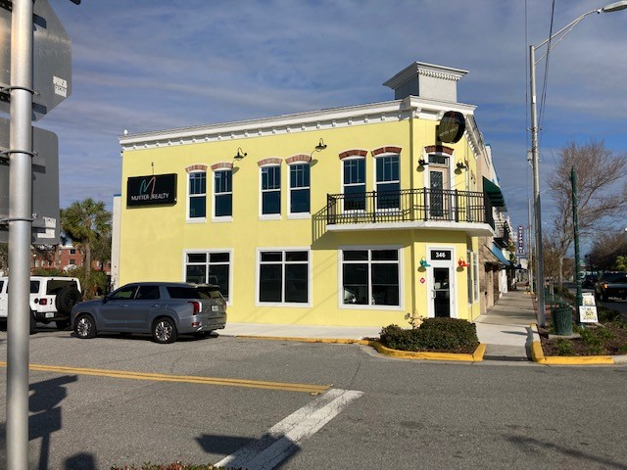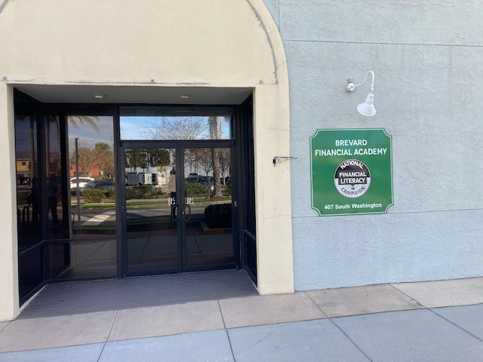
Mutter Realty Building almost complete Brevard Financial Academy

Summary of Redevelopment Plan Goals Achievement
State legislation requires a summary indicating to what extent, if any, the community redevelopment agency has achieved the goals set out in its redevelopment plan. As noted above an update to the 2015 Redevelopment Plan Update was prepared in FY 2022 but not adopted until October of 2022 in Fiscal Year 2023. Since the 2022 Redevelopment Plan Update was not adopted until FY 2023, a summary of the 2015 Redevelopment Plan Update goals achievement will be performed. The summary of the goal achievement is as follows.

Becoming a Trail Town
The CRA is well into achieving the goal of making downtown Titusville a “Trail Town” with the completion of the Downtown Connector Trail in FY2019; the installation of primary wayfinding signs and other amenities such as downtown directory signage, a downtown welcome center, bike racks, the purchase and installation of two (2) bicycle repair stations in past fiscal years, etc.; and by being designated the second Trail Town in the State of Florida by the Florida Department of Environmental Protection, Greenway & Trails Division in FY2019. Work was completed on the construction of the missing link of trail between Indian River Avenue and the A. Max Brewer Bridge in the CRA. The trail link from Parrish Park east of the A. Max Brewer Bridge to the Merritt Island Wildlife Refuge property line was completed in FY 2021. In FY 2022 an additional bicycle repair station was installed at Sand Point Park; side streets were paved; pedestrian lights were replaced on Julia Street and sidewalks were installed along Lemon Avenue and Broad Street. Work still needs to be done to construct the trail link from the west Merritt Island National Wildlife Refuge property line to the Canaveral National Seashore; providing better wayfinding signage for trail users in the CRA; and continuing to improve streets, parks, sidewalks, lighting, and parking in the downtown, including possible trail heads in the District.

Vibrant Community Initiative
The vibrant community initiative goal involves increasing residential development in the downtown, the support of arts and entertainment facilities, and integrating existing recreational facilities in the downtown to make downtown a live, work and play destination. The CRA is working to attain this goal with the Launch Now development under construction with the assistance of the CRA Grant Program. Launch Now will provide twenty (20) new boutique apartment units in a mixed use building in the heart of the Historic Downtown. The Launch Now project with the assistance of CRA Building Program grants is slated to be completed in fiscal year 2023. A second residential development with 384 total multifamily units known as Horizon at Sand Point is in the Building Permit stage and is taking advantage of the increase in residential density and building height in the Uptown Subdistrict of the CRA. The CRA provided design approval of the Horizon development in Fiscal Year 2021. The Horizon at Sand Point developer has acquired additional adjacent property in FY 2022 and revised their site plan during the fiscal year. Construction is estimated to begin in Fiscal Year 2023. More residential including workforce, and low & moderate housing is needed as pointed out in the City’s Strategic Economic Development Plan to make the CRA more vibrant. In addition, the Titusville Playhouse has purchased property in the Julia Street – Palm Avenue area and has plans to create an entertainment district in that area with plans to add a new 500 seat theater, a 150 seat black box theater, an outdoor concert and stage venue, and other ancillary uses including eating and drinking establishments which will add to the vibrancy of the CRA/downtown. The CRA will need to consider additional public infrastructure in this area to help make this area an entertainment district.

The City has used Federal American Recovery Act and American Rescue Plan funding to bring back the successful well attended Farmers Market to the Downtown CRA district in the fall of 2021, and the spring and fall of 2022 to provide food for low and moderate income people suffering from the economic issues caused by the lingering pandemic.
The CRA has supported the arts by wrapping traffic signal boxes designed by local artists along US Route 1 and by encouraging murals on buildings in the CRA. More and different kinds of art can be incorporated into the CRA to truly make the downtown a destination for visitors and residents.

The CRA is continuing to integrate existing recreational sites with the completion of the Downtown Connector Trail and by approving a feasibility study and then a final design and bid documents for a pedestrian observation pier to link two (2) existing parks separated by water. The pedestrian-observation pier will become a waterfront destination for residents and visitors wanting to view rocket launches and take in the scenic view of the Indian River Lagoon. Other park improvements have included a splash pad, BMX bicycle track, skateboard facility, etc. over the years. This past fiscal year in partnership with the North Brevard County Parks and Recreation staff, the CRA installed twelve (12) park benches in Sand Park and two (2) shade structures at the dog park in Marina Park. Long range plans call for a waterfront trail to connect recreational sites to the downtown and to areas to the south.
Community Policing
Community Policing is an ongoing endeavor in the CRA. Special details to combat homeless and panhandling issues, traffic issues like speeding on S. Washington Avenue and S. Hopkins Avenue, burglaries, prostitution solicitation issues, etc. will be needed to continue to make the CRA a safe place to live, work, visit, invest, and play. The use of cameras being installed in three (3) strategic areas of the CRA as a pilot project will help the Police Department in solving traffic incidents and crimes, and thus help in reducing criminal activities. The Police Department has also used mail-outs and banner signs to promote various crime prevention campaigns such as “Lock It or Lose It”, “Click It or Ticket”, and variable message board signs to promote traffic safety in the redevelopment district.

Historic Preservation
Historic Preservation is a tool for the revitalization and adaptive reuse of historic buildings in the City. The majority of historic structures in Titusville are located in the CRA. These historic buildings are an asset to the City and create the City’s character. This goal has been furthered with the creation of a Historic Preservation Board, a Historic Preservation Ordinance, the designation as a Certified Local Government; the designation of eleven (11) historic resources to the Local Historic Register as one (1) was demolished in FY 2022; the creation of a local Ad Valorem Property Tax Exemption Ordinance and the CRA Building Grant Program which can be used as an incentive to renovate historic resources; and the printing of a Titusville Historic Landmarks brochure. As stated earlier, the City obtained a State of Florida Division of Historic Resources Small Matching Grant in July 2020 in the amount of $30,000 to fund the creation of a Explore Historic Titusville booklet, mobile app, and website which provide walking/driving tours/audio recordings of historic landmarks in the City. The booklet and walking/driving tours help to identify the City’s historic resources and will help to provide economic development with visitors touring the city’s historic landmarks and visiting city businesses while touring the City. The “Explore Historic Titusville” program received a 2022 Florida Trust for Historic Preservation Communication/Media award. There are many more historic resources in the CRA that need to be designated to prevent their razing and/or inappropriate façade renovation in order to maintain the City’s downtown heritage and culture. A $40,000 Florida Department of Historical Resources FY 2023 Small Matching was awarded to the City in July, 2022 to develop architectural guidelines to help owners of historic buildings when making renovations to preserve the historic architectural characteristics of their buildings. The guidelines will be completed by June, 2023.
Commercial Beautification Grant & Structural Rehabilitation
The goal of the CRA’s Commercial Beautification & Structural Rehabilitation Grant Program is to provide incentives to existing and new property owners to upgrade the exteriors for aesthetics, interiors to meet code requirements, and to incentivize new construction that will ultimately lead to higher occupancy rates, increased property values, and to increase the visual appearance of the CRA. The creation of the CRA’s Commercial Interior Renovation Grant in previous years, the reinstituting of the Commercial Beautification Grant and the creation of the Building Permit and Impact Fee Grant that went into effect in FY 2019 helped to further this goal. As previously stated the return on investment of the grant program shows that the program is worthwhile in priming the pump of investment in the CRA. There are many properties in the CRA that can take advantage of this incentive and are as shown above in this report.

Side Street Streetscape
Side street streetscape refers to the streets that intersect with US Route 1 (Washington Avenue and Hopkins Avenue). The streets include Orange Street, Broad Street, Main Street, Julia Street, Pine Street, Palmetto Street, South Street, and St. Johns Street. In previous years the CRA has funded the resurfacing of Orange Street east of S. Washington Avenue, Main Street, Orange and Pine Streets west of Hopkins Avenue and Lemon Avenue. As was noted above in the report, the following side street segments located in the CRA: Grace Street between US-1 & S. Hopkins Avenue; Brevard Street east of S. Washington Avenue; Julia Street west of Palm Avenue; Broad Street east of Indian River Avenue and west of Palm Avenue; Palmetto Street; S. Hopkins Avenue from US-1 to Grace Street; Stephen House Way; and Mariners Way were resurfaced in FY 2022. Pedestrian street lights along Julia Street, between Palm Avenue and Hopkins Avenue, were replaced with new poles with LED lights during this past fiscal year. While working on the 2022 Redevelopment Plan streetscaping of side streets will become a major goal of the new Plan that was adopted in FY 2023.
Underground Utilities
Converting the overhead power lines on US Route 1 and on Broad Street to underground has been found to be cost prohibitive at this time. A study in 2007 found that the cost to convert the lines to underground as part of the US 1 Streetscaping project in 2010 would be $1.4 million. The cost would be even higher today. This goal of the Redevelopment Plan has been put on the back burner until it becomes financially feasible. The developers of the Launch Now development project near the corner of S. Washington Avenue and Main Street has buried the overhead electric wires along a stretch of S. Washington Avenue to accommodate their development. Future public – private partnerships may provide a way to bury power lines in the downtown at specific areas of the downtown.

Targeted Property Acquisition
Targeted property acquisition is a strategic measure that can be used to attract development or provide public improvements such as parks, storm water ponds and conveyance, roads, etc. Without obtaining a loan or bond, it is financially unfeasible for the CRA to purchase any properties at this time. It may be possible for the CRA to form a public-private partnership to acquire strategic property for a desired development, such as affordable housing developments, in the CRA with the use of tax increment reimbursement with potential developers.

Wayfinding Signage Program
The CRA has implemented the initial wayfinding signage to include seven (7) directional signs along the Downtown Connector Trail, two (2) downtown directory signs, and two (2) pole signs at the Welcome Center property directing visitors to the Welcome Center and Julia Street parking lot. Additional detailed wayfinding/directional signs are needed for the connector trail and for landmarks in the downtown such as the historic district, the Veterans Memorial, the Space Monuments, the fishing/shrimping pier, the various parks, and the municipal marina. The CRA will continue to look at implementing additional wayfinding signage in the district.

Event Sponsorship and Marketing
The CRA stopped funding Special Events in FY 2017. The CRA determined that it wanted to concentrate funding on brick and mortar projects and not on special events. Marketing of the CRA has been transferred to the City’s Economic Development Division. This goal continues to be no longer in effect.

Banner Signs
Street banners attached to pedestrian light poles in the CRA have included downtown activities such as music, dining, history, culture and the environment. Banners have also been installed to commemorate significant events in the city such as was done for the City’s celebration of the City’s 150th anniversary of it’s founding in 2017. Sixty six (66) holiday themed banners were purchased in FY 2019-2020 to provide for a more festive holiday season in the CRA. The installation of banners on a seasonal and on a replacement basis due to weathering and age will be a continuing activity that adds to the vibrancy of the City. In FY2022 banners were purchased to replace the weathered banners purchased in 2018 that promote the city’s culture, environment, space industry, and tourism.

Downtown Stormwater Plan
It has been determined that a regional stormwater master plan would be cost prohibitive to implement due to the number of drainage basins that traverse the CRA and due to the ruling that the City’s Stormwater Utility could not pay for the plan. In FY 2019 the CRA advocated the use of Low Impact Development (LID) techniques and public – private partnerships to create stormwater facilities to handle stormwater runoff in the CRA. The implementation of this goal will be a continuing process. Previously a baffle box was installed at the intersection of Indian River Avenue and Main Street to catch pollutants prior to entering the Indian River Lagoon. In FY2022 stormwater pipe linings funded by the CRA and improvements to Scobie Park including vegetated bioswales, mangrove plantings and upland vegetation funded by a grant were completed to help in treating stormwater entering the Indian River Lagoon. A future project to improve stormwater drainage in the CRA will involve tree infiltration box filters.

Financial Audit Information

The financial information for the Titusville CRA on the following pages is as reported by the independent auditing firm of James Moore & Company, 121 Executive Circle, Daytona Beach, Florida, 32114. The data was taken from the City of Titusville’s Comprehensive Annual Financial Report, Fiscal Year ended September 30, 2022. The financial statement provides information on the Agency’s assets, liabilities, income, and operating expenses as of the end of fiscal year 2021 – 2022 in accordance with Chapter 163, Part III, Florida Statutes. Total expenditures from the Redevelopment Trust Fund in the fiscal year were $1,336,082.

An audit report of the CRA’s FY2021 - 2022 expenditures by the James Moore & Company is also included in this financial section of the Annual Report.

The total amount of funds expended for affordable housing for low income and middle income persons and families was zero (0) in the CRA. It should be noted that the CRA adopted a new Redevelopment Plan in October, 2022 which provides for new CRA Housing Policies regarding providing for low and moderate and workforce housing in the CRA district. The CRA currently has a grant incentive for interior improvements such as ADA, Plumbing, Electrical, and HVAC to existing buildings to be brought up to code for mixed use buildings and or the conversion of commercial buildings to mixed use that can be used to help provide for low and moderate and workforce housing units. The Building Permit and Impact Fee Grant program can also be utilized to assist in the development of new low and moderate income housing in the redevelopment district. The CRA can also provide incentives such as tax increment reimbursement to potential low and moderate housing projects in the CRA district on a case by case basis.

