City of Titusville
Community Redevelopment Agency

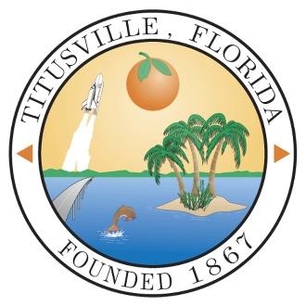

Annual Report
FY 2020 - 2021

Prepared by
City of Titusville
Community Development
& Finance Departments

Downtown Community Redevelopment Agency

CRA Board Members:

Daniel Diesel, Chairperson
Robert Jordan, Vice Chairperson
Greg Aker
Jim Ball
Jo Lynn Nelson
Joe Robinson
Sarah Stoeckel

CRA Staff:

Scott Larese, Executive Director, Community Redevelopment Agency
Richard Broome, City Attorney
Kevin Cook, P.E., Public Works Director
Teri Butler, Finance Director
Jenna Ryan, Finance Manager
Wanda Wells, City Clerk
Peggy Busacca, Community Development Department Director
Tim Ford, Redevelopment Planner

Introduction

The City of Titusville’s Community Redevelopment Agency (CRA) was created by the State of Florida in 1982, and the Community Redevelopment Plan was adopted in 1984. Since its creation, the Titusville Community Redevelopment Agency has played an integral role in the revitalization of the Downtown area and the surrounding community. The Downtown area has faced many challenges similar to those in other areas of Florida and the nation. The vision of Titusville’s Downtown was established by residents who attended workshops in the 1980’s, 1990’s and 2000’s and determined a set of goals and priorities that have evolved over the years. The original vision of the Redevelopment Plan still stands as a foundation for redevelopment in the Downtown and surrounding neighborhoods.

In an effort to provide residents and visitors with a memorable experience, the City envisions the addition of new mixed-use buildings on infill lots, renovated historic buildings, new open space amenities, enhanced streetscape conditions, new public facilities such as water and sewer infrastructure, and low impact development (LID) techniques for storm water. Development standards will be aimed at increasing the area’s capacity to accommodate new growth while preserving the historic character of the community. By combining these features with a smarter approach to growth, the City will realize a downtown that will attract sustainable growth and create a unique sense of place in which all residents can be proud.

The Downtown CRA encompasses approximately 300 (299.42) acres of land on the eastern edge of the City and is over a mile and half from its northernmost area at the municipal waterfront park and marina complex, to its southern terminus at Grace Street. The CRA includes the Historic Downtown, or core area and a number of small neighborhoods. The CRA is bounded by the Indian River waterfront on the east and north and by the Florida East Coast Railroad tracks on the west. The CRA parallels the Indian River and includes over 1.9 miles of waterfront as shown on the following map.
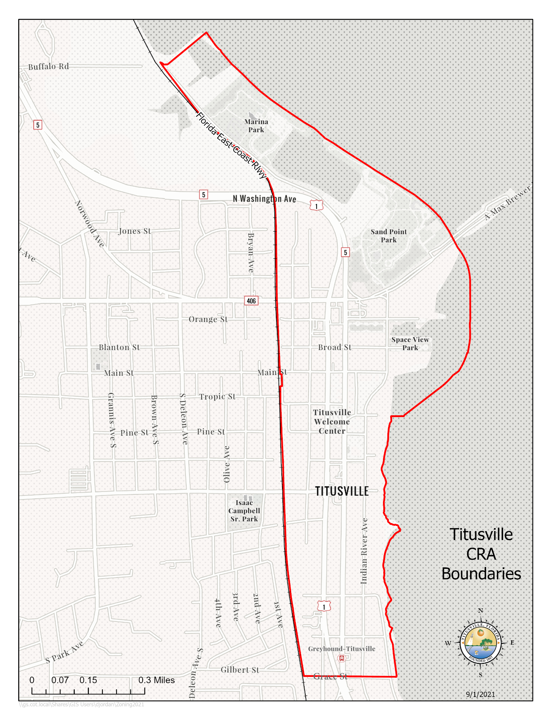
Assessed Real Property Values & Tax Increment Fund Revenue History

The original base year real property value for the Titusville Downtown CRA in 1982 was $20,495,020. The Titusville Downtown CRA assessed property value in the reporting year of FY 2021 was $115,007,903, which is an increase of $6,775,988 in value from the FY 2020 assessed property value.

A history of the Titusville CRA Tax Increment Revenue per year since FY2005–2006 is found in Table-1 below. Prior to FY 2005–2006 the Downtown CRA had a steady but low tax increment since its inception in 1982. Over the past decade, the CRA’s tax increment revenue has been more volatile due to the impacts of both new development and economic conditions.

Table 1: Tax Increment Revenues by Year (Audited)

FY 2005-2006 $286,787
FY 2006-2007 $589,533
FY 2007-2008 $922,899
FY 2008-2009 $876,391
FY 2009-2010 $792,703
FY 2010-2011 $724,997
FY 2011-2012 $655,653
FY 2012-2013 $631,488
FY 2013-2014 $699,901
FY 2014-2015 $712,212
FY 2015-2016 $766,683
FY 2016-2017 $793,838
FY 2017-2018 $867,986
FY 2018-2019 $919,020
FY 2019-2020 $961,910
FY 2020-2021 $979,345

The Tax Increment Financing (TIF) revenues for the Downtown CRA increased substantially in fiscal year 2006 - 2007 due to the completion of the Harbor Pointe condominium complex. The first building was added to the tax rolls in fiscal year 2006-2007. This revenue allowed the CRA to complete projects that were not possible with revenues from the previous years.

The three remaining Harbor Pointe buildings were added to the tax rolls in fiscal year 2007 - 2008. Due to the economic downturn, increased foreclosures nationwide, and the end of the NASA Space Shuttle Program, the revenue in fiscal years 2008 - 2009 to 2012-2013 decreased. The reduction in revenues during those years resulted in a greater percentage of revenues being dedicated to debt service, thereby limiting redevelopment projects that were being undertaken by the CRA during those years. After bottoming out in FY2012-2013, tax increment revenues have increased each year since to where they have surpassed the FY2007-2008 high.

In 2011, the CRA authorized issuance of a Public Improvement Revenue Note in an amount not to exceed $2,535,000 to finance roadway and landscaping improvements in conjunction with the FDOT U.S. 1 project. In February 2013, the CRA approved partial repayment of the loan for $850,000. The repayment funds were the result of lower than anticipated projects costs. The CRA’s action produced a total savings of $1.27 million. The CRA also paid off the Commons Project Bond at a cost of approximately $95,000. The loan repayments reduced the annual debt service in FY2014-2015 from 34% to 19% of the Annual Revenues, thus providing more opportunities for capital projects in the future. The percentage of annual debt service to annual tax increment values has continued to decline due to a combination of the increase in tax increment values and debt payments. The ratio of debt service to revenue in FY2020-2021 was 13.99%.

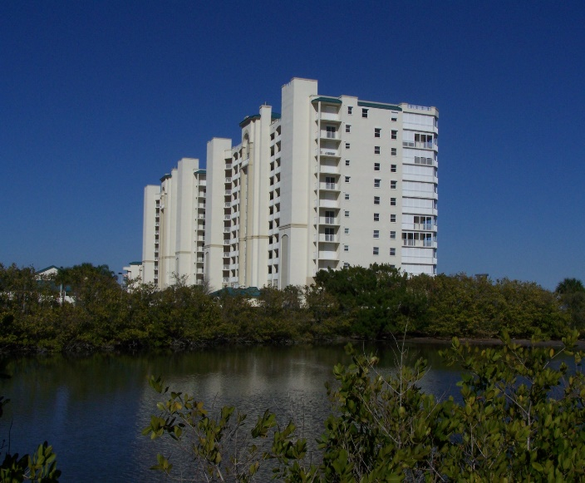
Harbor Pointe Condominiums on Indian River Avenue

Fiscal Year 2020-2021 Capital and Non-Capital Projects

The Downtown CRA has continued with existing projects during the 2020 - 2021 fiscal year as well as started new projects as shown below.
Completed Capital Projects and Their Estimated Cost:
- Commercial Interior Building Renovation, Commercial Beautification, and Permit & Fee Grant Programs (operational – see detailed grant payouts in the narrative below),
- Four (4) Street Lamp Post Holiday L.E.D. Lighted Wreath Decorations ($1,354),
- Utilities Sewer Main Cured In-place Pipe Lining ($295,686)
- U.S. 1 Landscaping Infill ($34,825)
- Landscape Bed Mulching ($15,000)
- Two (2) Bicycle Repair Stations ($3,335)
- Trash Receptacle for Main Street ($1,179)

Capital Projects Started but not Completed in the Fiscal Year and Their Estimated Cost:
- Stormwater Cured In-place Pipe Lining ($130,000)
- Sidewalk Infill ($58,000)
- Julia Street Light Improvements ($60,253)
More detail about these projects follows.

Commercial Interior Building Renovation, Commercial Beautification, and Permit and Impact Fee Incentive Grant Programs
In FY 2016 – 2017 the CRA created a Commercial Interior Renovation Incentive Grant Program to assist property owners and commercial tenants of older buildings to bring their structures up to current Americans with Disabilities Act (ADA), the Florida Fire Protection Code, and the Florida Building Code standards. The Commercial Interior Building Renovation Incentive Grant Program helps to expand and improve under-used buildings to increase commercial and mixed use intensity, bring buildings up to code, assist small businesses in the CRA to grow and prosper, and to promote job creation in the district. This grant program offers financial assistance in the form of a reimbursable, fifty present (50%) matching grant up to a maximum of $50,000 to the property owner or business owner for eligible expenses associated with the renovation and rehabilitation of the following interior elements of commercial and mixed use building space:
- ADA requirements
- Florida Fire Protection Code requirements
- Florida Building Code requirements including:
  - Interior plumbing to meet code
  - Interior electrical system including lighting to meet code
  - HVAC system to meet code

During fiscal year 2017-2018 the CRA expanded its matching Building Grants Incentive Programs by drafting and approving a new Permit & Impact Fee Incentive Grant Program, revising the Commercial Interior Renovation Grant Program and reactivating and revising its Commercial Beautification Grant Program. The Permit & Impact Fee Program provides a maximum $50,000 matching one-to-one grant to help offset the cost of permits and impact fees for new construction in the CRA. The Commercial Interior Renovation Grant Program was revised to provide an additional $50,000 matching one-to-one grant for interior building renovations that provide residential and nonresidential mixed-use as an incentive for residential units to be added to the CRA and spur housing in the downtown. The Commercial Beautification Grant Program provides a $40,000 matching one-to-one grant for façade and exterior improvements to buildings in the CRA to improve the appearance of the CRA/downtown and to eliminate blight. The Grant Programs were further revised to provide payment of seventy-five (75%) of the grant award at project completion and the remaining twenty-five (25%) of the grant award with occupancy of the building at one (1) year after completion of the improvements as an incentive for building owners to have their buildings occupied and not sit empty. The expanded grant program became operational in FY 2019.

One (1) Permit & Impact Fee grant for the construction of a new building in the CRA district was awarded in FY2021. The estimated total cost of the new building was $248,650. The total amount of the grant awarded was $8,796.50 based on an estimated total of $17,594.12 in impact and building fees.

Four (4) grant payouts were made during the fiscal year. The grant payments were for three (3) Commercial Beautification grants and one (1) Permit & Impact Fee grant. The total payout for the grants during the fiscal year was $46,219.05.

Since these are fifty (50%) matching reimbursable grants with a maximum cap, the grant program leverages more than double the grant amount of investment in the CRA. A CRA Grant Return on Investment History Report completed in FY 2019 found that for completed grant projects and for grant projects under construction the return on investment was $14.71 for every $1 of CRA grant money awarded. Considering only completed grant projects since 2008, the ROI was $3.14 for $1 of CRA grant money. The reason for the large difference between completed project and both completed and under construction is that there are two (2) major construction projects presently taking place in the CRA, the Launch Now project with an estimated cost of $5 million of construction and the Beachwave project with an estimated cost of $3 million. The Beachwave project was completed in FY2021. The Launch Now project is slated to be completed in FY2022.
The return on investment study shows how the grant program is helping to prevent deterioration of older historic properties in the CRA; stimulate interest and investment in the District; encourage the development of business and job growth; and encourage the utilization of existing business stock and new construction in the CRA.

Street Lamp Post Holiday Wreath Decorations
In FY2021 the CRA expanded its holiday decorations by adding four (4) 40-inch L.E.D. lighted holiday pole wreaths to be placed on pedestrian light poles at the intersections of US Route 1 with Garden Street at the north and South Street at the south. The four (4) wreaths were added to four (4) wreaths purchased in FY2020 so that there would be wreaths on each side of S. Washington Avenue and S. Hopkins Avenue. The total cost of the four (4) wreaths was $1,956.
L.E.D. Lighted 40 inch Wreath
Utility Infrastructure - Sewer Main Pipe Lining
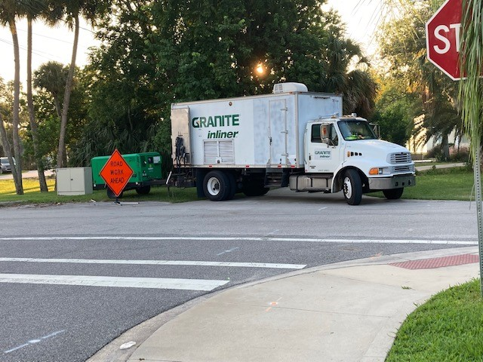Due to aged sewage main pipes in the CRA which are in danger of leaking and rupturing and affecting the nearby Indian River Lagoon, and to the large estimated cost of $12 million to repair and replace old sewer mains in the city, the CRA budgeted $128,216 to assist in funding cure in-place sewer main pipe lining in the CRA district.
On Christmas Eve of 2020 a major sewer force main broke underneath a U.S. 1 drainage pond near the intersection of N. Washington Avenue and A. Max Brewer Parkway and Sand Point Park causing sewage to spill into the drainage pond and an overflow ditch to the Indian River Lagoon. The CRA and City Council approved two (2) budget amendments to add $48,870 and $118,600 to provide a total of $295,686 to help expedite cure in-place sewer lining in the CRA district. The funding directly paid for 27 sewer pipe lines or 4,991 linear feet of eight (8) inch pipe and seven (7) sewer pipe lines or 1,924 linear feet of ten (10) inch sewer pipe to be repaired with cure in-place pipe lining. With this action the Titusville CRA helped to prolong the life of the sewer lines and helped to protect the nearby Indian River Lagoon’s water quality.
US-1 Landscape Infill
In March of 2021, the CRA funded the landscaping infill of the landscape islands in the US-1 right-of- way (S. Washington Avenue and S. Hopkins Avenue) from Grace Street to Broad Street. The bulk of the plantings were installed in the area between South Street and Grace Street. Mulch was also added to the landscape beds on US-1 and other areas in the CRA. The contract was awarded to JB Lawn Control at a cost of $34,825.

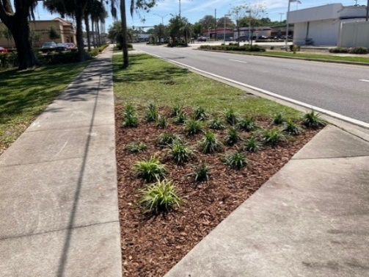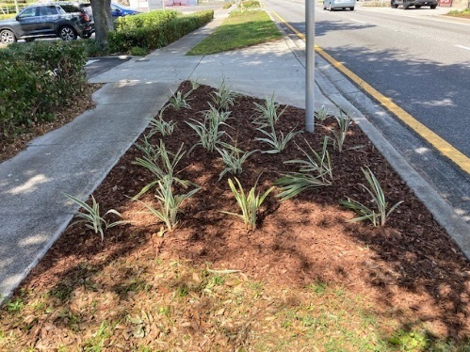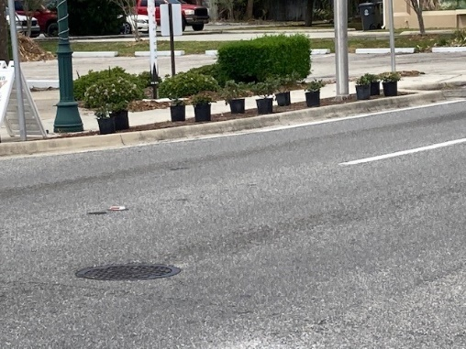

Landscape Bed Mulching
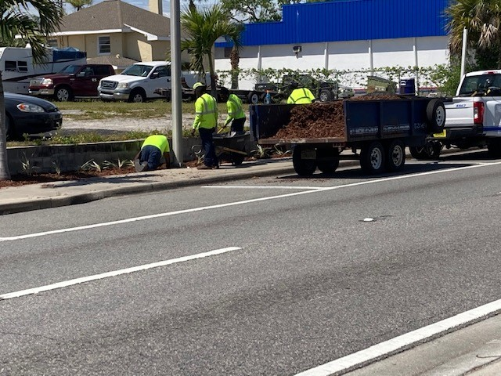Mulch was purchased and installed by Public Works employees to the US-1 beds and other landscape beds in the CRA for an approximate cost of $15,000.
Bicycle Repair Stations
With the closing of the bicycle shop at the Downtown Welcome Center in FY 2020 due to the Covid pandemic and supply and manufacturing shortages, there was a need for self-repair bicycle stations in the downtown and along the Downtown Connector bicycle trail. The CRA purchase two (2) bicycle repair stations at total cost of $3,335. One of the repair stations was installed at the Downtown Welcome Center and the other was installed at the trail adjacent to Indian River Avenue near the intersection of Broad Street and Indian River Avenue by Space View Park. Due to the popularity of the repair stations and the need for a repair station at Sand Point Park as informed by North Brevard County Parks & Recreation staff, a third bike repair station was ordered during the fiscal year but was not delivered until FY2022 due to manufacturing and distribution supply issues caused by the Covid pandemic.

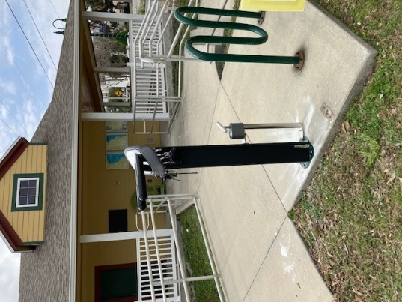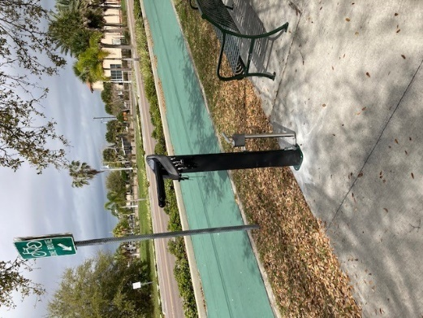
Welcome Center Repair Station Indian River Ave. Repair Station

Main Street Trash Receptacle
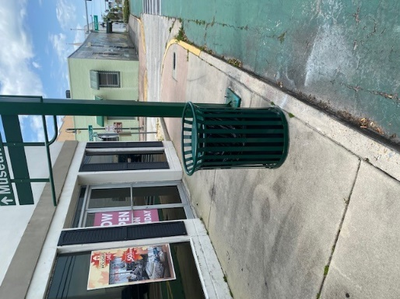Based on input from the Titusville Downtown Merchants Association regarding the need for an additional trash receptacle on Main Street between S. Washington Avenue and Indian River Avenue, a trash receptacle was purchased at a cost of $1,179. The trash can was located near the southeast corner of the intersection of Mariners Way and Main Street, midway between S. Washington Avenue and Indian River Avenue.

Stormwater Cured In-place Pipe Lining
In July of 2021 the CRA and City Council approved a Budget Amendment in the amount of $130,000 to install stormwater cured in-place pipe liner at two (2) locations in the CRA. The locations were Grace Street between US-1 and S. Hopkins Avenue and Palm Avenue between Main Street and Julia Street. Both locations were in critical need of repair. The cured in- place method is more cost effective and allows the roadways to remain open and usable during the process. The slip lining also allows for Grace Street to be resurfaced in FY2022 and prevents the excavation of newly paved Palm Avenue in order to repair the pipes. The project was started in FY2021 but was not completed until November, 2022.
Sidewalk Infill
The CRA proposed to provide infill sidewalks and Americans with Disabilities Act (ADA) improvements on Lemon Avenue and Broad Street. Due to issues with trying to piggy back the sidewalk and concrete repair work with Brevard County’s Sidewalk and Concrete Repair Contract, the CRA’s Sidewalk Infill project was moved to FY2021 so that a citywide sidewalk and concrete repair proposal could be advertised. The Public Works Department decided to complete the sidewalk work in-house due to issues with soliciting bid proposals. The sidewalk was designed during the fiscal year but will not be installed until FY2022.

Julia Street Light Improvements
During FY2020 Public Works staff worked on designing street lighting on the north side of Broad Street between S. Palm Avenue and Indian River Avenue, and replacing the purple pedestrian lamp posts on the south side of Julia Street in front of the Titusville Playhouse. At the September 8, 2020 CRA meeting, the CRA heard a presentation by staff regarding options and cost analyses to replacing the three (3) old lamp posts on Julia Street. The options involved possibly replacing the existing three (3) purple gothic lamp posts with lamp posts consistent with those lamp posts on S. Washington Avenue and S. Hopkins Avenue and if so, determining whether to opt for two (2) light poles on the south side of Julia Street, or six (6) lamp posts on both sides of Julia Street between S. Hopkins Avenue and S. Palm Avenue. Based on the cost analyses provided and the amount of funds currently budgeted, the CRA opted to direct staff to install two (2) new L.E.D. lamp posts similar to the rest of the downtown CRA on Julia Street. The project includes not only lamp posts but also trenching, running conduit, wiring, and power drops. An award of contract was issued to Rush Facilities in the amount of $60,253 to construct the pedestrian lights. The lights are to be installed in FY2022.

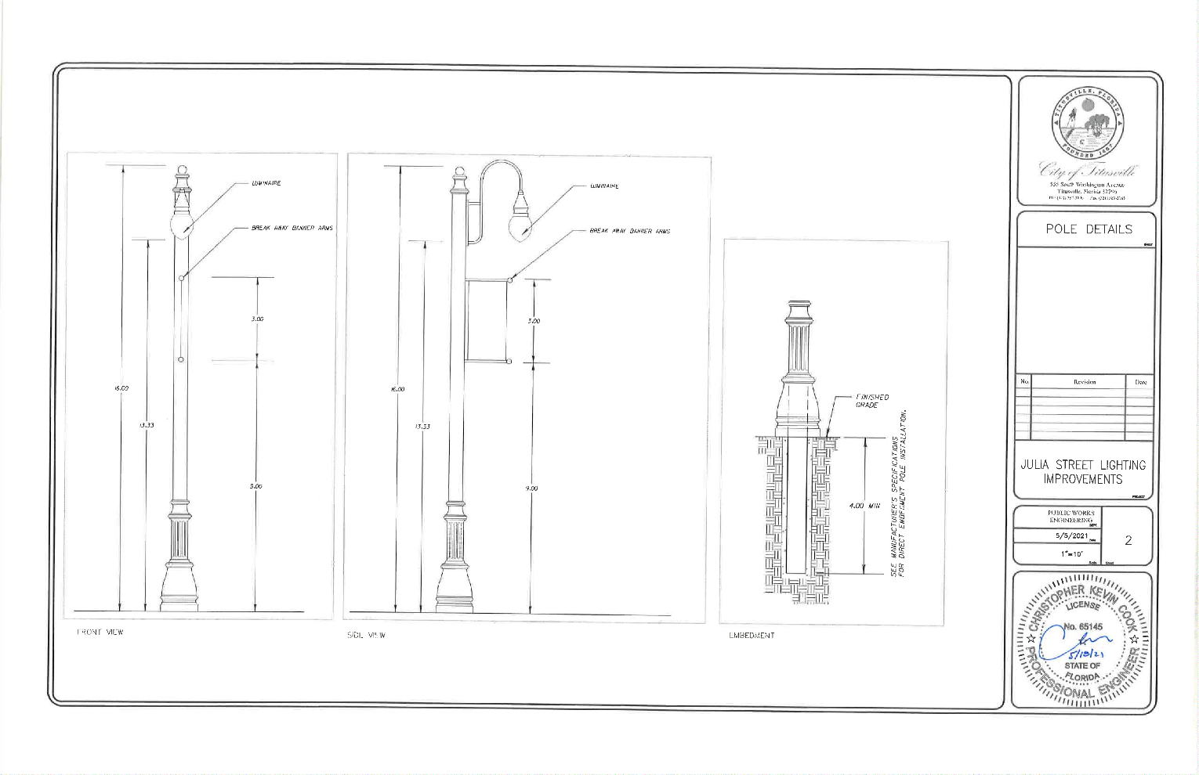
Julia Street Pedestrian Lights Detail
Non-Capital Projects
The Non-Capital Projects that occurred over the fiscal year are as follows:
- Spaceview Park Connecting Pedestrian Pier Feasibility Study/Final Design
- Streetscape Landscaping and Facilities Maintenance
- Community Policing
- Historic Preservation Activities
- Downtown Mixed Use Development Review Activities
- Memorandum of Agreement (MOA) for Temporary Use of Space at the Downtown Welcome Center
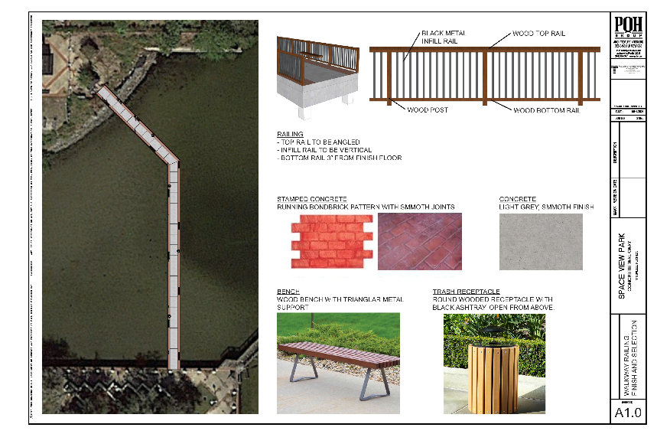
Spaceview Park Connecting Pedestrian Pier Feasibility Study
The CRA approved advisability in July 2019 and a budget amendment in September 2019 to fund a feasibility study for a pedestrian pier to connect Spaceview Mercury Park to Spaceview Gemini Park. The parks are separated by an inlet that requires visitors to back track to visit both parks. If found feasible to construct, the pier will meet the CRA’s Plan goal of connecting the City’s parks and providing a water front attraction for residents and visitors to view rocket launches. In January 2020 a Request for Qualifications (RFQ) was advertised to conduct a Feasibility and Conceptual Design Study. Taylor Engineering, Jacksonville, Florida, was selected in March 2020 to do the study. A contract with Taylor Engineering was signed in July 2020. In February of 2021 Taylor Engineering presented the Feasibility Study and Conceptual Design to the CRA. Based on the presentation, the CRA recommended moving forward to have a contract for a final design of the presented Concept #1. At the May 2021 CRA meeting the CRA and City Council approved an award of contract for Taylor Engineering to provide a final design of the Spaceview Park Connecting Pedestrian Pier at a cost of $92,833. The design is estimated to be finalized by March of 2022.

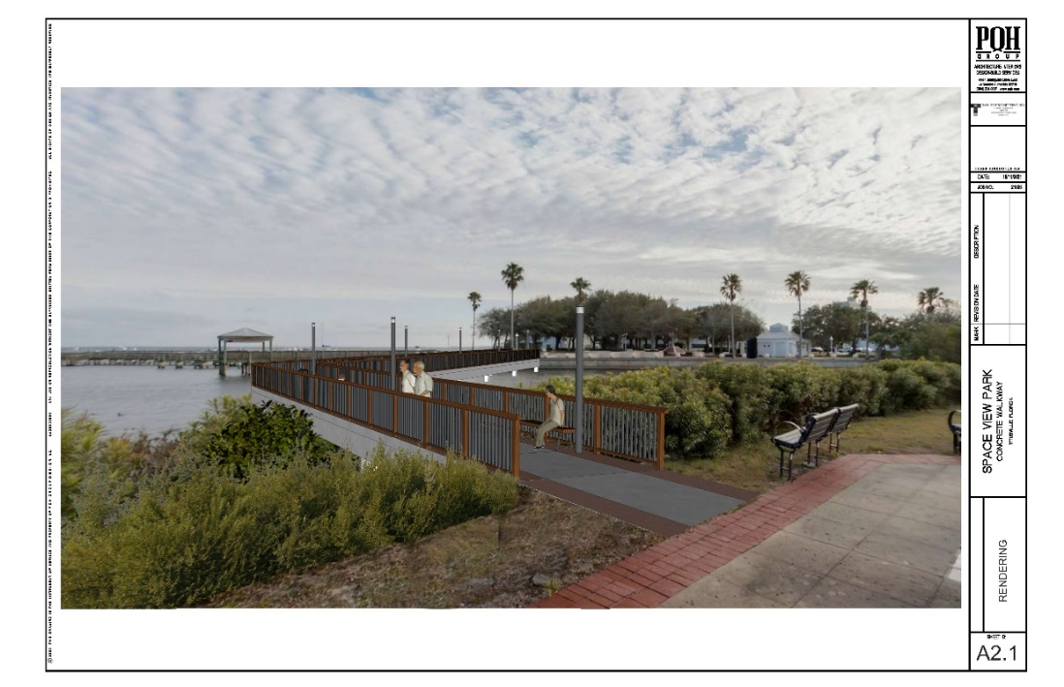
Artist computer rendition of the Connecting Pedestrian Pier
Streetscape Landscaping and Facilities Maintenance
The CRA continued its funding of the general maintenance of the plantings, lighting and street furniture funded by the CRA along the US-1 corridor (Washington Avenue & Hopkins Avenue) and in the Titusville Downtown Commons area. The maintenance provided by the CRA along the US-1 corridor is at a higher level of maintenance than provided by the Florida Department of Transportation and helps to protect the CRA’s investment. The CRA also continues to fund the cost of irrigation and utilities along US 1 and a full time maintenance worker.

Community Policing
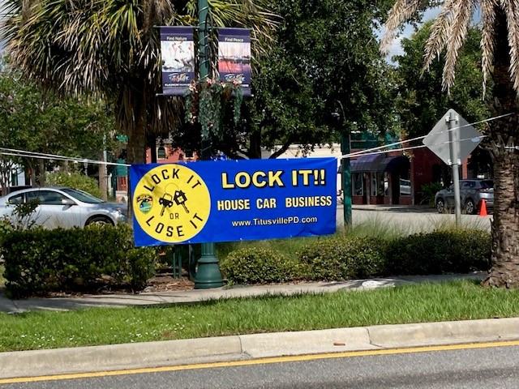In June 2014, the CRA initiated a Community Policing program. The program consists of law enforcement officers deployed on an overtime basis during varying days and times. Increased activities in the CRA District include business contacts, directed patrols, traffic details, community relations, neighborhood patrols and anti-burglary details. This is thought to be a more cost-effective method to provide coverage as needed, rather than one full-time officer who would have less flexibility to address issues as they arise.

Program accomplishments for the fiscal year are listed below. As the community policing initiative augments the Titusville Police Department’s regular presence in the CRA, only those activities conducted during the community policing details are provided. CRA Police Details totaled 480.75 hours for the fiscal year and the details involved 1,001 Property Checks; 127 Traffic Stops; and 31 Suspicious Persons/ Vehicles/Incidents.

Total incident statistics in the redevelopment district for the fiscal year not part of the CRA Police details were as follows:

Property Checks -2,225
Suspicious Persons/Vehicles/Incidents – 506

Vehicle Burglaries – 18 (FY 2020 - 16)(FY2019 - 41)
Residential Burglaries – 0 (FY2020 - 2)(FY2019 – 2)
Commercial Burglaries – 4 (FY2020 - 10)(FY2019 – 11)

Traffic Stops – 1,269 (FY2020 - 1,140) (FY 2019 – 748)
Traffic Accidents without injuries – 138 (FY2020 – 122) (FY 2019 -165)
Traffic Accidents with injuries – 52 (FY2020 -54) (FY 2019 – 29)

Burglary Comparison between the CRA and Citywide:
CRA District – 28 (FY2020 – 28)
City Wide – 402 (FY2020 – 555)

Calls for Service between the CRA and Citywide:
CRA – 8,683
Citywide – 114,392

The incident statistics show that the Community Policing details had an emphasis on reducing vehicle burglaries and enforcing traffic laws during the fiscal year. The residents and property owners within the CRA have acknowledged the Community Policing program as a success.
Historic Preservation Activities
The CRA District is home to many of the City’s historic resources. The preservation of these historic resources in the Community Redevelopment District adds to the City’s pride and creates pedestrian and visitor appeal, which provides economic development for the City. Historic Preservation activities that directly involved the CRA District included obtaining of a State of Florida Division of Historical Resources Small Matching Grant in July 2020 in the amount of $30,000 to fund the creation of an Explore Historic Titusville booklet, mobile phone app and web site ( http://history.titusville.com ) providing walking/driving tours/audio recordings of historic resources of the City from the areas first indigenous inhabitants to the Space Program. The majority of the history and historic landmarks in the booklet, app and web site walking/driving tour are found in the Redevelopment District.


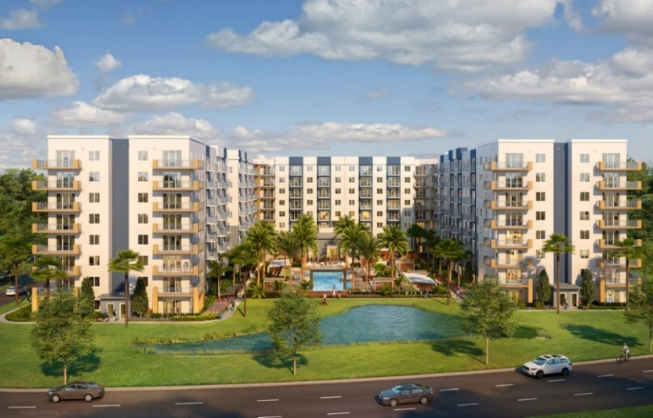
Downtown Development Design Review Activities
The Downtown Mixed Use zoning district regulations call for the CRA to have design approval of development projects with either more than 10,000 square feet of building and or have greater than 1.5 acres of area and to approve any zoning waivers for such sized developments. In April of 2021, the CRA approved the development plans for the Horizon at Sand Point development which involves a development with a mixed-use multistory apartment – commercial/hotel complex to be developed in four (4) phases on 14.1 acres located at 300 N. Washington Avenue. The project proposes 384 apartment units to be built in the first two phases of the development. The development will provide a much need residential component to the CRA area that will help to support commercial uses in the CRA. The CRA also reviewed and provided a recommendation for approval of a Conditional Use request for a car rental agency to operate at 1026 S. Hopkins Avenue.

Memorandum of Agreement (MOA) for Temporary Use of Space at the Downtown Welcome Center
With the construction of a new visitor center proposed at the Merritt Island National Wildlife Refuge proposed, a MOA was entered into between the CRA, the City of Titusville, and the Merritt Island Wildlife Association (MIWA) in December, 2020 for the MIWA to temporarily use space at the Downtown Welcome Center as a Gift Shop. MIWA used the space for approximately four (4) months.
New Construction & Businesses
A goal of the City’s CRA Plan is to encourage private sector investment in the CRA. New building construction and major renovation work to existing buildings helps the City in combating blight. It also encourages others to invest in the CRA. Sixty nine (69) new Business Tax Receipts (BTR) were approved in the CRA District during the fiscal year. Here are some examples of some of the new businesses and major renovation and construction that occurred in FY 2020 – 2021 in the CRA District:

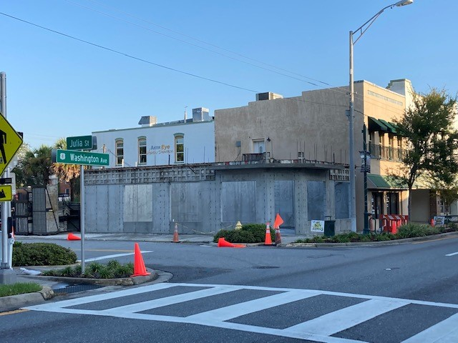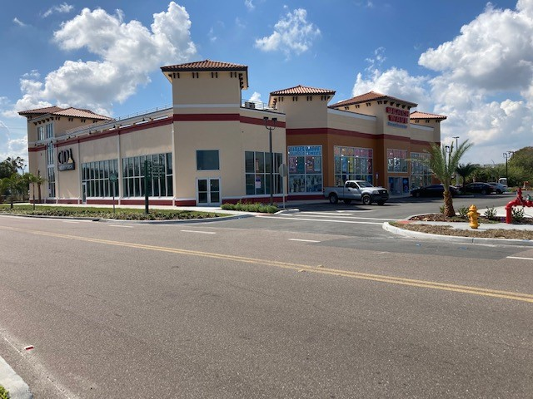
346 S. Washington Ave. Mutter Realty Building Beachwave Building completed

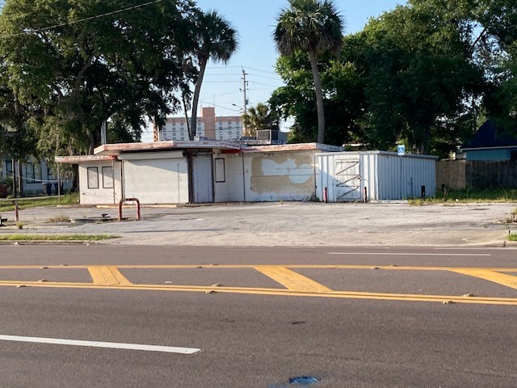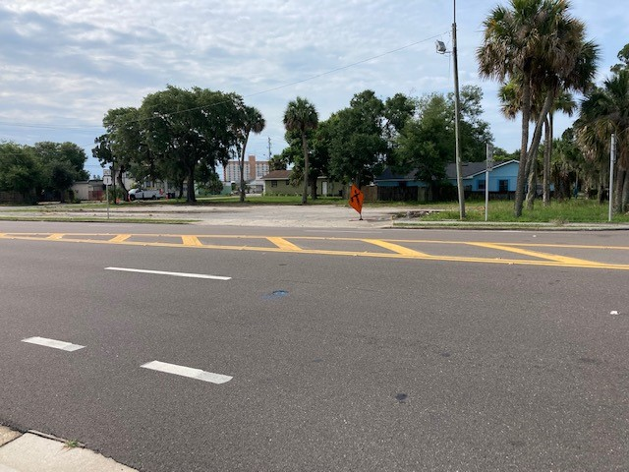
Vacant gas station at 405 Garden St. before demolition 405 Garden St. after demolition – proposed Double O’s Coffee site

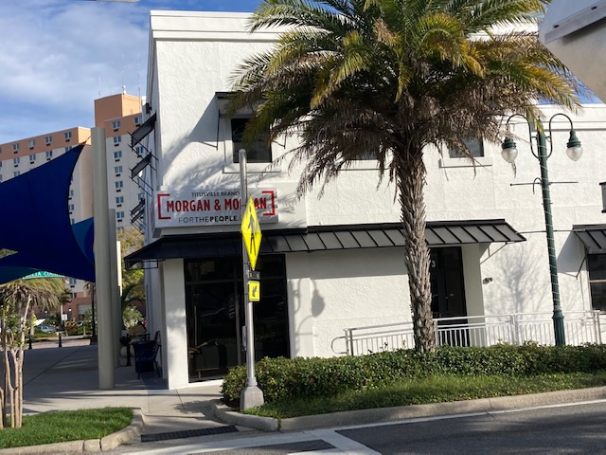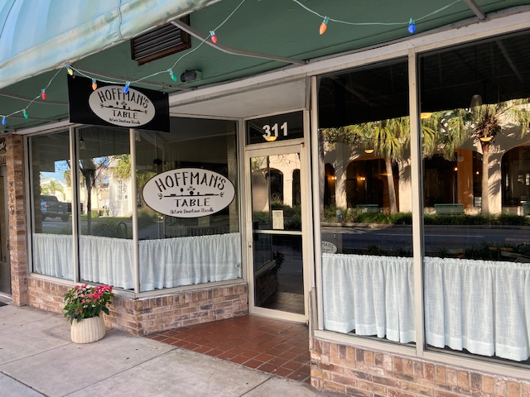
Morgan & Morgan Law Office at 407 S. Washington Ave. Hoffman’s Table Restaurant at 311 S. Washington Ave.

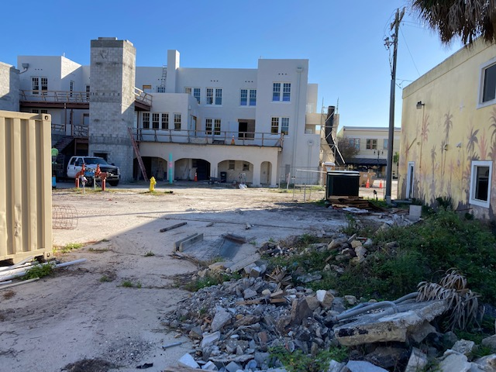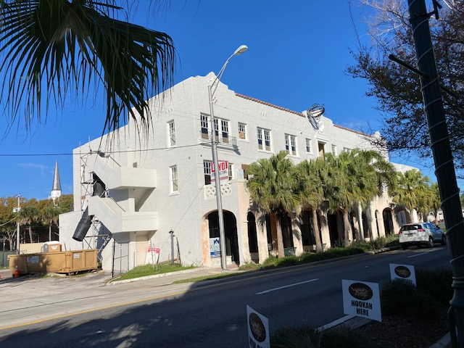
Rear of the Launch Now development at 300-310 S. Washington Ave. S.E. front corner of the Launch Now development

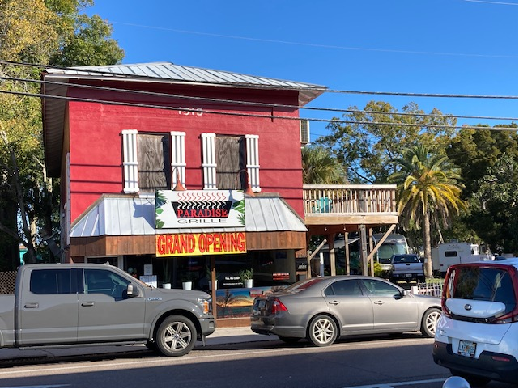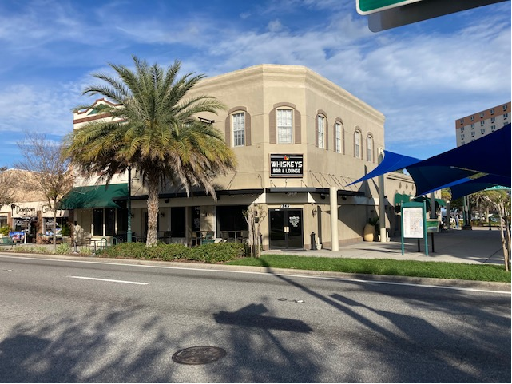
Paradise Grill at 106 Main St. Whiskey’s Bar & Lounge at 349 S. Washington Ave.

Summary of Redevelopment Plan Goals Achievement
State legislation now requires a summary indicating to what extent, if any, the community redevelopment agency has achieved the goals set out in its redevelopment plan. A summary of the redevelopment plan goals achievement by the Agency follows.

Becoming a Trail Town
The CRA is well into achieving the goal of making downtown Titusville a “Trail Town” with the completion of the Downtown Connector Trail in FY2019; the installation of primary wayfinding signs and other amenities such as downtown directory signage, a downtown welcome center, bike racks, the purchase and installation of two (2) bicycle repair stations this past fiscal year, etc.; and by being designated the second Trail Town in the State of Florida by the Florida Department of Environmental Protection, Greenway & Trails Division in FY2019. Work was completed on the construction of the missing link of trail between Indian River Avenue and the A. Max Brewer Bridge in the CRA. The trail link from Parrish Park east of the A. Max Brewer Bridge to the Merritt Island Wildlife Refuge property line was completed. Work still needs to be done to construct the trail link from the west Merritt Island National Wildlife Refuge property line to the Canaveral National Seashore; providing better wayfinding for trail users in the CRA; and continuing to improve streets, parks, sidewalks, lighting, wayfinding signage, and parking in the downtown, including possible trail heads in the District.

Vibrant Community Initiative
The vibrant community initiative goal involves increasing residential development in the downtown, the support of arts and entertainment facilities, and integrating existing recreational facilities in the downtown to make downtown a live, work and play destination. The CRA is working to attain this goal with the Launch Now development under construction with the assistance of the CRA Grant Program. Launch Now will provide twenty (20) new boutique apartment units in a mixed use building in the heart of the Historic Downtown. A second residential development with 384 total multifamily units known as Horizon at Sand Point is in the Building Permit stage and is taking advantage of the increase in residential density and building height in the Uptown Subdistrict of the CRA. The CRA provided design approval of the Horizon development this fiscal year. More residential however is needed as pointed out in the City’s Strategic Economic Development Plan to make the CRA more vibrant. In addition, the Titusville Playhouse has purchased property in the Julia Street – Palm Avenue area and has plans to create an entertainment district in that area with plans to add a new 500 seat theater, a 150 seat black box theater, an outdoor concert and stage venue, and other ancillary uses including eating and drinking establishments which will add to the vibrancy of the CRA/downtown. The CRA will need to consider additional public infrastructure in this area to help make this area an entertainment district.

The COVID pandemic, which began in March of 2020 and continued throughout the 2020 fiscal year and into the 2021 fiscal year, curtailed activities and commerce in the CRA with the shutdown of nonessential businesses and private events, such as the Downtown Street Parties put on by the Downtown Merchants Association, running races, etc. The City used Federal American Recovery Act funding to bring back the successful well attended Farmers Market in September, 2021 to provide food for low and moderate income people suffering from the economic issues caused by the lingering pandemic.
The CRA has supported the arts by wrapping traffic signal boxes designed by local artists along US Route 1 and by encouraging murals on buildings in the CRA. More and different kinds of art can be incorporated into the CRA to truly make the downtown a destination for visitors and residents.

The CRA is continuing to integrate existing recreational sites with the completion of the Downtown Connector Trail and by approving a feasibility study and then a final design for a pedestrian observation pier to link two (2) existing parks separated by water. The pedestrian-observation pier will become a waterfront destination for residents and visitors wanting to view rocket launches and take in the scenic view of the Indian River Lagoon. Other park improvements have included a splash pad, BMX bicycle track, skateboard facility, etc. over the years. City staff met with North Brevard County Parks and Recreation staff in Fiscal Year 2021 to investigate a partnership where the CRA could fund park improvements in the CRA district that would then be maintained by the Parks and Recreation Department. Long range plans call for a waterfront trail to connect recreational sites to the downtown and to areas to the south.
Community Policing
Community Policing is an ongoing endeavor in the CRA. Special details to combat homeless and panhandling issues, traffic issues like speeding on S. Washington Avenue and S. Hopkins Avenue, burglaries, prostitution solicitation issues, etc. will be needed to continue to make the CRA a safe place to live, work, visit, invest, and play. The use of cameras being installed in three (3) strategic areas of the CRA as a pilot project will help the Police Department in solving traffic incidents and crimes, and thus help in reducing criminal activities. The Police Department has also used mail-outs and banner signs to promote various crime prevention campaigns such as “Lock It or Loose It” and variable message board signs to promote traffic safety in the redevelopment district.

Historic Preservation
Historic Preservation is a tool for the revitalization and adaptive reuse of historic buildings in the City. The majority of historic structures in Titusville are located in the CRA. These historic buildings are an asset to the City and create the City’s character. This goal has been furthered with the creation of a Historic Preservation Board, a Historic Preservation Ordinance, the designation as a Certified Local Government; the designation of twelve (12) historic resources to the Local Historic Register; the creation of a local Ad Valorem Property Tax Exemption Ordinance and the CRA Building Grant Program which can be used as incentives to renovate historic resources; and the printing of a Titusville Historic Landmarks brochure. As stated earlier, the City obtained a State of Florida Division of Historic Resources Small Matching Grant in July 2020 in the amount of $30,000 to fund the creation of a Explore Historic Titusville booklet, mobile app, and website which provide walking/driving tours/audio recordings of historic landmarks in the City. The booklet and walking/driving tours help to identify the City’s historic resources and will help to provide economic development with visitors touring the city’s historic landmarks and visiting city businesses while touring the City. There are many more historic resources in the CRA that need to be designated to prevent their razing and/or inappropriate façade renovation in order to maintain the City’s downtown heritage and culture. A future grant project hopes to develop architectural guidelines to help owners of historic buildings when making renovations to preserve the historic architectural characteristics of their buildings.
Commercial Beautification Grant & Structural Rehabilitation
The goal of the CRA’s Commercial Beautification & Structural Rehabilitation Grant Program is to provide incentives to existing and new property owners to upgrade the exteriors for aesthetics, interiors to meet code requirements, and to incentivize new construction that will ultimately lead to higher occupancy rates, increased property values, and to increase the visual appearance of the CRA. The creation of the CRA’s Commercial Interior Renovation Grant in previous years, the reinstituting of the Commercial Beautification Grant and the creation of the Building Permit and Impact Fee Grant that went into effect in FY 2019 helped to further this goal. As previously stated the return on investment of the grant program shows that the program is worthwhile in priming the pump of investment in the CRA. There are many properties in the CRA that can take advantage of this incentive.

Side Street Streetscape
Side street streetscape refers to the streets that intersect with US Route 1 (Washington Avenue and Hopkins Avenue). The streets include Orange Street, Broad Street, Main Street, Julia Street, Pine Street, Palmetto Street, South Street, and St. Johns Street. Orange Street east of S. Washington Avenue, and Main Street have been resurfaced. Orange and Pine Streets west of Hopkins Avenue as well as Lemon Avenue were resurfaced during the fiscal year. The resurfacing of other side streets in the CRA and the possible creation of landscape islands on Broad Street similar to what was done on Indian River Avenue when the trail was installed need to be done. Increased lighting including street and pedestrian lights are needed to be added to these side streets to provide a safe night time environment.
Underground Utilities
Converting the overhead power lines on US Route 1 and on Broad Street to underground has been found to be cost prohibitive at this time. A study in 2007 found that the cost to convert the lines to underground as part of the US 1 Streetscaping project in 2010 would be $1.4 million. The cost would be even higher today. This goal of the Redevelopment Plan has been put on the back burner until it becomes financially feasible.

Targeted Property Acquisition
Targeted property acquisition is a strategic measure that can be used to attract development or provide public improvements such as parks, storm water ponds and conveyance, roads, etc. Without obtaining a loan or bond, it is financially unfeasible for the CRA to purchase any properties at this time. It may be possible for the CRA to form a public-private partnership to acquire strategic property for a desired development in the CRA with the use of tax increment reimbursement with potential developers.
Wayfinding Signage Program
The CRA has implemented the initial wayfinding signage to include seven (7) directional signs along the Downtown Connector Trail, two (2) downtown directory signs, and two (2) pole signs at the Welcome Center property directing visitors to the Welcome Center and Julia Street parking lot. Additional detailed wayfinding/directional signs are needed for the connector trail and for landmarks in the downtown such as the historic district, the Veterans Memorial, the Space Monuments, the fishing/shrimping pier, the various parks, and the municipal marina.

Event Sponsorship and Marketing
The CRA stopped funding Special Events in FY 2017. The CRA determined that it wanted to concentrate funding on brick and mortar projects and not on special events. Marketing of the CRA has been transferred to the City’s Economic Development Division. This goal is no longer in effect.

Banner Signs
Street banners attached to pedestrian light poles in the CRA have included downtown activities such as music, dining, history, culture and the environment. Banners have also been installed to commemorate significant events in the city such as was done for the City’s celebration of the City’s 150th anniversary of it’s founding in 2017. Sixty six (66) holiday themed banners were purchased in FY 2019-2020 to provide for a more festive holiday season in the CRA. The installation of banners on a seasonal and on a replacement basis due to weathering and age will be a continuing activity that adds to the vibrancy of the City.

Downtown Stormwater Plan
It has been determined that a regional stormwater master plan would be cost prohibitive to implement due to the number of drainage basins that traverse the CRA and due to the ruling that the City’s Stormwater Utility could not pay for the plan. In FY 2019 the CRA advocated the use of Low Impact Development (LID) techniques and public – private partnerships to create stormwater facilities to handle stormwater runoff in the CRA. The implementation of this goal will be a continuing process.
Financial Audit Information

The financial information for the Titusville CRA on the following pages is as reported by the independent auditing firm of James Moore & Company, 121 Executive Circle, Daytona Beach, Florida, 32114. The data was taken from the City of Titusville’s Comprehensive Annual Financial Report, Fiscal Year ended September 30, 2021. The financial statement provides information on the Agency’s assets, liabilities, income, and operating expenses as of the end of fiscal year 2020 – 2021 in accordance with Chapter 163, Part III, Florida Statutes. Total expenditures from the Redevelopment Trust Fund in the fiscal year were $726,356.

An audit report of the CRA’s FY2020 - 2021 expenditures by the James Moore & Company is also included in this financial section of the Annual Report.

The total amount of funds expended for affordable housing for low income and middle income persons and families was zero (0) in the CRA. It should be noted that affordable housing is not one of the goals of the current CRA Plan.

